I feel !

(Student’s photo)

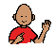

I can

