Hello:

As of today, our SORA collection of decodable ebooks is now at 340+ Below is a screen shot of what the ribbon (collection) containing Supersonic Phonics, Jump! Decodables & My Decodable Readers looks like in SORA when you click on the binoculars icon to "Explore.” You can also search by typing in the particular series you are interested in.

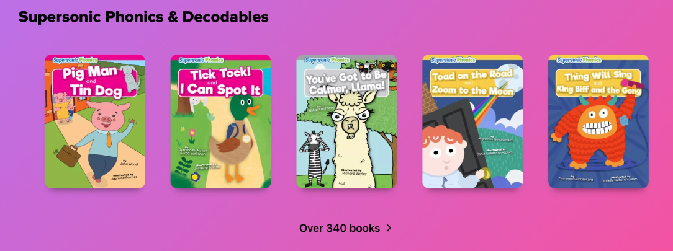

Below is a link to information I just posted to learn71 about LRC print decodable books (including TwERL Phonics and Tween Emergent Readers for Intermediate students) as well as the ebook decodable readers in Sora. Links to the progression charts for the various series provided will help you determine which titles fit your individual students the best.

https://learn71.ca/lrc-reading-resources/

Yes, Nides parents and students across the province have access to these digital titles in Sora. Enjoy!

Joan

