Creating a Greenscreen Movie in Canva
In Canva it is easy to remove a background from a movie and add any background that you would like. You can only do 90 second segments at this time.

Steps:
1 | Create your movie with a regular background using whatever filming method you wish (ex. Ipad video or phone).
2 | Open up Canva and from the home page click to start a Video (or Educational Video). | 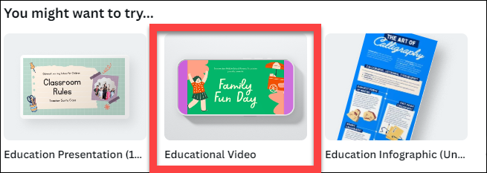
3 | Click on Elements on the left and find a background that you would like for your video. | 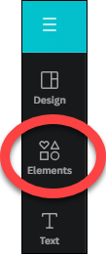
4 | Click on Uploads on the left and then Upload files. Then find your video and upload it to Canva. Now you can click and drag the corners of your video so it doesn’t take up the whole screen or leave it full screen. | 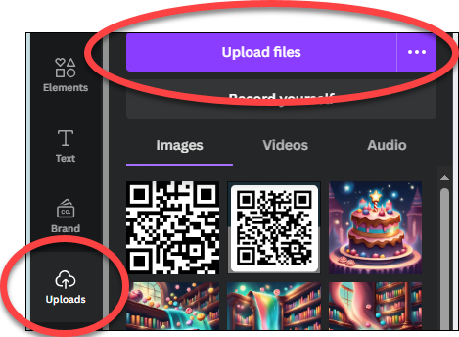
5 | Click on Edit Video at the top. | 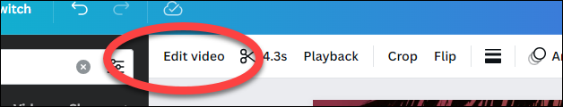
6 | Click on Background Remover. Then wait until the times is done and the background disappears. Now you can move your video anywhere on the screen and you will see your background instead of your original one! | 