MAKE THE STICKS JUMP

MATERIALS: 6 – 10 sticks of various lengths (6” – 10” work well!)
3 small rocks per person
INSTRUCTIONS:
- Set up the playing zone in an open field or dirt area in the woods.
- Draw or designate a starting line from which the players will throw their rocks.
- Place the sticks at regular intervals from the starting line.
- Assign a point value to each stick (the one closest to the starting line is worth the least, the one furthest away will be worth the most.
- Have players take turns throwing their rocks from the starting line with the objective of trying to hit the sticks.
- When the player hits the stick with their rock, and the stick jumps into the air, they are awarded the point value of the stick.
- Play for a set number of rounds or until one player reaches a predetermined number of points.
FUNDAMENTAL MOVEMENT SKILLS: Underhand throw, Overhand throw
CROSS-CURRICULAR – Number sense, counting, skip-counting
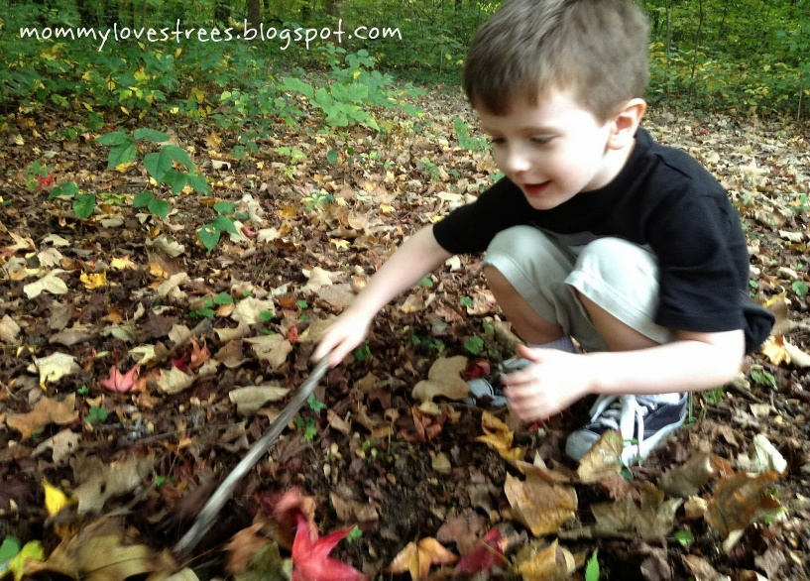
Indigenous Games. Presented by Cole Wilson. Saskatchewan Physical Education Association. https://www.speaonline.ca/uploads/3/8/2/9/38299825/indiginous_games_handout_by_cole_wilson.pdf

Indigenous Games for Children. HIGH FIVE: Parks and Recreation Ontario. https://intranet.csf.bc.ca/wp-content/uploads/sites/2/2019/12/ressources/EA_indigenous-games-for-children-en.pdf
This Photo by Unknown Author is licensed under CC BY-NC

