JUMP YOUR HEIGHT

MATERIALS: None

INSTRUCTIONS:
- Find an open area where you can lay down on your back.
- Have a friend make a line at your feet and then another at the top of your head.
- Standing at the line marking your feet, with feet hip width apart, bend your knees and swing your arms behind you.
- Swing your arms forward, straighten your legs and drive your body forward off the ground as far as you can and see if you can land at the line which marked your head
- Try starting back and running up to the line. How far past the line can you go?
FUNDAMENTAL MOVEMENT SKILLS: Jumping, Hopping, Leaping
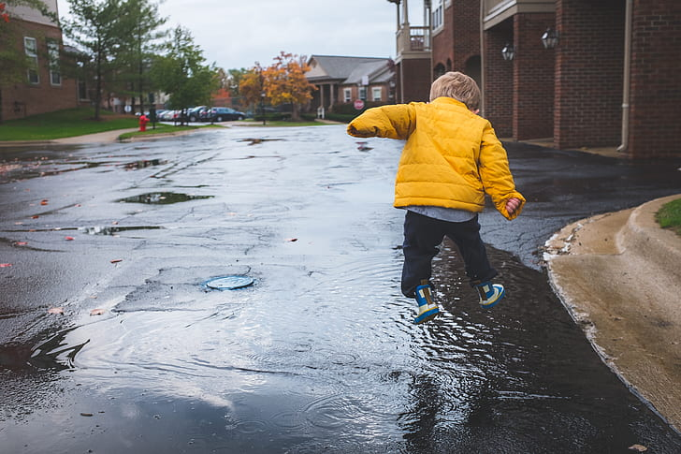
First Nations Winter Games. https://www.spsd.sk.ca/Schools/brightwater/teacher/midteachers/resources/Documents/First%20Nations%20Winter%20Games.pdf

