War Card Game
IDEA #1- Gym
Line up across from a partner or start in the middle of the gym as a group
Go to the outside of the gym and pick up a card
Find another student to play war against
Show cards- higher card wins the other person's card
You must place the card you played last at the bottom of your pile
IDEA #2- Outside
Play outside on the field or in the forest
All students start with a card... On go...
Students try to tag one another
When tagged the students play war... flip your card at the same time and the higher card wins the other student's card, and it must go on the bottom of the pile in their hand.
If you lose your card you must run to the teacher and get another card.
At the end of the game all the students come in and count how many cards they have.
Joker is the highest card possible, and Ace is the second highest
War Card Game (PE Style)
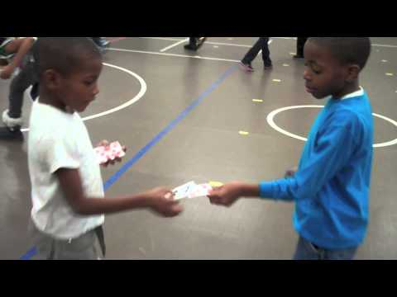

JENGA BATTLE
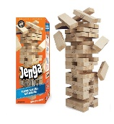
Set-Up:
- Create 4 teams and each team has an area with cones around the building area (space to build on)
- Everyone has a scarf tail and pinnies to separate the 4 teams
- Create a coned off area in the middle where you place all the Jenga blocks, dodgeballs, bin for scarves

Jenga Blocks Extra Scarves Balls

The Game:
- Try to steal scarf tails from other teams
- If you steal a scarf, you can bring it to the middle to get a building block for your team or you can wait to get 3 scarves and get a bomb (dodgeball)
- 1 Scarf= 1 block 3 scarves= bomb A bomb can be thrown at structures
- The object of the game is to get the tallest structure built by the end of the game without a bomb knocking it down.
- If you lose your scarf you go into the middle to get another one from the teacher.
- Level 1 – One scarf = one block for your team to build and one builder
Level 2 – One scarf = one block and 3 scarves = a ball to hit structures
One builder and one defender
The ball may be thrown at a structure- If the thrower misses and runs and gets the ball, they may keep throwing. If a non-thrower gets the ball, then they bring it back to the center to stop them. If a structure is knocked over then the builder quickly rebuilds.
Level 3- Same as above but if you knock a team's structure over – you win the blocks that fall over (i.e. only the top falls off, you win those blocks)

