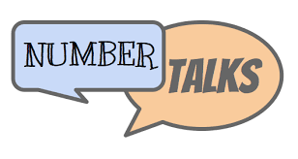
Planning Guide

Strategy Focus

Number Talk

Anticipated Strategies

Question Prompts

Math Language

