105 – 1750 West 75th Avenue, Vancouver, B.C., Canada V6P 6G2
Phone: 604.261.9450 Fax: 604.261.2256 www.setbc.org

iPad Basics: Guided Access

Introduction
This is a brief overview of how to use Guided Access on your iPad.

Learning Objectives
Completion of this tutorial will give you experience with the following:
- Guided Access

This tutorial assumes
- that you have an iPad

Case Study
Ralph is working on writing a paragraph for class and is using the iPad to support his written output. He loves watching YouTube videos on the iPad and has a difficult time staying on task. His teacher will set his iPad to Guided Access for ten minutes, so that he can focus on writing for ten minutes, and then have a break.

Guided Access
1 | Open Settings and tap General, then Accessibility. | 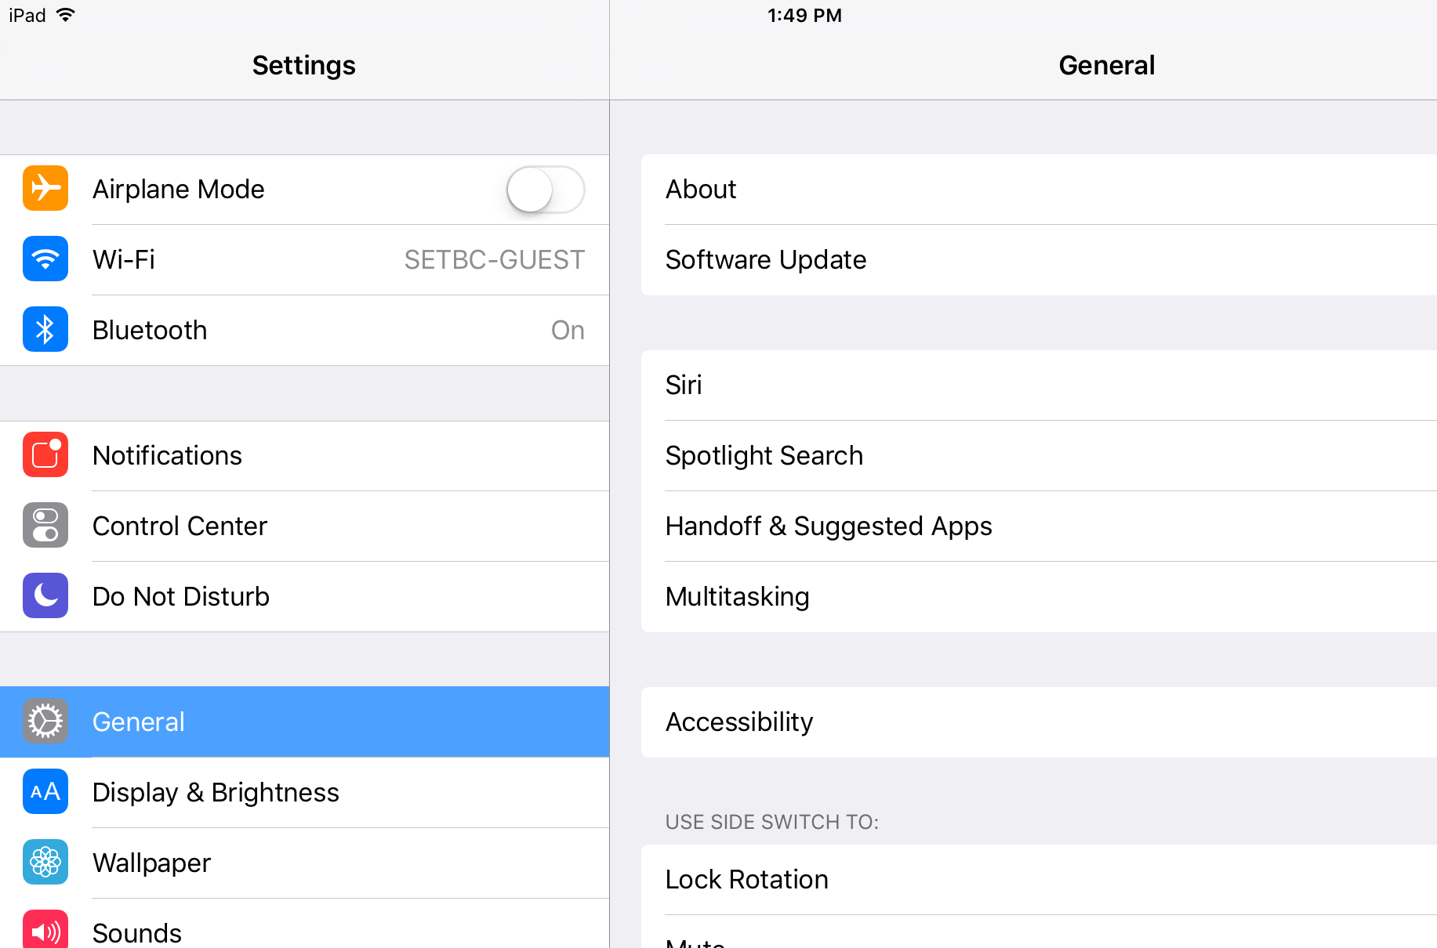
2 | Scroll to the bottom and tap Guided Access. | 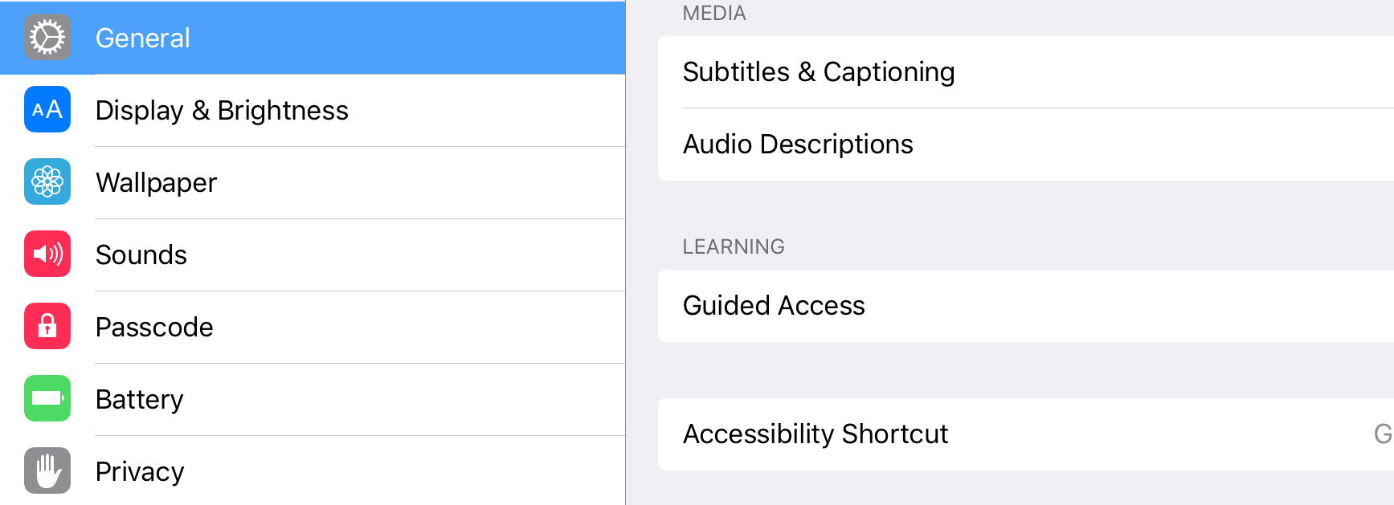
3 | Toggle the Guided Access switch on (green). | 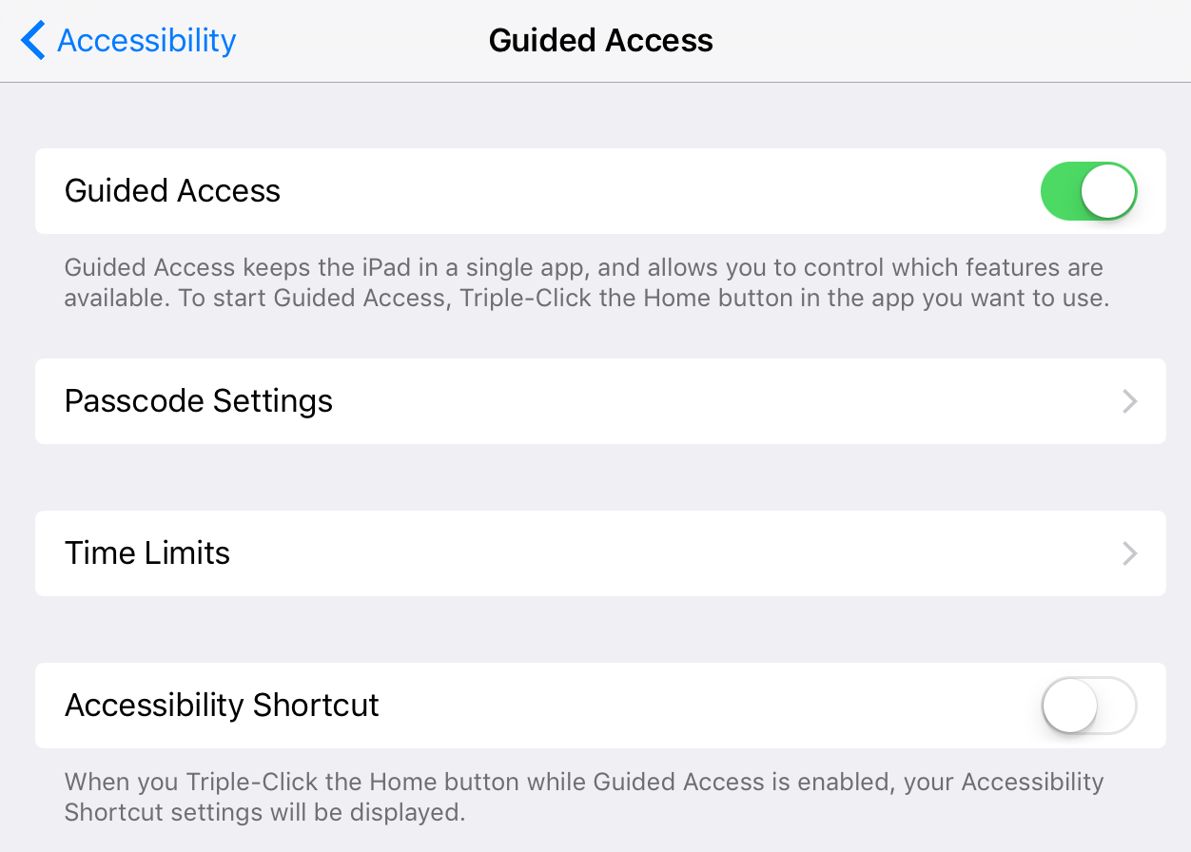
4 | Tap Passcode Settings. Tap Set Guided Access Passcode. Enter a passcode. Re-enter you passcode to confirm. | 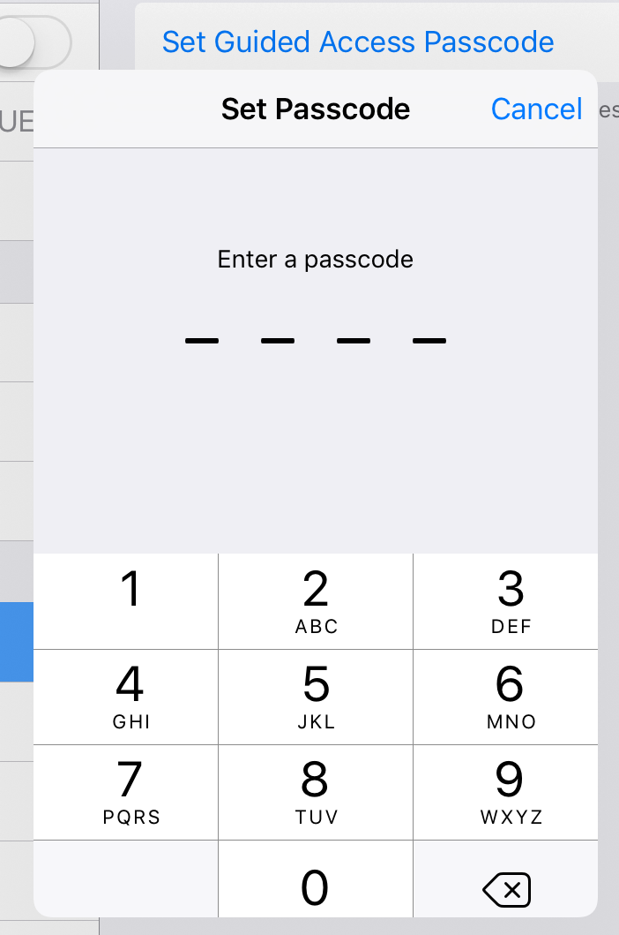
5 | Hit the home button and go to the app your student will be working in (in this example, Notes). Set up the page so that the student is ready to work. Triple click the home button. Guided Access will begin. | 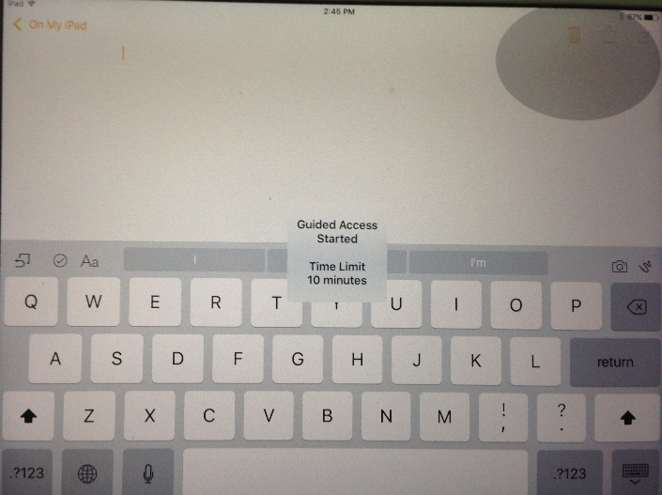
6 | To exit Guided Access, triple click the home button again. Enter your passcode. | 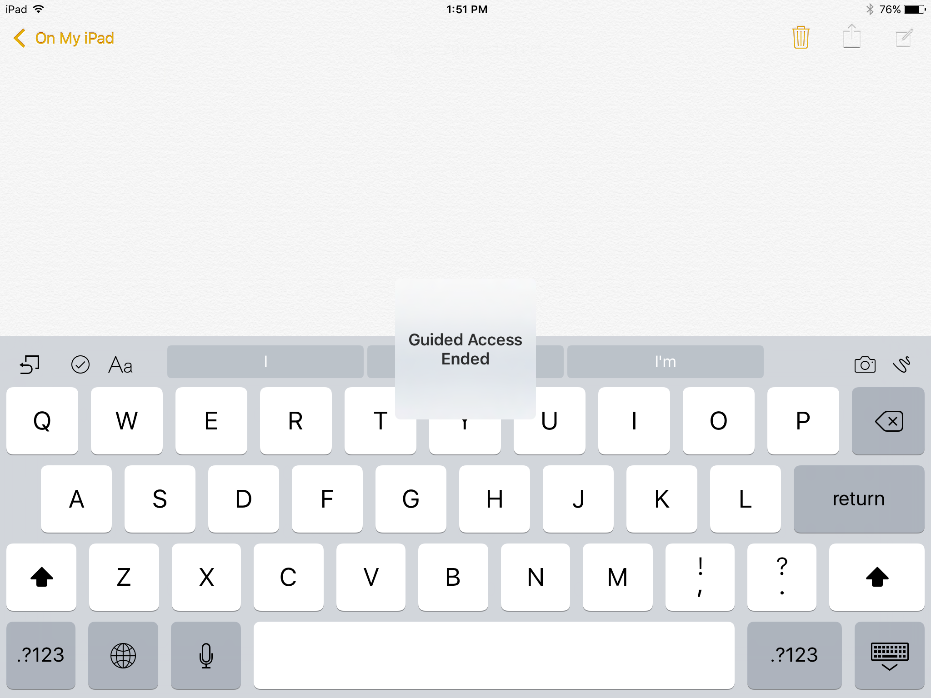
7 | You will now see the Guided Access screen. (If you don’t see it, triple click again to resume). Tap End (top left corner) to end Guided Access and Resume (top right corner) to resume. | 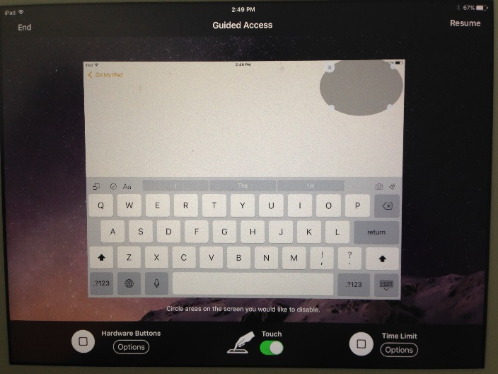
8 | Tap Hardware Button Options (bottom left) to change access to hardware buttons. | 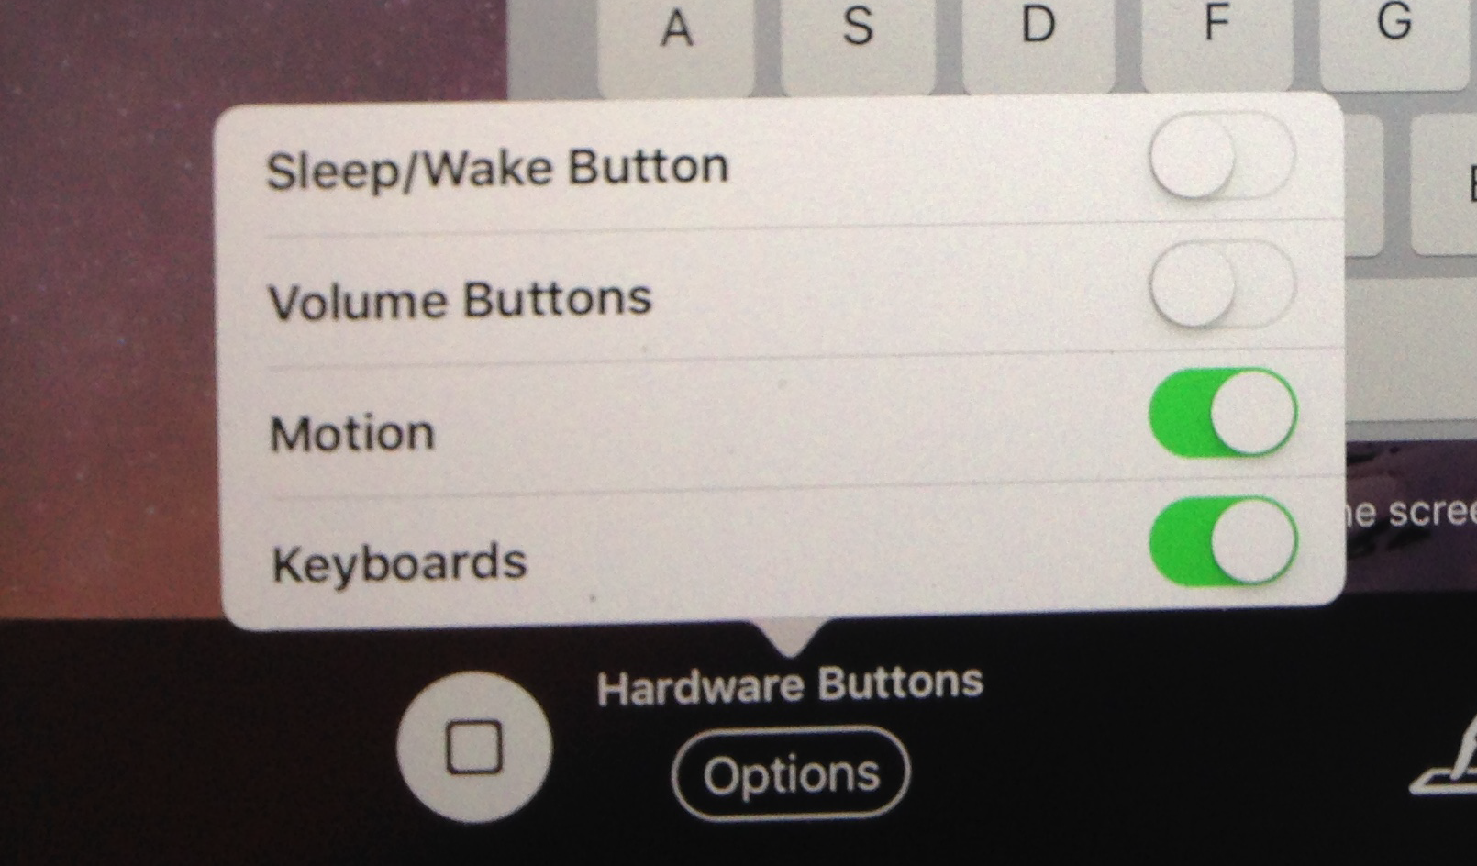
9 | Tap Touch (bottom centre) to block access to certain areas of the screen. Once the switch is toggled on (green), draw a circle around the area of the screen you would like to prevent access to. These shaded areas can then be moved around by dragging, or deleted by tapping the x. | 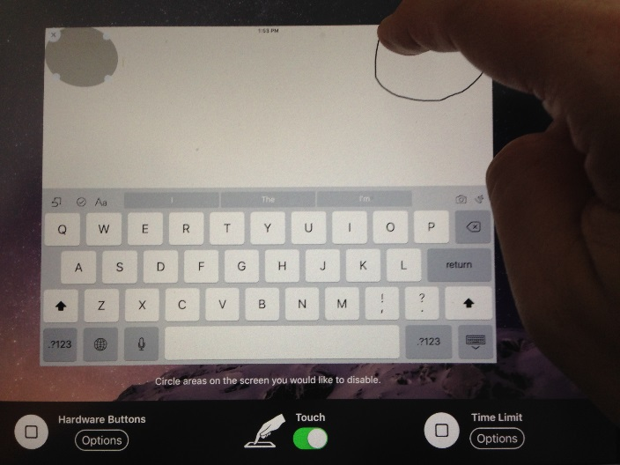
10 | Tap Time Limit Options to set a time limit for Guided Access. | 