Use Guided Access with iPhone, iPad, and iPod touch
Guided Access limits your device to a single app and lets you control which features are available. You can turn on Guided Access when you let a child use your device, or when accidental gestures might distract you.
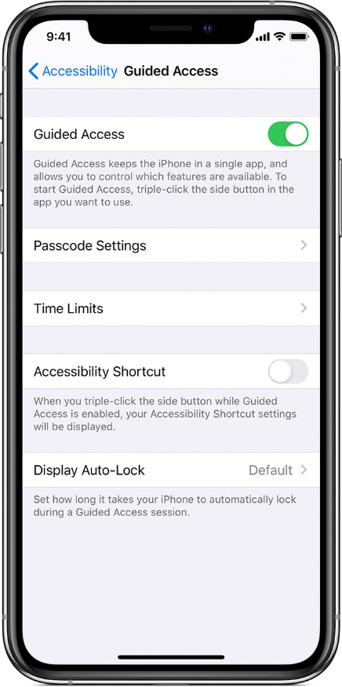

Set up Guided Access
- Go to Settings > Accessibility, then turn on Guided Access.
- Tap Passcode Settings, then tap Set Guided Access Passcode.
- Enter a passcode, then re-enter it. Write it down so you remember it.
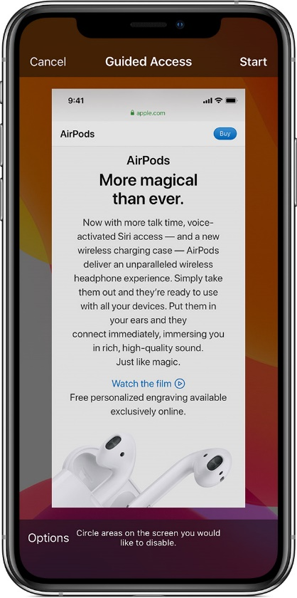

Start a Guided Access session
- Open the app that you want.
- On an iPad triple-click the Home button.
- If you want parts of your screen to stop responding to touch, use one finger to circle those areas. You can move or resize the circle or tap the X to remove it.
- Tap Guided Access, then tap Start.

Control which features are available
- To turn off features or set a time limit, triple-click the Home button, then tap Options. If you don't see Options, triple-click the Home button again and enter your passcode.
- Turn on the options that you want, then tap Done.
Sleep/Wake Button
To turn off the Sleep/Wake button on your device, turn this off.
Volume Buttons
To turn off the volume buttons on your device, turn this off.
Motion
To limit how your device responds to motion, turn this off. For example, your screen won't respond when shaken, and the screen won't rotate no matter how you hold your device.
Keyboards
To turn off the keyboard so that it does not appear, turn this off.
Touch
If you want your device to ignore screen touches, turn this off.
Dictionary Lookup
To use the Look Up feature when you select text, turn this on.
Time Limit
To choose a time limit for your Guided Access session, turn this on.

End a Guided Access session
Triple-click the Home button, enter your Guided Access passcode, then tap End.

