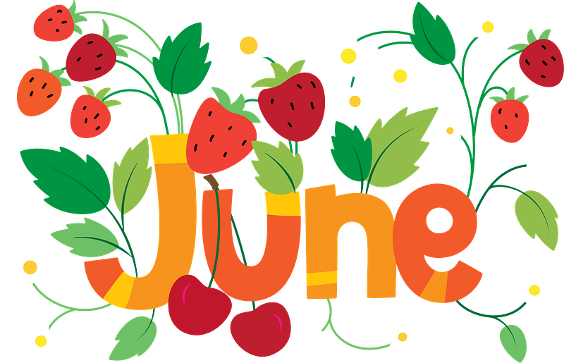
Megan Zeni’s

General school garden guidelines
&
month by month to do list

***Will vary by garden exposure, add/ delete to each month your own notes

June:

Direct instruction:
  - Why and how to harvest garlic scapes
  - How to monitor the soil for moisture
  - How to use the hose and spigot
  - How to weed without pulling out seedlings
  - Honorable harvest techniques

Garden tasks:
  - Prep summer weed/watering schedule
  - Meet with your garden committee

Direct seed in garden:
  - Basil & cilantro
  - Cucumbers
  - Pumpkins

Transplants that can go in the garden
(succession planting like peas and carrots are also a good idea):
  - Peppers
  - Tomatoes
  - Eggplant

Harvest
(harvest crops that are ready, make a plan for summer harvest if not ready before end of June):

  - Beets
  - Garlic
  - Onions
  - Leeks
  - Broccoli
  - Cauliflower
  - Strawberries
  - Blueberries
  - Peas
  - Broad beans
  - Lettuce
  - Carrots
  - Swiss chard
  - Potatoes

