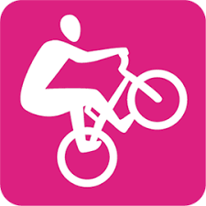
Biking Lesson 2 – Advanced bike handling skills
Day 2

- Bike check & Helmet check – Rainbow formation

- Warm up – follow the leader - communication

- Intro. road ride – straight line and distance from the curb/cars

- Straight Line Glide
- Lay rope fold in half into straight line
- Mark start and finish with cones
- Students ride hard to first cone
- Then glide along rope in neutral standing position (feet neutral, butt of seat, ready position arms, eyes forward)

- Game - Shark Island
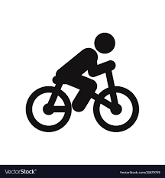
- Review neutral position and ratchetting
- Full class on bikes inside marked out circle
- Must be riding
- If bike goes out of circle “eaten by sharks” = out
- If foot touches ground in circle “ground is lava”= out
- As people go “out” the island gets smaller – “tide comes in”
- Continue to make circle smaller as people get eliminated
- Last person on bike upright wins

- Hill weave and gear change – hill climb sit/stand, gear changing

- Limbo – ready position & neutral position

- Bike handling- advanced – Challenge by choice
- Plank ride
- Ramp drop
- Log rides
- ‘A’ Frame
- Teeter Totters

