Megan Zeni’s

General school garden guidelines
&
month by month to do list

March

Direct instruction:
  - Protect important early bloomers for bees: dandelions, kale gone to seed “vernalization”
  - Weeding is a pattering activity- use string lines over new seed plantings to help identify new seedlings so they don’t get weeded!
  - Split any perennials that will be used in a plant sale (rhubarb, oregano, chives, perennial flowers)
  - Watch for pest life cycles in your soil and interrupt
  - Honorable harvest techniques

Garden tasks:
  - Prep paper seed pots, fill with seed starting soil, plant seeds after spring break
  - Rebuild bug hotel
  - Clean up any winter damage, repair garden beds
  - Conduct a soil audit if you have old soil: sift and amend soil, count worms and other life in the soil
  - Amend soil, add compost and organic material to the soil
  - Clean shed and organize for the growing season
  - Lay out gloves and tarps and anything wet on sunny days to dry out!
  - Meet with your garden committee

Seeds to start indoors (a small example):

  - Tomatoes
  - Broccoli
  - Peppers
  - Ground cherries
  - Peppers
  - Cucamelons
  - Lettuces
  - Pac Choi
  - Basil

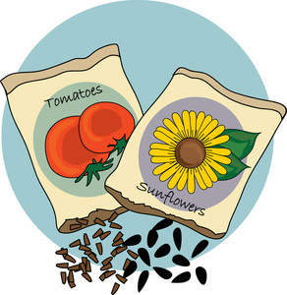
Direct seed in garden (a small example):
  - Radishes
  - Spinach
  - Snow peas
  - Broad beans

