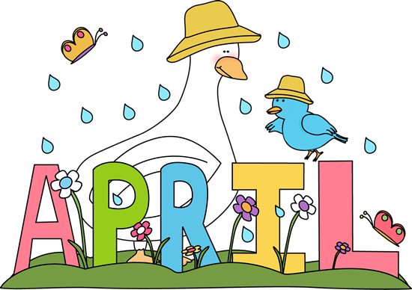
Megan Zeni’s

General school garden guidelines
&
month by month to do list

April
***Will vary by garden exposure, add/ delete to each month your own notes

Direct instruction:
  - Begin thinning seed rows (radish, carrots, pac choi will need to be thinned)
  - Monitor soil moisture, water if necessary
  - Teach about vernalization, teach how to honorably harvest the kale flowers (leave some for the bees and some for seeds to grow)
  - Honorable harvest techniques

Garden tasks:
  - Build team & meet with your garden committee
  - Clean up garden if not already done & amend soil (if not already done)
  - Meet with your garden committee

Direct seed in garden (a small example):

  - Carrots
  - Radish
  - Spinach
  - Peas
  - Lemon balm
  - Lettuces
  - Parsnips
  - Scallions
  - Snow peas
  - Nasturtiums
  - Potatoes
  - Beets
  - Specific Flowers like:
calendula, poppies, cornflowers, cosmos, delphinium, lupin, marigolds, nasturtium, rudbeckia, and sunflowers

Transplants that can go in the garden (a small example):
  - Celery
  - Strawberries
  - Onion sets

Seeds to start indoors (a small example):
  - Squash, pumpkin, zucchini etc.
  - Cucumbers

Harvest:
  - Radishes
  - Kale
  - Perennial herbs: chives, oregano, mint etc.
  - Rhubarb
  - Lettice greens
