Word Sort for Hard and Soft c
Name: _____________________

The Rule: This is a spelling and a reading rule
- “C” makes the soft /s/ sound when it is followed by “e,” “i” or “y.”
- It makes the hard /k/ sound when it is followed by all other letters.
- This is a predictable rule.

Instructions: Sort the following word bank into hard and soft “c.”

acid Pacific concert fence caustic
object peace process hectic gigantic
cyclone sincere bicycle panic science
circus drastic electric carousel extravagance

hard “c soft “c”

Word Sort for Hard and Soft c
Name: _____________________

The Rule: This is a spelling and a reading rule
- “C” makes the soft /s/ sound when it is followed by “e,” “i” or “y.”
- It makes the hard /k/ sound when it is followed by all other letters.
- This is a predictable rule.

Instructions: Sort the following word bank into hard and soft “c.”

acid carry circus peace cotton
music citrus pencil juice combine
Pacific climb certain place cemetery
bicycle electric decide ounce panic

hard “c soft “c”

Name: ___________________________

Directions:
- Mark a “H” on all of the pictures where the “c” makes the hard /k/ sound.
- Mark ca “C” on all of the pictures where the “c” makes the soft /s/ sound.
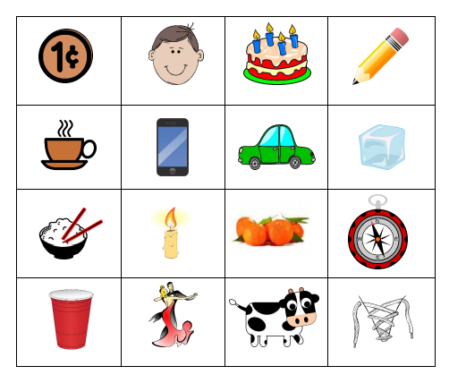

Pictures: Cent, face, cake, pencil, coffee, cell, car, cube, rice, candle, citrus, compass, cup, dance, cow, lace

