Discovering Decomposers!
Grade
1-4 could be extended to grade 7
Curriculum Links: Science
Grade | Big Ideas | Biology-Curricular Content
1 | • Living things have features and behaviours that help them survive in their environment. | • structural features of living things in the local environment  • behavioural adaptations of animals in the local environment
2 | • Living things have life cycles adapted to their environment. | • similarities and differences between offspring and parent
3 | • Living things are diverse, can be grouped, and interact in their ecosystems. | • biodiversity in the local environment  • energy is needed for life
4 | • All living things sense and respond to their environment. | • sensing and responding: – humans – other animals – plants
First Peoples Principles of Learning
Learning is holistic, reflexive, reflective, experiential, and relational (focused on connectedness, on reciprocal relationships, and a sense of place).

Materials:
- Hard writing surface (clip board, cardboard with clip)
- Pencil
- Coloured pencils (optional, helps with drawings and observations)
- Magnifine glasses (optional, kids love to use them)
- Ruler (optional, helps with observations)
- Small plastic container, white or clear (optional)
- Phone with camera

Handouts and Additional Resources:
Scavenger Hunt: See Appendix A below
Video: The Dirt on Decomposers: Crash Course Kids- https://www.youtube.com/watch?v=uB61rfeeAsM
Insect ID App: Picture Insect https://play.google.com/store/apps/details?id=com.glority.pictureinsect&hl=en_CA
HCTF-Education- Wood bugs - https://www.hctfeducation.ca/wp-content/uploads/2016/08/Wood-Bug-Article.pdf
Science World- Decomposers- https://www.scienceworld.ca/resource/introducing-decomposers/

Background:
Decomposers play a critical role in the flow of energy through an ecosystem. They break apart dead organisms into simpler inorganic materials, making nutrients available to primary producers.
Decomposers feed on dead things: dead plant materials such as leaf litter and wood, animal carcasses, and feces. They perform a valuable service as Earth’s cleanup crew. Without decomposers, dead leaves, dead insects, and dead animals would pile up everywhere. Imagine what the world would look like!
More importantly, decomposers make vital nutrients available to an ecosystem’s primary producers—usually plants and algae. Decomposers break apart complex organic materials into more elementary substances: water and carbon dioxide, plus simple compounds containing nitrogen, phosphorus, and calcium. All of these components are substances that plants need to grow.
* Adapted from: https://www.nationalgeographic.org/encyclopedia/decomposers/

Common Decomposers found in the forest
Decomposer | Example | Description
Fungi | 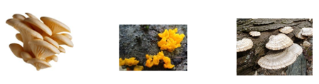 | Fungi release chemicals externally to break down dead plants or animals into simpler substances. They absorb some of these substances for growth, but others are utilized by other organisms, including plants.
Bacteria | 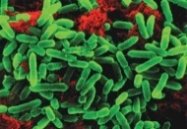 | Bacteria are tiny, microscopic organisms. The ones that live on dead materials help break them down into nutrients which are returned to the soil.
Invertebrates | 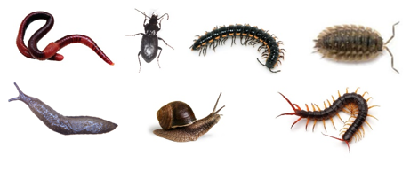 | Earthworms digest rotting plants, animal matter, fungi, and bacteria as they swallow soil. The waste that comes out of their bodies at the other end contains important minerals and nutrients ready for plants to absorb.  Millipedes, sow bugs, and fly larvae (maggots) do a similar process, at different rates, but they rely on a different food source.  Centipedes are part of the decomposer group because they eat other invertebrate decomposers, thereby keeping the decomposer populations balanced.  Wood bugs Not a bug – a crustacean Related to shrimp and lobsters – where do those live? Wood bugs breathe through simple lungs that need to be very moist, therefore need moisture in the air Keep them under leaves provided. You can handle them gently, but not for long or they will run out of air.

Decomposer Day - Activities:
- Go to your designated outdoor area.
- Start off by asking if anyone knows what a decomposer is? Can they think of any examples?
- Share instructions before handing out materials:
- Have students pair up
- Each pair will receive materials listed above
- Set out designated boundary for decomposer discovery
- You will be going on a decomposer discovery. Use the scavenger hunt paper to help guide you (appendix A).
- Students must try to find the three decomposer on the sheet by rolling over decomposing logs, rocks, leaves in a forested area- and make close observations. Prep students on what are appropriate observations for their age.
- There are three blank spots on the scavenger hunt. Have students record any other ‘creatures’ they find that the think would fit into the decomposer category and record observations.
- Finish the three questions at the bottom of the scavenger hunt with their partner.
- Come back to group and share their discoveries
- Back in class give time to finish up scavenger hunt paper. Students will hand this in r put in their portfolios
- Watch the: The Dirt on Decomposers: Crash Course Kids https://www.youtube.com/watch?v=uB61rfeeAsM
- Look at extensions to dive deeper into decomposers.

Assessment:
- Students will hand in scavenger hunt and submit to science portfolio
- Video record students’ findings during scavenger hunt-add to portfolio
- Student is enthusiastic and engage during activity
- Student shares their findings
- Student can identify and locate local decomposers
- Student can describe the importance of decomposers to the forest eco-system

Extensions:
Dive deeper and get to know a decomposer. This could be as a class, small group, pairs or individual.
Questions to consider:
*adapted from https://www.hctfeducation.ca/wp-content/uploads/2016/08/Wood-Bug-Article.pdf
Grade | Features | Function | Lifestyle
1-2 | How many legs?  Are there males and females?  What texture are they? Do they have any markings? Stripes? Dots?  Where are their eyes located? | Do they only eat rotten wood?  Do they eat dead animals and humans? How many times a day do they poop?  How far/fast can they run in two minutes? How do they live?  How do they crawl into small spaces?  How do they eat?  How do they get water under a log? | How long do they live? How many eggs do they lay?  How long for the eggs to hatch?  How long do they live?
3-4 | How many legs do they have? Why?  Do they have antennas? Why?  Why are they the colour they are?  Why do they have certain markings?  Can you tell male from female?  Why or why not do they have an exoskeleton? | What do they eat? Why do they need water (moisture) to breathe?  Do they eat garbage?  Can they swim?  Do they think? About what?  Do they make a sound? Can they talk? Interact? | How does your decomposer attract a mate?  How are they born? What happens to the newborn babies?  How do they feed babies?  How small are the babies when born?  Why do parents go away from babies? How big do they get? How long can they live? Or how old?

Safety Considerations:
- ***Mushrooms*** – Look don’t touch or pick
- Prepare Students– ensure students are aware of this extra time spent outdoors. Go over appropriate clothing and behaviours while out on your decomposer mission.
- Prepare Parents – Ensure parents are aware of the extra time spent outdoors and recommend appropriate clothing for the season. If you are going off school grounds make sure all required permission forms have been filled out.
- Prepare Yourself
- Do a reconnaissance trip so you know your way to and from your location and time needed to travel to and from.
- Check the weather, high winds in the forest are reason to switch to a plan “B”
- Ensure you have appropriate clothing and footwear for the day.
- Have a plan “B”
- Bring a sound signalling device (whistle, harmonica, bells etc.)
- Grab and go first aid kit, and any medications specific to students in you class/group
- Communication device (cell phone) with pre-programmed school administration numbers
- Gather required materials for the activity
- Ensure the front office or your admin know of your outdoor location and the time range you will be out
Sustainability Considerations:
Please remember to return all decomposers and any moved forest items back to their original location.
Appendix A- Decomposer Scavenger Hunt
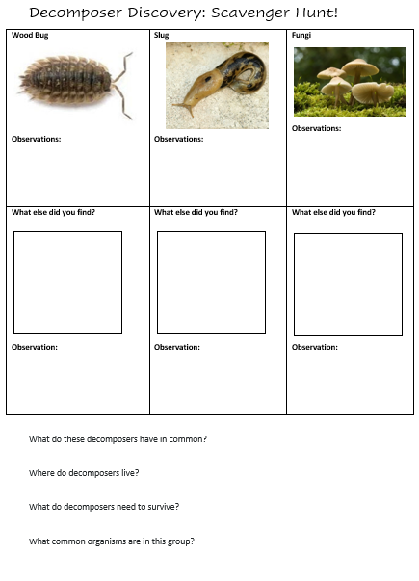

Resources:
HCTF-Education: https://www.hctfeducation.ca/wp-content/uploads/2016/08/Wood-Bug-Article.pdf
HCTF-Education- Wood bugs - https://www.hctfeducation.ca/wp-content/uploads/2016/08/Wood-Bug-Article.pdf
The Dirt on Decomposers: Crash Course Kids- https://www.youtube.com/watch?v=uB61rfeeAsM
Science World- Decomposers- https://www.scienceworld.ca/resource/introducing-decomposers/

National Geographic: https://www.nationalgeographic.org/encyclopedia/decomposers/

Picture Insect https://play.google.com/store/apps/details?id=com.glority.pictureinsect&hl=en_CA

