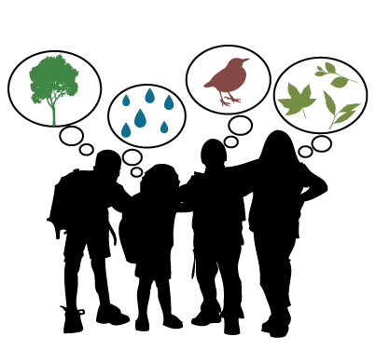
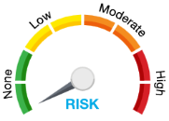
Outdoor Learning Risk Assessment Checklist

Reconnaissance
Before taking your class to an area either on or near the school grounds it is best practice to explore the area ahead of time and asses it for risks and feel comfortable with your surroundings.

Communications
Ensure you have communicated with students, parents, and administration that you will be taking your learning outside and off school grounds. Helpful to leave a note on your door with date and location of where you are that day. For walking field trip forms click HERE.
- Parents
- Admin
- Students
- Community Stakeholders (if going off school grounds)

Preparation
- Prepare yourself
Do you have proper footwear and clothing to be an good example and comfortable in the weather conditions? Do you have a leader back pack ready for your outing?
- Prepare your students
How to be dressed for the day. Go over outdoor learning expectations-this is your outdoor classroom indoor behaviour should be the same as outdoor behaviours.
- Prepare your parents
Communicate your why and when to your parents. Share a visual of how to best dress their children for the weather. Cold weather is different clothing then wet weather. Click HERE for a good visual to share with parents. Ask your parents to join and help out.

Safety Plan: click HERE & HERE for supportive document- think through some of these scenarios before heading out.

- Boundaries
- Lost child
- Runner
- Large mammals
- High winds
- First Aid
- Alerting tool (ex. Whistle)
- Risky play & challenge by choice- practice your language
- Wasp nest
- Eating mushrooms or poisonous plants
- Sharps
- Bathroom breaks & accidents

Safety practice
Include students in this process through games and conversations.
Safety Charades Game: designate one of the below scenario to either pairs or small groups. In silence they act out their scenario to the group, the group has to guess what the hazard it. After each presentation ask… What would we do in this scenario?
In small groups or pairs have students list out possible hazards while out on your excursion (school yard to overnight expeditions. Make a poster or presentation of the hazard-probability-consequence-defence for each. This will help arm your students to become their own risk assessors and to help you while outdoors.
Hazard | Probability | Consequence | Defence
Rain | Med | Low-med | Dress for the weather, hat or toque, shelter available, hydrate, and food fuel.
Large Mammals | Low | Med-High | Safety plan in place & practiced, noise, buddy system, stay within boundaries.

Set Boundaries
Set your outdoor boundaries and make sure your students know and respect them. Use either obvious boundaries already in place (eg. Road, fence, sidewalk, building), pylons or a bright visual they must be able to see at all times.

Student call back & buddies
Have a clear call back for when your students need to return to you. Practice it lots, till they can all do it quickly and calmly. Best practice to have a buddy and go over the role and responsibilities of buddies. Remember buddies do not replace adults.
Group Call Back VS. Emergency Call Back
X3

Leader Backpack, Frist Aid Kit & Cell Phone
Safety first!! Make sure you have a well stocked, portable first aid and know how to use it. Also, be sure to have a charged cell phone with numbers of school and staff you need to contact in an emergency. When in doubt call 911.

Plan B
Planning, time, and commitment goes into any teaching practice. Outdoor excursions and learning is no different. Having and knowing when to move into plan ‘B’ is paramount to your safety planning.
Ex. High winds: It is protocol if there is a “High Wind Warning” with Environment Canada you should put Plan B into effect.

