Renewable Energy Education Kit Overview:
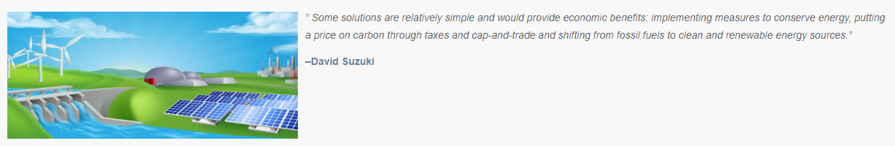

Intro:
We hope this kit inspires and supports you and your students as you dive into the world of renewable energy. This is a rapidly growing industry, renewable energy technology that we know today will be far more advanced than the renewable energy of 5 years from now. A reminder, however, that no other energy source we know of will meet the demands of our current consumption habits like fossil fuels have, becoming more energy responsible is part of the process in utilizing renewable energies as much as it should be for fossil fuels. No matter what energy source we are using it will leave a mark on our planet as they all use resources. Reducing our footprint is the goal, it is impossible to eliminate it.

Lesson Ideas:
What would it take for the Comox Valley to switch to more sustainable energy sources?
PART 1:
- Eco-Footprint evaluation- take a survey of students individual consumption usage
- Brainstorm- ways to reduce energy consumption in our everyday lives
- Challenge- Take the Cool It! Challenge with Sustainable Energy BC- Royston Elementary was the 2019 champions.

PART 2
- Pair and share / Group brainstorm- Draw or write the different sources we can get energy to our homes and schools. ‘Know-Wonder’
- Watch a short video on renewable energy 101
- Group - the above resources into renewable and non-renewable energy.
- Quick overview about alternate energy sources (teacher lead)- see below resources to support your lesson.
- Research- Organize into small groups- choose a card of one of the energy sources. After a guided research of the source work on building a human model (use of props is welcomed) with a narrator to help explain how your system works-take the presentations outside!
- Invite someone from the community!
- Hakai Energy - a local solar panel company - https://hakaienergysolutions.com/
Resources:
All the below resources and more can be found in one location on SD71’s district Environmental and Outdoor Learning website located from the main district page under programs and services or via LEARN71: http://learn71.ca/environmental-outdoor-learning-eol/teacher-resources/energy/
Eco footprint calculator -- http://www.footprintcalculator.org/
Eco-hand print lesson -- http://climatechangeconnection.org/resources/climate-friendly-schools/resources-for-schools/
Energy types, information and videos -- https://www.studentenergy.org/map

Community Connections
Hakai Energy - a local Comox Valley solar panel company - https://hakaienergysolutions.com/

