Nature Connection
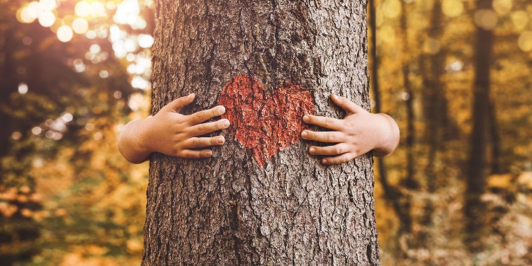
NATURE CONNECTION- How does developing a stronger connection with the natural world help create personal resilience to address climate change and global sustainability?
Students will learn about deep and shallow ecology, benefits of natural space, the Gaia Hypothesis and Biophillia. Students will then spend some time in a quiet spot outdoors to connect with nature, during this time, they will reflect and record on what they hear, feel and experience.

Activities:
- Work through some of the activity suggestion in the Nature Connections section of this booklet.
- Start by going outdoors with your class on a regular bases 2-3 times a week is best but once a week can work too.

Nature is Everywhere video! Emma Marris – watch this video on your own time to gain inspiration on where to find ‘nature’. https://www.ted.com/talks/emma_marris_nature_is_everywhere_we_just_need_to_learn_to_see_it?language=en

Consider visiting the Districts Environmental and Outdoor Learning website and search for outdoor nature based activities with your kids to help launch into the experience of connecting with nature. http://learn71.ca/environmental-outdoor-learning-eol/teacher-resources/nature-education/

