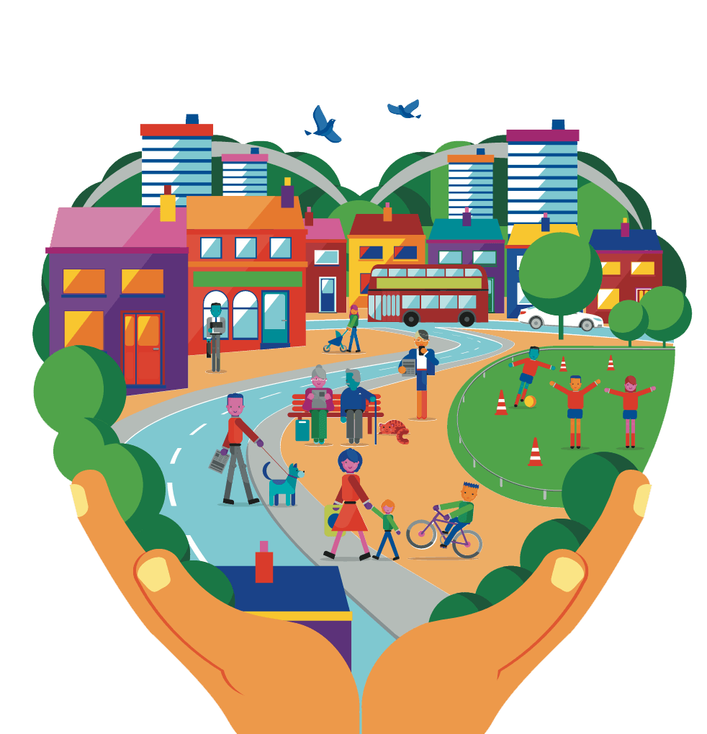
Community Connections

COMMUNITY CONNECTION & SUSTAINABILTY– How does engaging in and getting to know your urban community help build resilience and an optimistic future?

Students will be exposed to different aspects of their community and evaluate their value to them personally and through the lens of others. Students will then have the opportunity to weigh what is important to them in their community and how they can improve the shared space for a more sustainable future.

Activities:

PHASE 1:
Connect with your local museum, plan a walking tour with a museum representative to help pain a picture of the town you are exploring (Comox, Courtenay, Cumberland).

This field excursion will help shed new light to the use of the area from multiple perspective. Be sure to include Indigenous historical lens and a colonial historical lens. There were many different ethic groups that lived in the Comox Valley at varying times, where did they live and reside in the community?

PHASE 2:
For you second outing (or combine with phase 1) take a walk downtown Courtenay, Comox, or Cumberland. Look at different features and observe surroundings. If you need help planning your walk to highlight certain features please get in touch with the Environmental and Outdoor Learning District Teacher Serina Allison (serina.allison@sd71.bc.ca). Have students make a picture log of aspects they like, aspects they would like to see improved, aspects that are new to them.
Check out this site for some fun motivation https://www.pps.org/gps/lqc
Things to consider highlighting on the community walk:

- Parking
- Pedestrian walkways
- Accessibility
- Biking lanes
- Urban recreation ie. Skateparks, basketball courts etc.
- Bike parking
- Trees & plants
- Drainage (raingardens upper fifth street)
- Public shared spaces – parks, walkways etc. – What could enhance and improve these spaces? Trees, playgrounds, covered areas?
- Food gardens- residential, community, school.
- Small local businesses, cafes, restaurants.
- Consider the space during different seasons
- Access to river or ocean
- Buildings- exterior look and design
- Condensed living (upstairs units)
- Solar panels?
- Vacant lots
- Public transportation
- Urban streams and waterways
- Urban forests
- Electric car parking and charging stations
- Go for a public bus ride!

- Consider using the UBC-Cool Kit lesson to guide your outing, my favourite is the leaping squirrel test.

- On google maps have students find their walking field trip and print/upload the satellite view of the area. Circle and label features they recorded in their picture log onto the map, include pictures and recoded comments in the project.

PHASE 3 (stations)
Station 1: Input on an Official Community Plan:
As a class/small groups make a list of things you would like to see more of. OR use the already made cards.
Place the labelled index cards along with a vessel to hold voting beads. Each student gets 10 beads to vote on what is a priority for improving their community. This could also be done by looking specifically at the school grounds.
Consider taking the activity to your outdoor space.
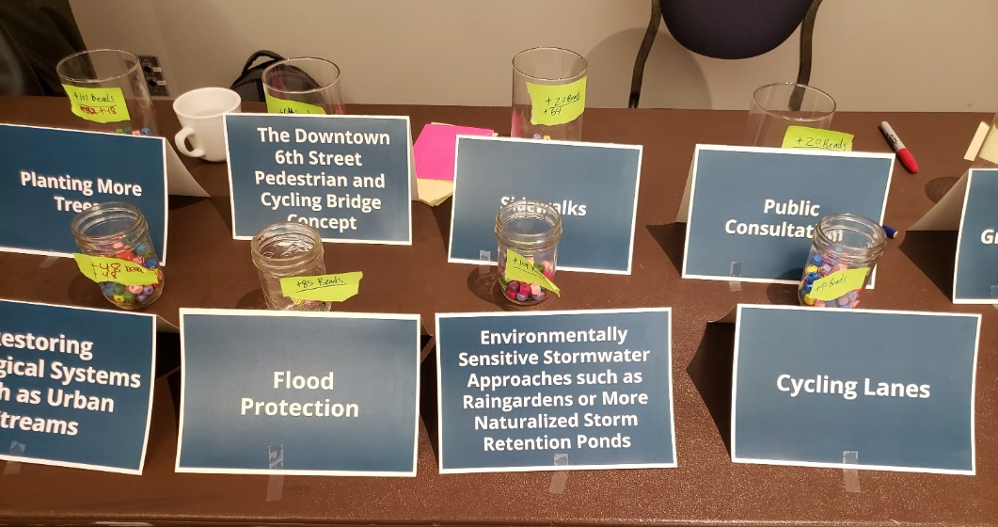
Adapted from Courtenay’s OCP public gathering, February 2020.

Station 4: Poster note brainstorm
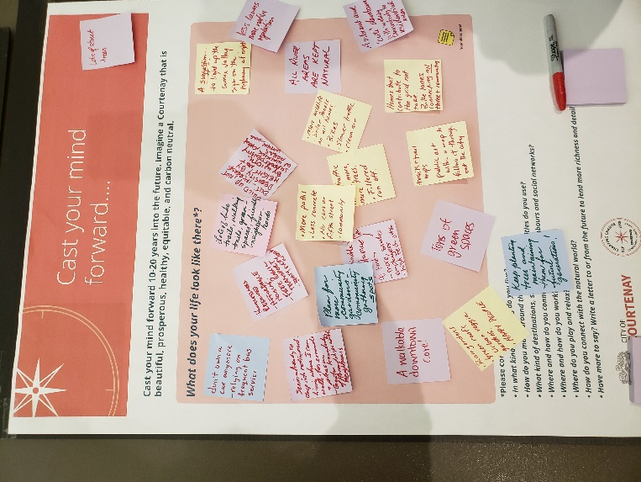
As part of the station rotation have students post sticky notes on the posters found in your kit:
- Cast your mnd forward…
- What do you cherish? What needs to change?

Action Project:
Individually, in small groups, or as a whole class have students students develop a proposal or modle of how to improve their community space (school yard, park, neighbourhood, down town).

Consider the next steps needed to implement the action project:
- Why is this project important to me (us)?
- Who is the audience I (we) would present to?
- What further background inforamtion is valuable to know prior to presenting the vision?
- What is the best way to communicate our vision?

PHASE 4: In their Shoes….

- Choose a card, read the story, and put yourself in their shoes.
- On a sheet choose 6 people from below, provide some ideas to enhance your community for these individuals. Do not be afraid to be creative.

- Parent
- Youth skateboarder/scooter
- Biker
- Shop keeper
- Restaurant owner
- Active individual
- Young child
- Truck driver
- Homeless individual
- Visitor/Tourist
- Teen
- Parent with stroller
- Mobility restricted individual
- Farmer
- Commuter

Further Resources:

Community Connection:
Nancy Gothard – Policy & Environmental Planner
City of Courtenay
ngothard@courtenay.ca

Nancy is supportive and enthusiastic to connect with youth interested in sustainable city planning. Nancy is open to coming and meeting with your class to discuss options, plans and ideas around local policy and environmental planning.

