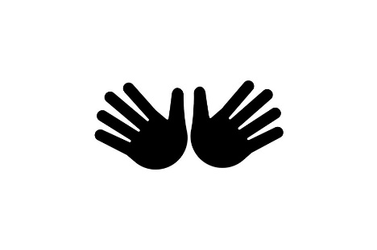
My tree feels
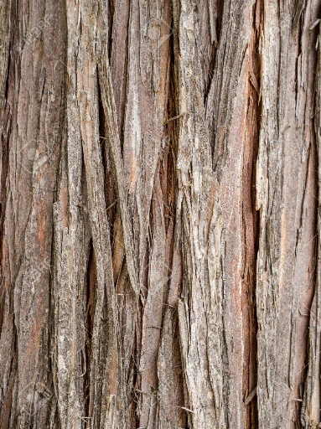
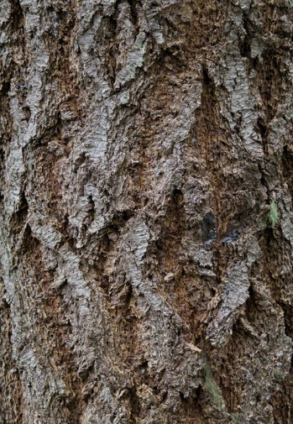
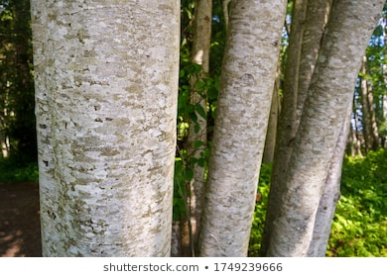

Rough Hairy Smooth

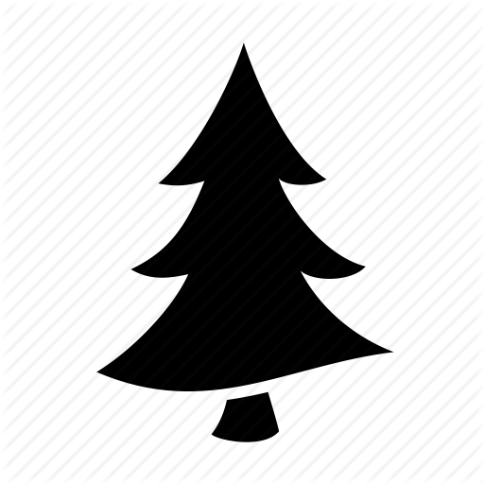
How tall is my tree?

I choose this tree because…..

Instructions:
- Individually, in your designated area find a tree.

- Look at the tree. Circle the pictures that best matches your tree.

- Use the blank paper and colour crayons to make a bark rubbing of your tree.

- Introduce your tree to your buddy. Point out the parts of the tree that you like or have noticed. Explain why you choose this tree.

- A challenge is to find the tree again on the next forest visit.

