Navigate Home Instructor LRC Tips - September 23, 2020

How to login to access the LRC Resources online
Contact your teacher. He/she will contact the LRC with the information needed for the LRC to set up an account for you. The information you will need to give your teacher is:
- Your name and your child’s name(s) and grades
- The program your child is in
- Your email address
- Your cell or home phone number
- Whether you would like to have kits delivered to Tsolum school or if you prefer to pick them up at the LRC
*Your login to the LRC will be set up as Username: OT1234 and Password: OT1234 Note that your child does not have access to the LRC to book materials. They have access, however, to our Destiny Library online catalogue, the District Digital collection (SORA), as well as the online Research Databases. Their login is set up by the IT Help Desk and is the same as their email, access to computers while at a school etc. It is Username: student number. Password: Initial first name + Initial last name + last four digits of their student number. Note that the initials are in lower case, and that if they changed their password it may be different.

How to see all resources available to you
Go to https://learn71.ca then click on LRC/Library Learning Commons http://learn71.ca/library-commons/. This screen appears:

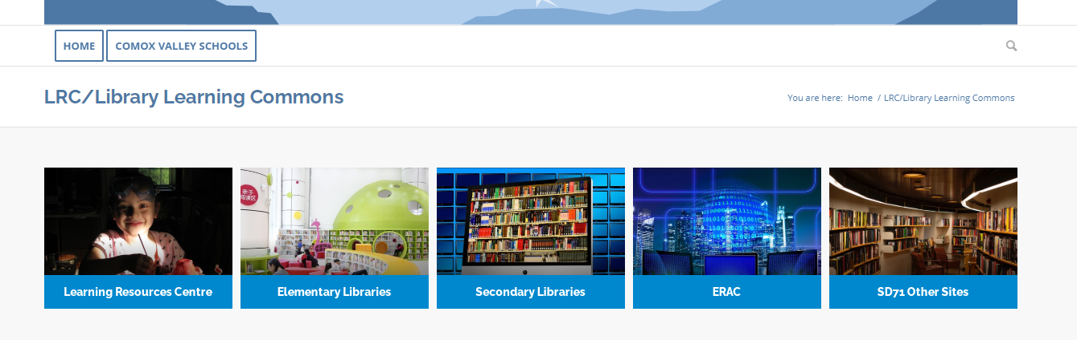
The two buttons the most important to you are “Learning Resources Centre” and “SD71 Other Sites.”

What is in the “Learning Resources Centre” button?
Below are the main sections:
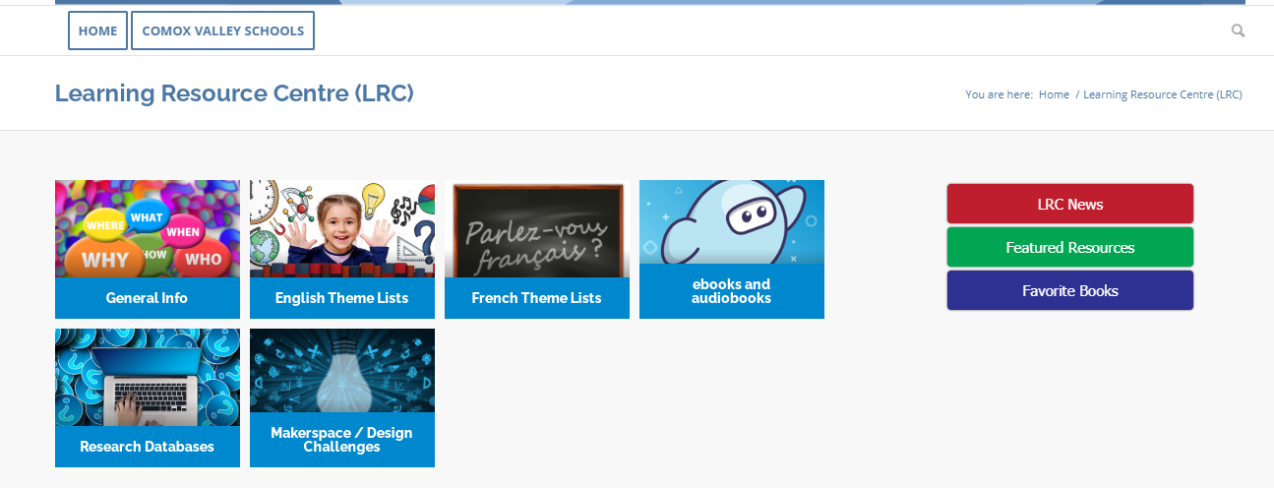
Be sure to check out “General Info” as it has information on Borrowing Guidelines for Navigate Home Instructors as well as a tip sheet on Searching the LRC and Booking Materials. The latter needs updating as I am now encouraging SD71 Other Site users, such as yourself, to go in through learn71.ca instead of the school district home page, but once in the steps are the same so the tip sheet is still very useful. “General Information” also has information on when the LRC is open, and the people to contact if you need help. This will usually be the LRC Circulation Desk: lrc.circulationdesk@sd71.bc.ca 250-338-7926 ext. 12101

What is in the “SD71 Other Sites” button?
Here is the main menu:
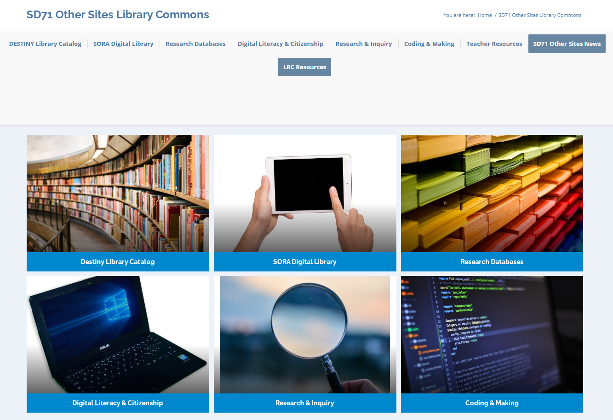
Be sure to explore all the options. Some to note are:
“Destiny Library Catalog”
Clicking on this brings up a list of sites in the district:
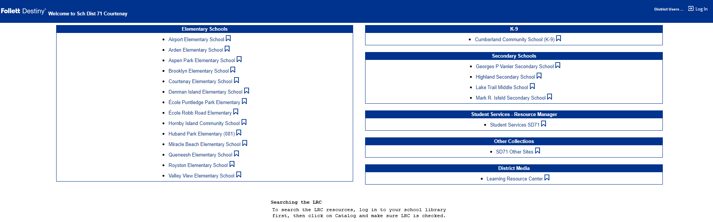
To search the LRC, you need to click on “SD71 Other Sites.” Do not click on “Learning Resources Centre.” Once you have done this, you will need to click on “Log in” in the upper right-hand corner. If you do not login you will be able to browse LRC materials but not book them. Logging in gives you this screen:
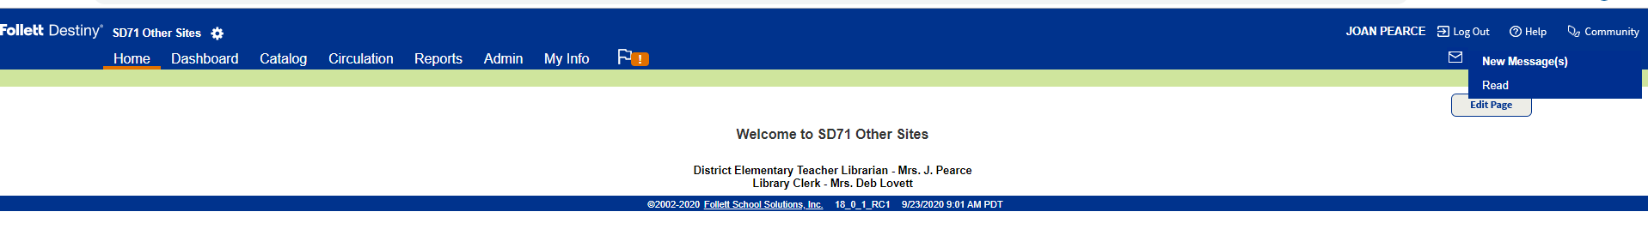
With your login you will not have some of the tabs in the blue navigation bar. You will, however, have Home, Catalog and My Info. It is through the Catalog that you search and book materials from the LRC. The tip sheet has detailed information on this.
SORA Digital Library
This is the district’s collection of ebooks, audiobooks and read-alongs. Your child has access to it by logging in with their login as described above.
Research Databases
This is the district’s online collection of encyclopedias, films etc. Your child has access to it by logging in with their login as described above. Your teacher will have the login information needed if your child access them while at home.
Click here for a tip sheet on the SORA collection as well as the Research Databases.
Teacher Resources
This tab will take you to the home page of learn71 from which all online lesson plans for all subjects are posted. It is a provincial treasure!
SD71 Other Sites News
This is where I will paste information related to all patrons of this site, which incudes Navigate students, teachers and Home Instructors. This tip sheet will be posted there as well.

