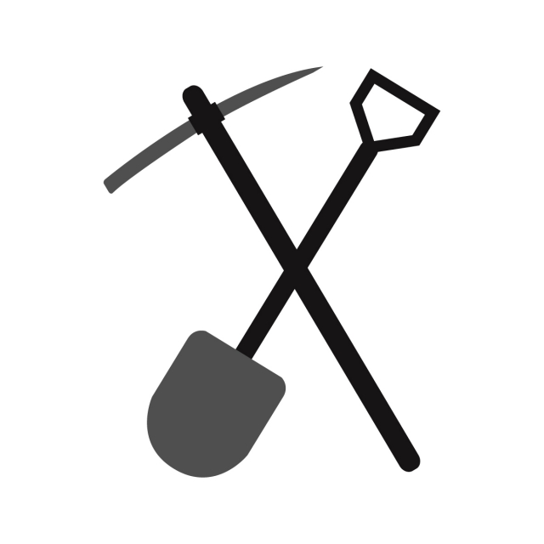

Name: Jack Chow | Visit the following places in order
You are a miner from the Union Coal Mining Company. You’ve left camp to go into Cowboy Town for the day. It’s important that you bring back supplies for your family.  Follow the instructions and visit the four locations listed. | First Station | Blacksmith  You are required to bring your own tools into the mine for work, do you need anything at the Blacksmith?
Second Station | Company Office
Go to the Company office and pick up your money. You are
owed pay for 45 days.
Third Station | General Store
It’s important to take a selection of groceries home with you for your family.
Fourth Station | Saloon
Now it’s your time to relax and
have fun before returning home.

