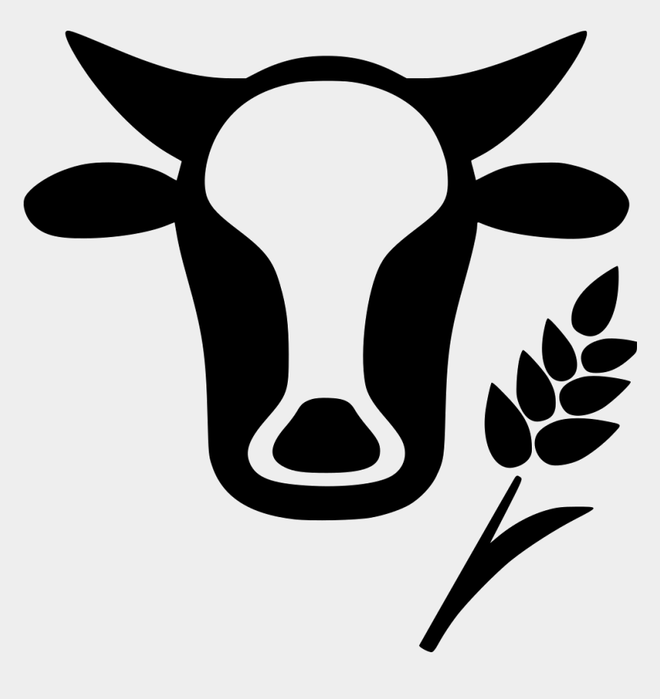

Name: Tom Sutherland | Visit the following places in order
You are a livestock farmer from the growing village of Courtenay. You have a family and are coming into the Cowboy Town to sell your milk and cuts of beef.  Follow the instructions and visit the four locations listed in order and make sure you bring flour home for your family’s backing project. | First Station | General Store  Drop off your milk and beef cuts for sale. Don’t forget to get flour to take home.
Second Station | Saloon
Enjoy some fun entertainment and have a good meal.
Third Station | Company Office
At the Company office you will be required to pay land tax. Hope you didn’t spend all your $ at the Saloon.
Fourth Station | Blacksmith
Some of your equipment is getting old, now is a good time to have it repaired or buy something new.

