Kahoot in TEAMs

How to add Kahoot
- Go to the Top of the TEAM page, click the + , and search for Kahoot
- If you have a Kahoot! Account, log in. Otherwise you can login in using your Office365 credentials.
- Your Kahoots will automatically appear

Live Game
You can run the game while in a TEAMs meeting.
- Click ’play’ on the Kahoot you want to use
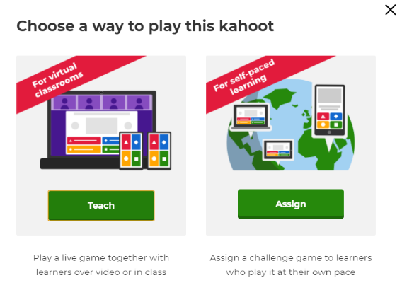
Click ‘TEACH’

- 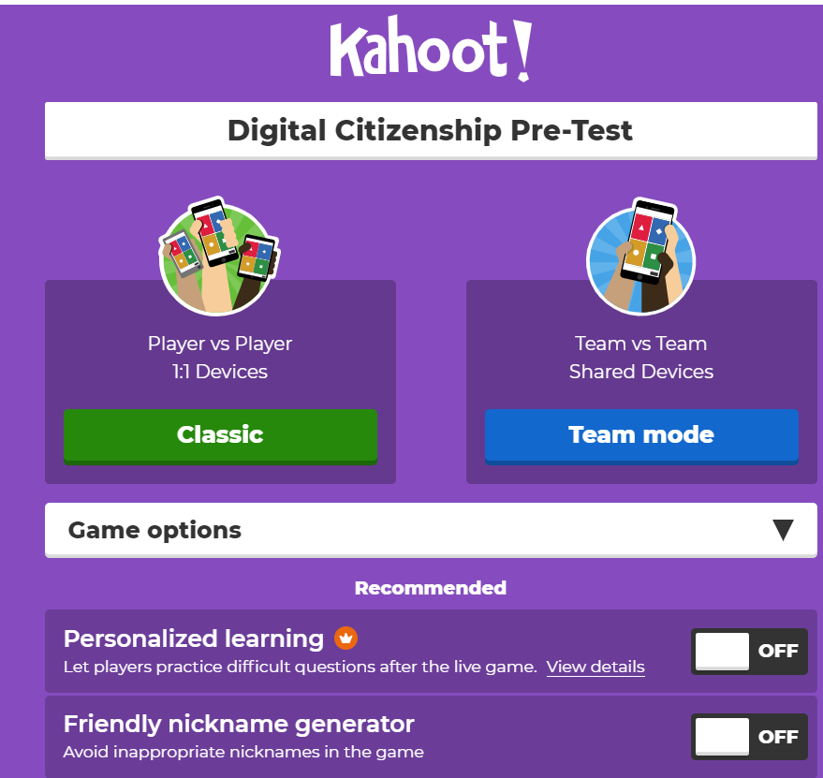 click ‘Team Mode’ (Love the friendly nickname generator or have students log in with real name)
- The usual game code will appear for students to join (you may want to have students have the app downloaded or the website preloaded on computer before starting)
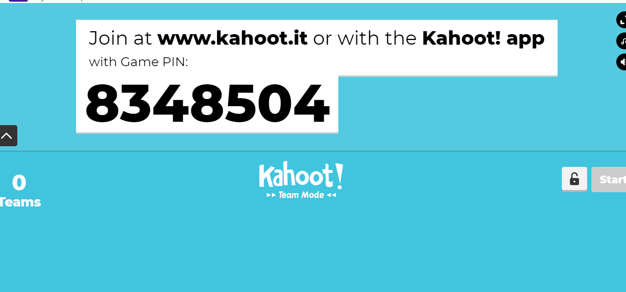

Assign Kahoot as a challenge
- click ‘play’ on the kahoot you want to use

Click Assign

- Choose your options
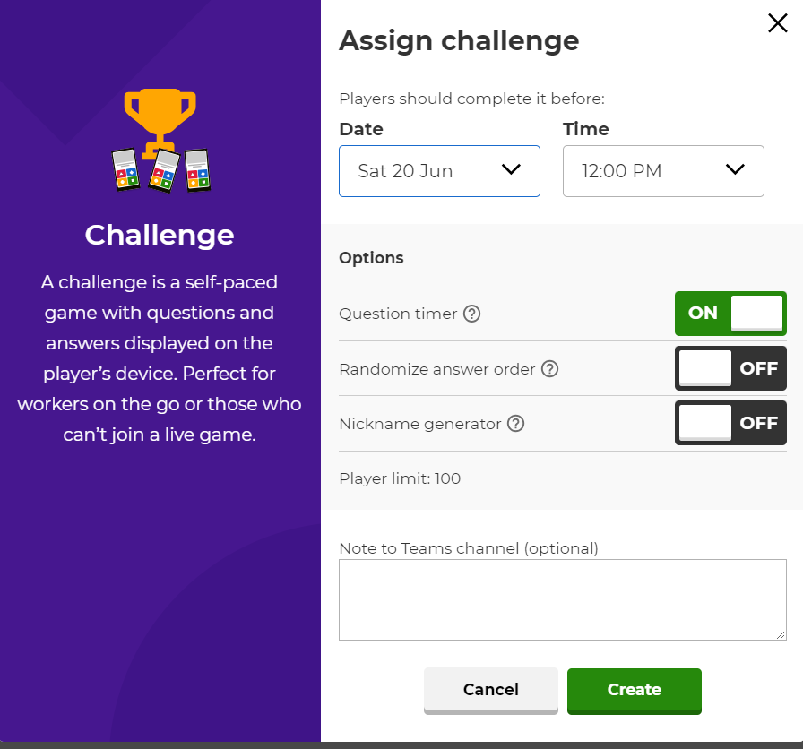
- TEAMs will make a post on the general channel about the game 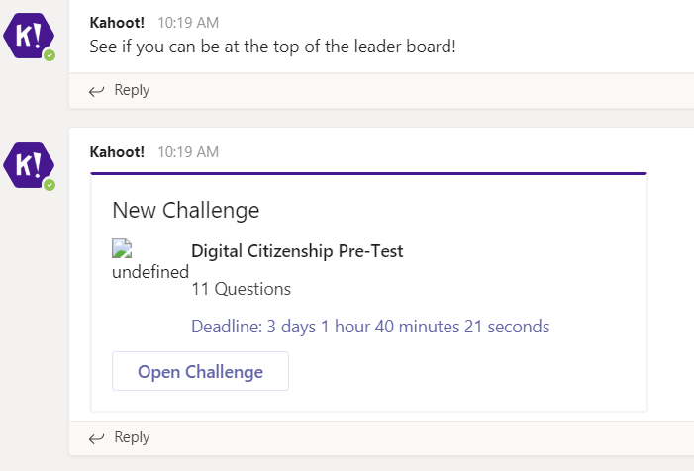
- You can see the leaderboard when the time you set on the challenge is up (a set date? Time? Your choice) – in general tab

