How to Recover Files you Thought You Lost or Open a Previous Version of a File in Office 365
Recycle Bin:
Open OneDrive (Go to the school district website, click on Utility Links, then Office 365, then click on OneDrive).
1. Click on Recycle Bin on the left side
2. Right click on the item that you would like to use
3. Click on Restore
4. You will now find the item back in with all of your good files.
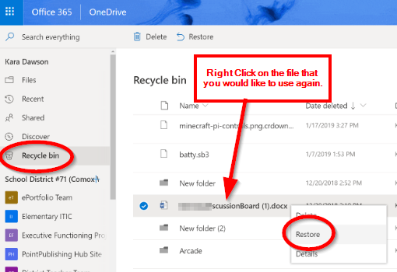
Version History:
Version History is super handy when you have changed something and it auto saved with a mistake that you don't want. You can now go back and find the version of your work before the mistake was saved.
1. Open One Drive (Go to the school district website, click on Utility Links and then Office 365, then click on OneDrive).
2. Locate the file that you would like to reopen a past version of.
3. Right click on the file or click on the three vertical dots that appear after the file name.
4. Click on Version History. You will see all of the times that it has been saved.
6. Click on the three dots again or right click and then click on Open File. This will open a previous version of your work.
