Supporting Basic Math Facts Using Cover-Copy-Compare
This quick, easy, and effective strategy helps improve the memorization of basic arithmetic facts. It can be used for improving addition, subtraction, multiplication, or division facts. For more details feel free to refer to the following link: https://www.interventioncentral.org/academic-interventions/math-facts/how-master-math-facts-cover-copy-compare
STEP ONE: Adult selects up to 10 math facts for child to practice. They write those facts (the number sentence and the answer) as correct models on the left side of a piece of paper. The adult then pre-folds the sheet to cover the facts. You could create your own on a blank piece of paper or use the downloadable worksheet available at the link listed above.
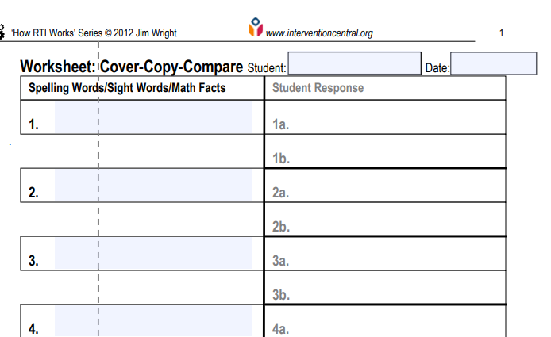
STEP TWO: Initially an adult will need to teach the child the procedures for this strategy. It will not take long before the child will be able to go through the steps independently.
- Ask the child to look at the correctly completed math fact (model) that appears in the left column of the sheet.
- Ask them to fold the left side of the page over at the pre-folded vertical crease to hide the original math fact ('Cover').
- They then copy from memory the math fact and answer, writing it in the first response blank on the right-hand side of the paper (‘Copy’).
- Then they uncover the original correct model and compare it to their response ('Compare'). If the child has written the math fact and answer correctly, they move to the next item on the list and repeat these procedures. If the child has written the math fact incorrectly, they draw a line through the incorrect response, studies the correct model again, covers the model, copies the model again from memory onto the right-hand side of the paper.
- Continue until all math facts on the sheet have been copied and checked against the correct models.

