Get to know your iPad

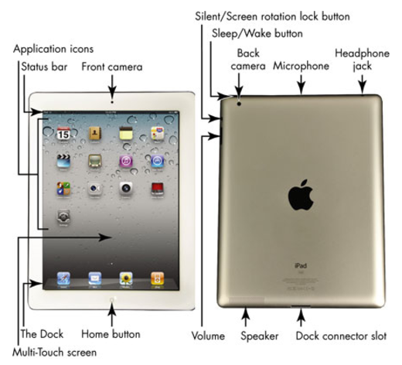

Source: http://www.dummies.com/consumer-electronics/tablets/ipad/apples-ipad-2-what-those-buttons-are-for/

