Lesley University’s Center for Mathematics Achievement in collaboration with the Kentucky Center for Mathematics have put together this resource guide for parents and caregivers to be able to support children’s mathematics learning at home during school closures for the COVID-19 outbreak. All the suggested resources below are free, with the exception of the board games.

This guide is most appropriate for families whose children are in Preschool through Fifth Grade.

Click on the Blue Links to take you to the page.
Important Suggestions 2
Preschool Resources 3
Kindergarten Resources 4
1st Grade Resources 5
2nd Grade Resources 6
3rd Grade Resources 7
4th Grade Resources 8
5th Grade Resources 9
Other Resources 10
Popular Board Games 11
Math Specific Board Games 12
En Español 13

Don’t forget that playing board games at home is a great way to embed problem-solving and math skills. Simply engaging in fun games at home will be plenty for your child(ren)!

We also encourage families to create a daily schedule with your child(ren). Schedules and routines help us stay active and motivated. Consider example schedules, such as this or this.
Scan the QR code with your phone to access this document from another device.

Preschool Resources
Books and Songs
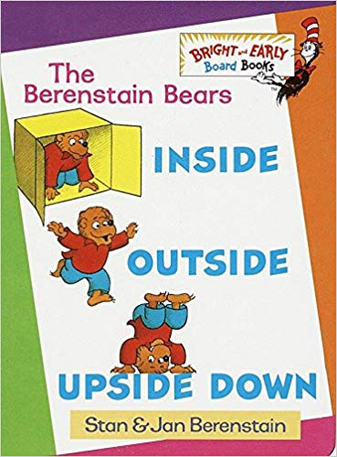

Inside Outside Upside Down - By Stan and Jan Berenstain + Math Guide
Don’t have the book? No worries! View and listen to the book here.
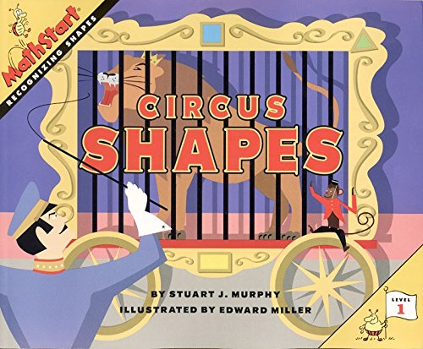

Circus Shapes by Stuart J. Murphy + Math Guide
Don’t have the book? No worries! View and listen to the book here.
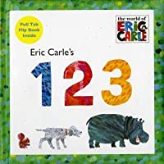

1, 2, 3 by Eric Carle + Math Guide
Don’t have the book? No worries! View and listen to the book here.
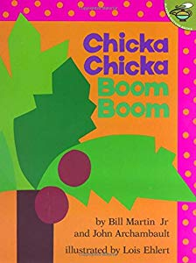

Chicka Chicka Boom Boom by + Math Activity
Don’t have the book? No worries! View and listen to the book here.

Count to 10 and Back: 1 to 10 and 10 to 1 Song
Count to 20: 1 to 20 Song
Count to 100: Counting to 100 Song
Singing About Shapes: Shape Song
More Shapes: Shape Song #2

Online Games
Counting Games - https://www.splashlearn.com/counting-games
Problem Solving - Peg + Cat PBS Games
Matching Numbers - Match Numbers to Pictures
Assorted Games - https://www.education.com/games/preschool/math/

Printable Games
Tic-Tac-Toe (5 to 1) - (Backwards Counting)
While working with the game board and cards, your child will see and practice how the numbers are ordered verbally and visually. You will also practice counting forward and backward out loud. This will help your child reach the goal of reading numerals and counting backward from five to one.

Match (1 to 5) - (Connecting quantity to symbols)
This activity is a great way for kids to learn how to match quantities and numerals one to five.
The Pocket Game - (Counting)
Great game with few materials to play at home to help make sense of numbers.

Kindergarten Resources
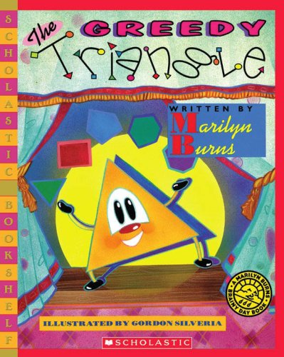
Books and Songs

The Greedy Triangle by Marilyn Burns + Math Guide
Don’t have the book? No worries! View and listen to the book here.

Sing-A-Long: Counting to 100 Song
Adding to 10: My Dog Named Ten Song
Identifying Shapes: 3-D Shapes Song

Online Games
Counting Game - Okta's Rescue - Check out the exploration questions to ask your child!
Adding to 10 - Addition Blocks Game - Click on the blocks that add to the numbered block shown.
Sums to 10 - Ten-Frame Game - Check out the exploration questions to ask your child!
Subtraction Practice - How Many Under the Shell? - Check out the exploration questions!
Matching Shapes, Numbers - Concentration Game - Shapes, Numbers, and More!
Assorted Games - https://www.education.com/games/kindergarten/math/

Printable Games
How Much?- (Numbers 1-5)
You and your child will be matching numerals and quantities in order to make a line. You can print out dot cards or use a standard die to roll a quantity and then cover the numeral on the game board with your marker. The goal is to cover three numerals in a row with your counters.

How Much?- (Numbers 1-10)
You and your child will be matching numerals and quantities in order to make a line. You can print out dot cards or use a standard die to roll a quantity and then cover the numeral on the game board with your marker. The goal is to cover three numerals in a row on the board with your counters.

Road Trip - (Numbers 1-10)
You and your child can have a lot of fun practicing reading and identifying numerals 1-10. There is no limit on the number of players. You will select a game card, finding the correct vehicle on the game board and then read/identify the numerals located in that column as quickly as possible.

Tic-Tac-Toe (10 to 1) (Backwards Counting)
This activity brings the fun of Tic-Tac-Toe to the skill of counting back from ten. You will use the Tic-Tac-Toe Board labeled one to nine and number cards to try to make a line of the three numerals in the proper order. You will take turns picking cards, counting backwards, and placing game markers on your boards. The winner is the first to cover three in a line.

1st Grade Resources
Books and Songs
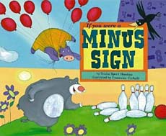
If You Were a Minus Sign by Tricia Shaskin - Ask your child to write subtraction equations and their related addition number sentences.

Hundreds, Tens, Ones: Place Value Song
Counting by 5: Skip Counting by 5 Song
Reading a Clock: Telling Time to the Nearest Half-Hour Song
Identifying Shapes: 3-D Shapes Song

Online Games
Comparing Quantities - How Many?
Addition Practice - Alien Addition - Change the range of numbers so it meets your child’s needs!
Subtraction Practice - Minus Mission - Change the range of numbers so it meets your child’s needs!
Build Shapes - Pattern Blocks - Ask your child to make a picture and count the total number of each shape they used or how the shapes are similar or different.
Coins - Learning Coins - Sort coins, then make $1 using coins, and use addition skills.
Assorted Games - https://www.education.com/games/first-grade/math/

Printable Games
How Many? - (Problem-Solving)
This activity is a great way to help your child develop different ways to solve problems that involve adding and subtracting! It is a fun way to explore and build strategies for solving problems dealing with adding and subtracting.

Teacher's Mistake - (No Materials Needed)
This activity is great for quick math practice with sequencing number from thirty to one hundred. You can do this anywhere because there are no materials needed! You say a set of numbers in sequence in the range of thirty to one hundred and leave one number out. Your child has to guess what number you missed. Then your child can have a turn being the teacher and see if you can figure out what number they left out. This is a great opportunity to fit some fun math practice in anytime.

Go Fish - (Numbers 1-10)
This game is not only fun, but also a great way to help kids learn different ways to make the number ten! This game is played like traditional Go Fish, except that a “match” is two cards that can be added together to make ten.

Bingo Addition - (Numbers 2-12)
Bingo is a game that everyone can enjoy! This version, however, is a fun way to help kids learn simple addition using the numbers 1-6. Having lots of practice adding these numbers together in different combinations is a great way for kids to begin “internalizing” these facts.

2nd Grade Resources
Books and Songs
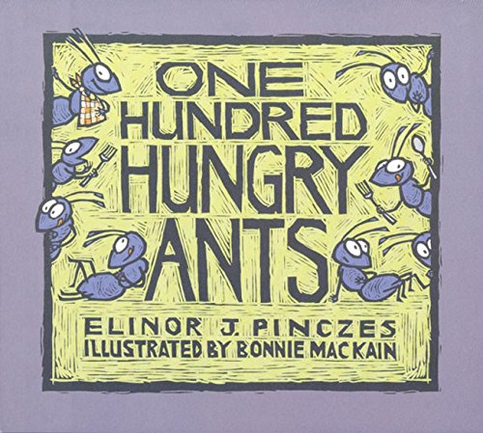
One Hundred Hungry Ants by Elinor J. Pinczes - Practice skip counting by 10s, 20s, 50s, and 100s with your child. Ask your child to draw pictures of the rows of ants. Ask them to notice what changes each time.

Practice Counting by 20s: Skip Counting by 20s Song
Practicing Counting: Skip Counting by 100 Song
Reading Time on a Clock: Telling Time to Nearest 5 Minutes Song

Online Games
Arrays & Repeated Addition - Matching Pictures and Equations/Expressions
Place Value - Place Value Basketball
Assorted Games - https://www.education.com/games/second-grade/math/
Addition Practice - Kakooma

Printable Games
Pyramid (Make 20) - (Double-Ten Frames)
Values are represented in many different ways. Your child can practice combining values to make twenty in this fun game based on the card game pyramid. They will be combining values to form twenty from the pyramid in order to discover the mystery card.

Salute! - (Fluency Practice)
This fun activity is made for groups of three. You will be using mental math strategies to find sums and differences while playing the part of sergeant and soldiers.

School Day - (Addition & Subtraction Within 100; use of coins)
A classic board game is transformed into an engaging math story about your child’s school day using the concept of tracking money transactions. She or he will be practicing adding and subtracting one and two digit numbers while working their way around a game board, collecting rewards for positive school deeds or paying in the opposite situation. This is a great game to play with your child and an opportunity to model good mathematical practices, and promote important life skills.

Acing Math - (Multiple Operations)
60 Math Games using only a deck of cards!

Pepperoni Pizza - (Repeated Addition)
This game builds children’s ability to add repeatedly, which will lead to their ability to multiply in Grade 3. Encourage children to write repeated addition sentences.

How Close to 25? - (Addition and Subtraction)
Page 4 are the directions and page 5 is the game board. Use coins if counters aren’t available.

3rd Grade Resources
Books and Songs
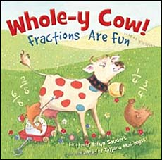

Whole-y Cow: Fractions Are Fun! by Taryn Souder - Review fractions with your child by reading about them! Can your child name all the fractions in the story?

Multiples of 5: Skip Count by 5 and Multiply
Multiples of 6: Skip Count by 6 and Multiply
Multiples of 7: Skip Count by 7 and Multiply
Multiples of 8: Skip Count by 8 and Multiply
Fractions: Fractions on a Number Line

Online Games
Addition Game - Deep Sea Duel - available in English & Spanish
Multiplication Practice - Equal Groups - Multiplication Mine
Multiplying by Breaking Apart - Bunny Times - Area Models
Strategy Game with Factors and Products (Multiplication) - Product Game
Fractions on Number Lines - Fraction Game
Addition or Multiplication Practice - Kakooma

Printable Games
Composite Cookie Company - (Building Multiplicative Thinking)
You are working for the Composite Cookie Company and the orders are coming in! It is fun for kids to pretend to work for a cookie company and also practice their multiplication mental math skills. Your child will pick a task card where they will be directed to either make equal groups of cookies or share cookies into equal groups and see if there are any leftovers. This activity is a fun way to spend time with an important child in your life while helping them explore and build strategies for solving real world problems using multiplication and division. Now it’s time to get to work!

Making Rectangles - (Area & Multiplication)
This activity asks your child to connect the dots with horizontal and vertical lines to find the number of squares that will fit in given rectangle. Once they make lines to create the blocks they can count the total number of blocks they have created. The number of rows of blocks and the number of blocks in each row can be multiplied together to give the total number of blocks in the rectangle. They will then write the multiplication sentence to match the rectangle model giving them the area of the rectangle.

Pop Drop Move It - (Multiples of 3)
This game is poppin’ with fun and action! Hard to believe for a math game? Well, math is fun! You and your child will use popsicle sticks and markers to toss and solve multiplication problems. You will also have each other’s markers “move-it” off the game board as you try to get rid of your own markers. The first person to use all their markers wins. This game will keep you moving and multiplying until those three facts “pop” right into your child’s head.

4th Grade Resources
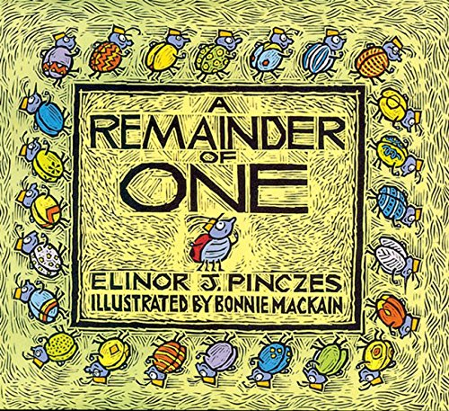
Books and Songs

A Remainder of One by Elinor J. Pinczes [Book]
Ask your child to write several division equations that have a remainder of 1.

Prime & Composite Numbers: Prime, Square, Composite Song
Understanding Same Value: Equivalent Fractions Song
Angle Measures: Right, Acute, Obtuse Angles Song
Types of Lines: Perpendicular, Parallel, Intersecting Lines Song
Skip Counting by 12 (Multiplication): Multiples of 12 Song

Online Games
Addition Game - Deep Sea Duel - available in English & Spanish
Make 24 Game - 4Nums Game or Make 24
Multiplying by Breaking Apart - Bunny Times - Area Models
Strategy Game with Factors and Products (Multiplication) - Product Game
Fractions on Number Lines - Fraction Game
Addition or Multiplication Practice - Kakooma

Printable Games
School Day - (Addition/Subtraction Within 1000)
A classic board game is transformed into an engaging math story about your child’s school day using the concept of tracking money transactions. She or he will be practicing add and subtracting two and three digit numbers while working their way around a game board, collecting rewards for positive school deeds or paying in the opposite situation. This is a great game to play with your child and model good mathematical practices and also promote important life skills.

24 Game - (Multiple Operations)
The object of the game is to make 24. You can add, subtract, multiply & divide. Use all four numbers given on a card, but use each number only once. Kids can then make their own cards to challenge others.

Acing Math - (Multiple Operations)
60 Math Games using only a deck of cards!

Worldwide Delivery Service - (Place Value; Multi-digit Numbers to 1,000,000)
This activity challenges students to identify numerals within a given range of numbers and compare and order them from lowest to highest. *Need to print materials for this activity.

Fraction Talks - (Fractions)
Download the PDF. Ask your child to determine what fraction of the whole shape each color represents.

5th Grade Resources
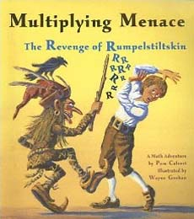
Books and Songs

Multiplying Menace: The Revenge of Rumpelstiltskin by Pam Calvert
Ask your child about multiplying fractions less than 1. What happens? Why?

Order of Operations: Writing and Interpreting Numerical Expressions Song
Understanding Decimals: Ordering Decimals Song
Measurement: Volume of Cubes Song

Online Games
Balanced Hangers, Who am I?, Mystery Grid - Solve Me Puzzles
Matching Game - Concentration Game - Fractions, Decimals, Multiplication Facts
Addition Game - Deep Sea Duel - English & Spanish - turn on the decimal feature!
Make 24 Game - 4Nums Game or Make 24
Multiples (Multiplication) - Number Ninja
Exploring Shapes: Interactive Quadrilaterals - Ask your child to explore quadrilaterals!
Addition or Multiplication Practice - Kakooma

Printable Games
School Day - (Addition/Subtraction Within 1000)
A classic board game is transformed into an engaging math story about your child’s school day using the concept of tracking money transactions. She or he will be practicing add and subtracting two and three digit numbers while working their way around a game board, collecting rewards for positive school deeds or paying in the opposite situation. This is a great game to play with your child and model good mathematical practices and also promote important life skills.

24 Game - (Multiple operations)
The object of the game is to make 24. You can add, subtract, multiply & divide. Use all four numbers given on a card, but use each number only once. Kids can then make their own cards to challenge others.

Acing Math - (Multiple Operations)
60 Math Games using only a deck of cards!

Fraction Talks - (Fractions)
Download the PDF. Ask your child to determine what fraction of the whole shape each color represents.

Four 4s - (Multiple Operations)
Using only the number 4, four times, can your child find every number between 1 and 20 using only four 4s and any operation? For added challenge, go beyond 20.

Other Resources
Children’s FREE Ebooks and Audibles:
- https://mimshousebooks.com/collections/ebooks
- https://www.funbrain.com/books
- https://www.nypl.org/books-music-movies/ebookcentral/simplye
- https://stories.audible.com/discovery

Cross Curricular Projects:
- 12 Museums From Around the World That You Can Visit Virtually
- Scholastic Learn at Home - preschool - middle school activities
- https://www.youtube.com/studiojjk - Illustration Art Daily Lessons LIVE at 2 PM ET
Printable Books for Coloring and Reading:
- http://youngmathematicians.edc.org/math-books/mini-books/ - available in English and Spanish, each book is 8 pages long, preschool - Grade 1

K-5 Estimation Resources
- Esti-Mysteries - Download the PowerPoints and put them in “present mode.” Have your child guess how many objects there are. Using the clues, narrow down the guesses!
- Estimation 180 - Pick a picture and estimate! Have your child type their responses in the boxes if they want or just talk with you. If you click Estimates, you will see kids’ work from all over the nation!
- Loop-De-Loops - Predict where your spiral will go! Did you estimate correctly?

K-5 Number Sense Resources
- Splat! - Download the PowerPoints and put them in “present mode.” Have your child guess how many shapes there are under the Splat.
- Solve Me Puzzles - Three different types of puzzles that will challenge your child to make sense of numbers. Most of these puzzles are appropriate for Grade 2 +.
- Four 4s Problem - This classic game asks students to use multiple operations and their strategic problem-solving skills to turn Four 4s into many different numbers. Appropriate for Grades 3 +.
- How Many Rows? - Try to get the most number of squares by making rectangles. Appropriate for Grades 3 +.
- Tic-Tac-Toe Sums - A twist on the classic tic-tac-toe game, this time trying to use strategy to find the total of two numbers
- Which One Doesn't Belong? - Pick a picture and find a reason why each part doesn’t belong. Which one is not like the others? Perfect to print out or show on your device while breaking bread.
- Greg Tang's Math Resources - Sign up for email list and hundreds of printable games become available for you that are free and high-quality!
- Yohaku Puzzles - Fun math puzzles for Kindergarten +.
- Ken Ken Puzzles - Fun math puzzles for Kindergarten +.
- Talking Math at Home - Slidedeck of pictures with math questions for Kindergarten +.

Popular Board Games
Below we’ve listed popular board games you may already have at home or might want to purchase. For ease, we’ve provided links to purchase. Games are a great way to engage in math skills!

Chutes and Ladders
Preschool - Grade 1
Math involved: counting, number recognition, number identification
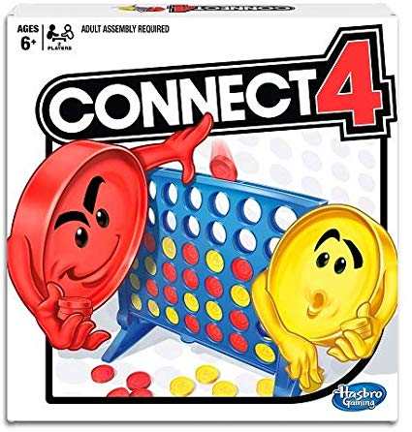

Connect 4
Grade 1+
Math involved: counting, problem-solving, strategy

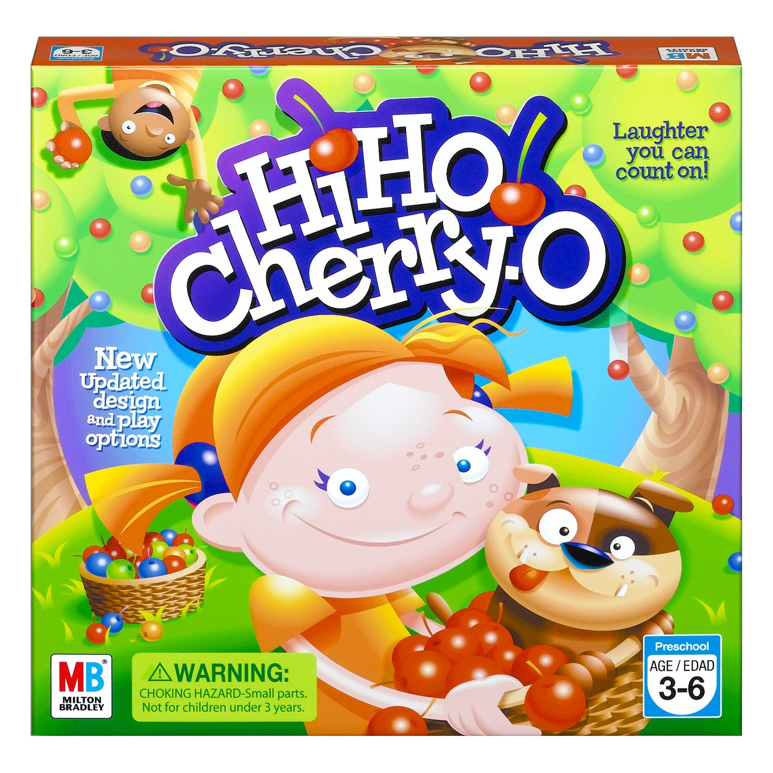

Hi Ho! Cherry-O
Preschool - Grade 1
Math involved: counting, addition, and subtraction
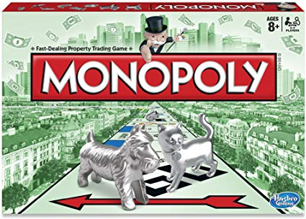

Monopoly Jr. or Monopoly
Monopoly Jr.: Kindergarten +, Monopoly: Grade 2+
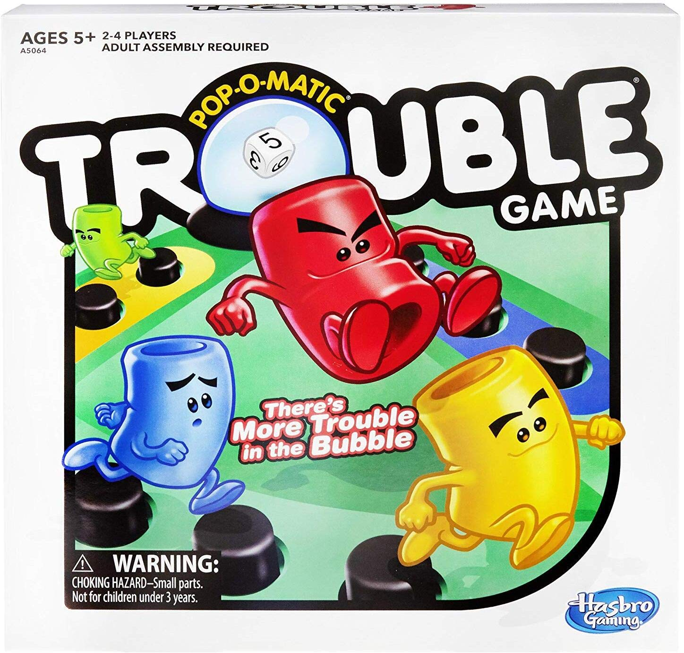
Math involved: addition, subtraction, skip counting, strategy, problem-solving, estimation

Trouble or Trouble Jr,
Kindergarten +
Math involved: counting, addition, subtraction, problem-solving, strategy
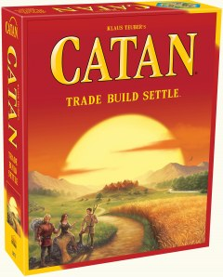
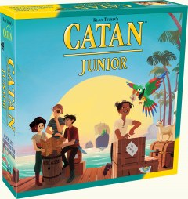

Catan or Catan Jr,
Catan: Grade 5 +; Catan Jr.: Kindergarten +
Math involved: problem-solving, strategic analysis, probability, economics
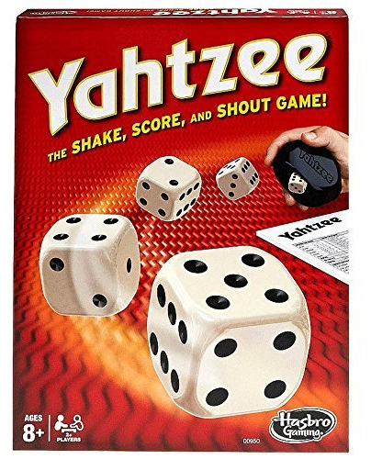

Yahtzee
Grade 1 +
Math involved: addition, strategy, estimation

Math Specific Board Games
Below we’ve listed popular math specific board games you may already have at home or might want to purchase. For ease, we’ve provided links to purchase.
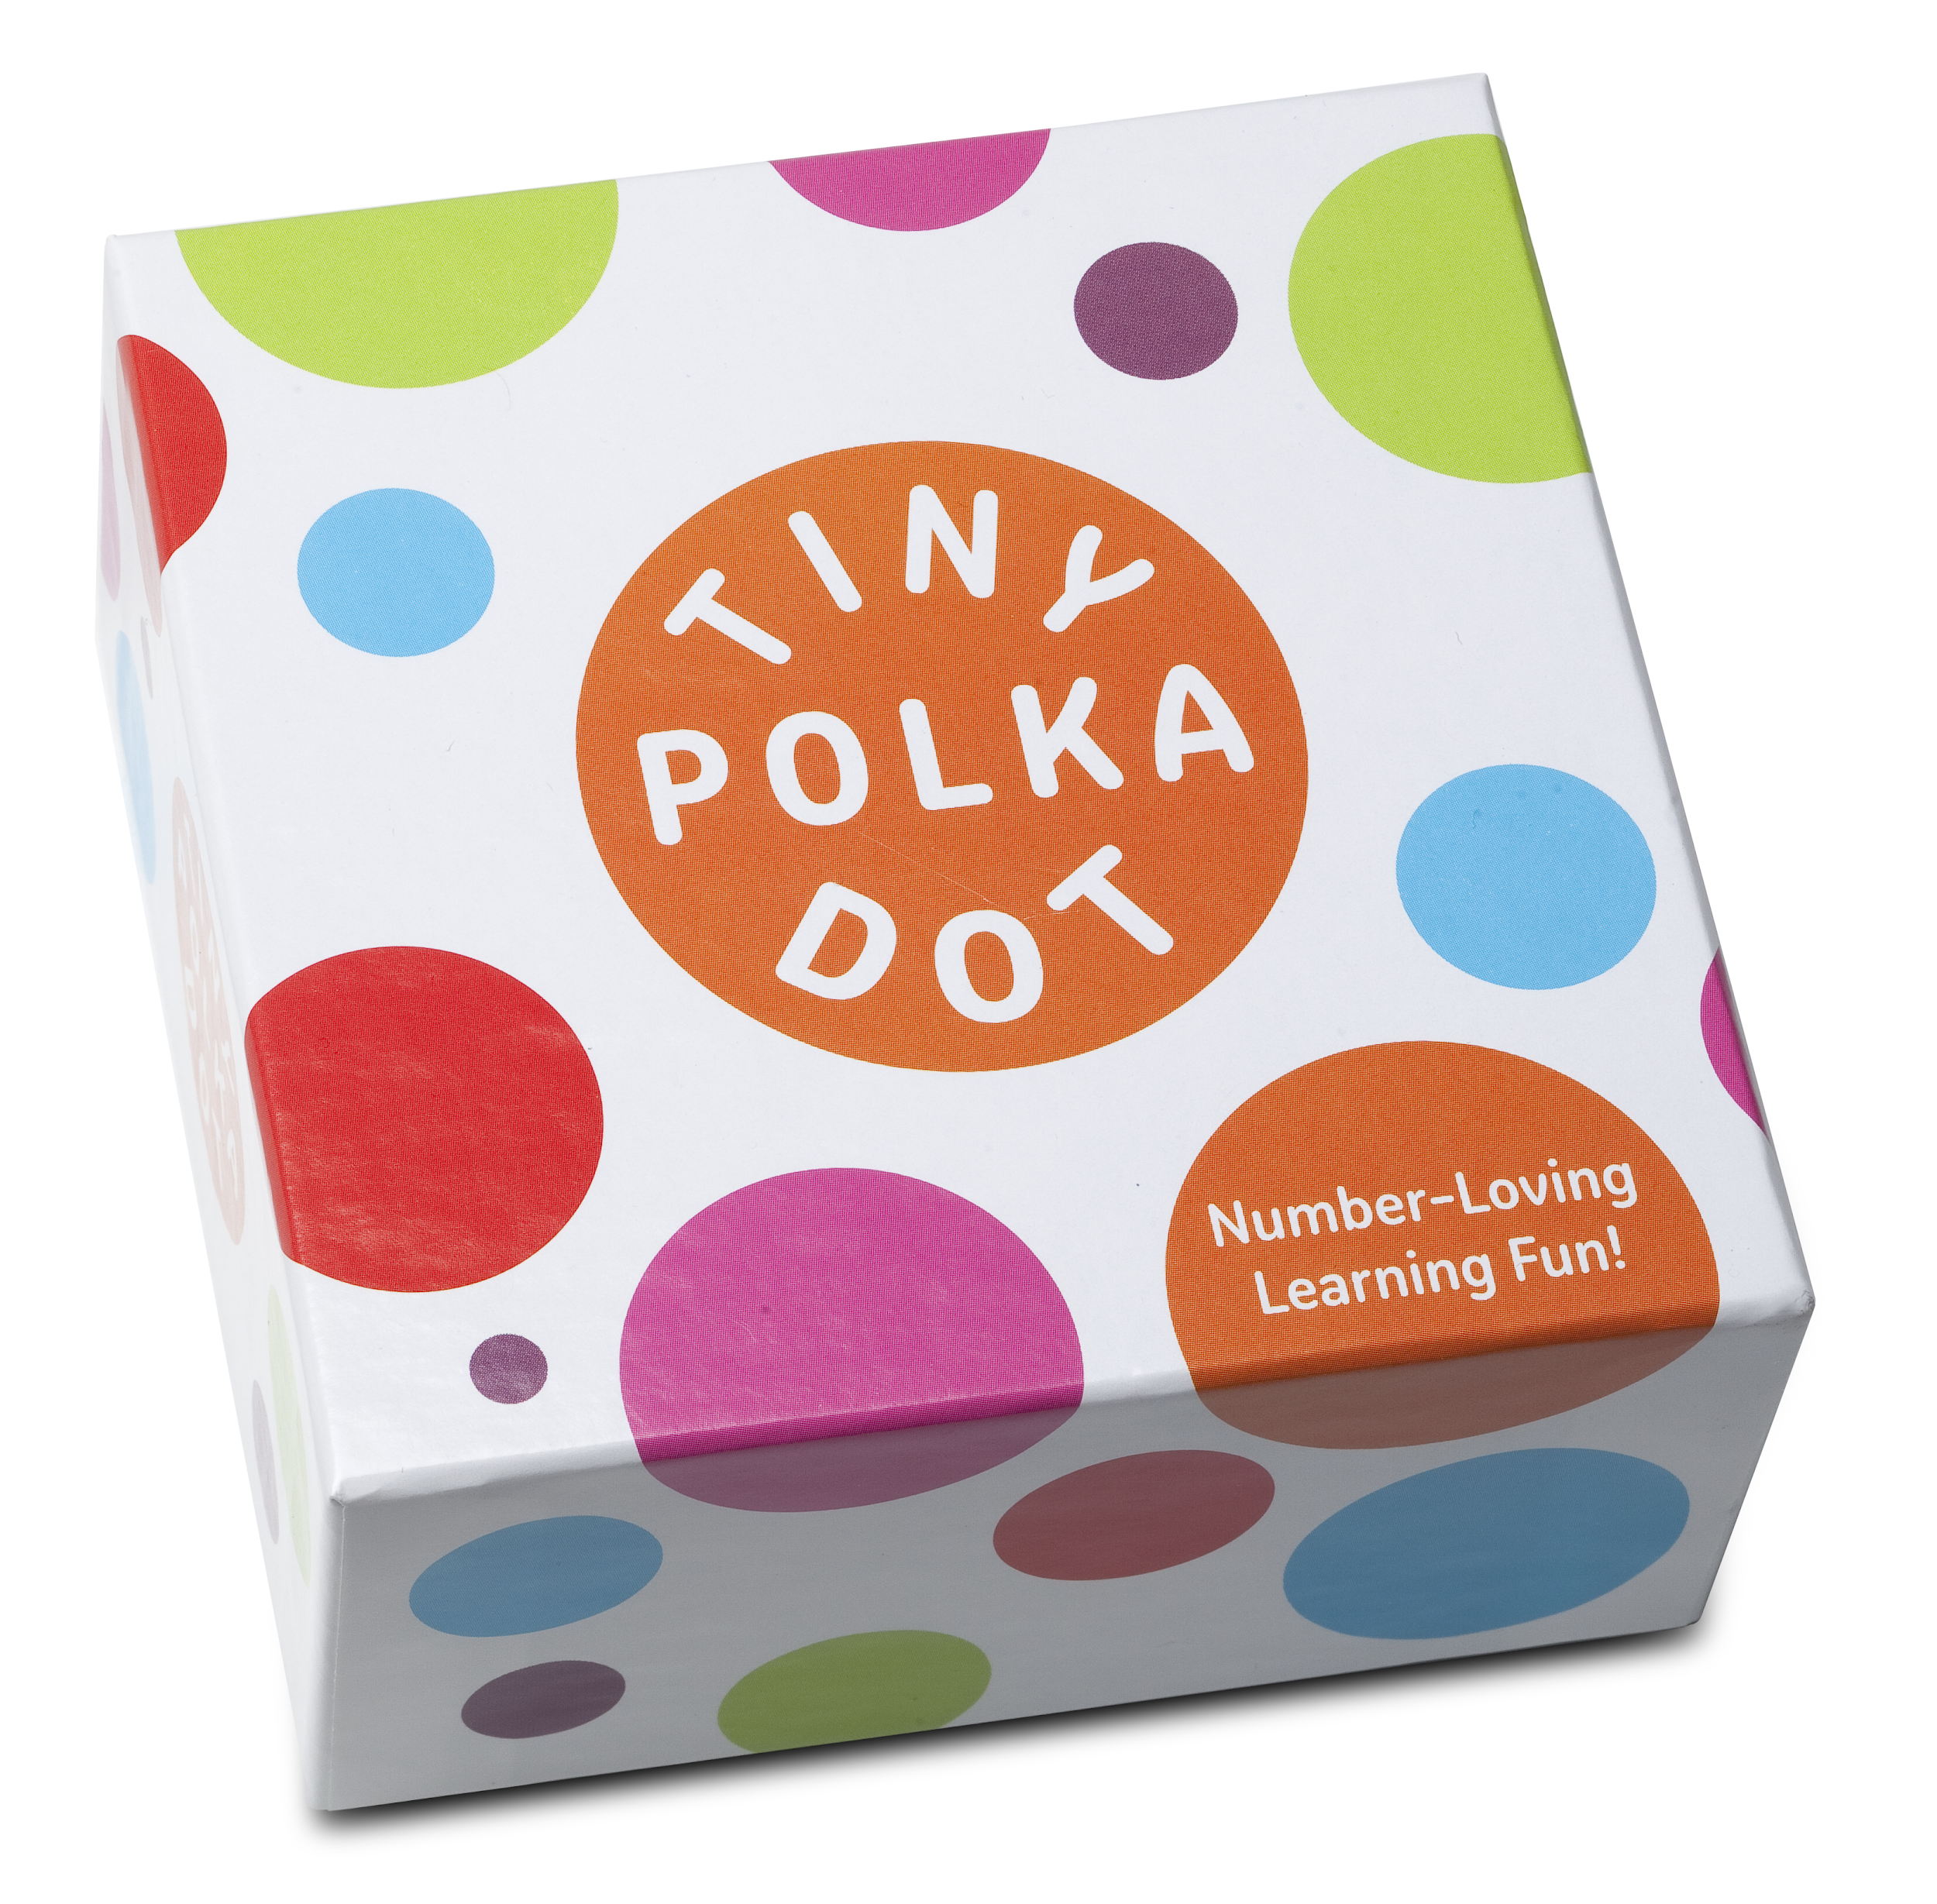

Tiny Polka Dot
Preschool - Grade 1
Math involved: counting, numeral identification, identifying quantities, match numbers and corresponding quantities

Albert’s Insomnia
Grade 3 +
Math involved: addition, subtraction, multiplication, division, strategy
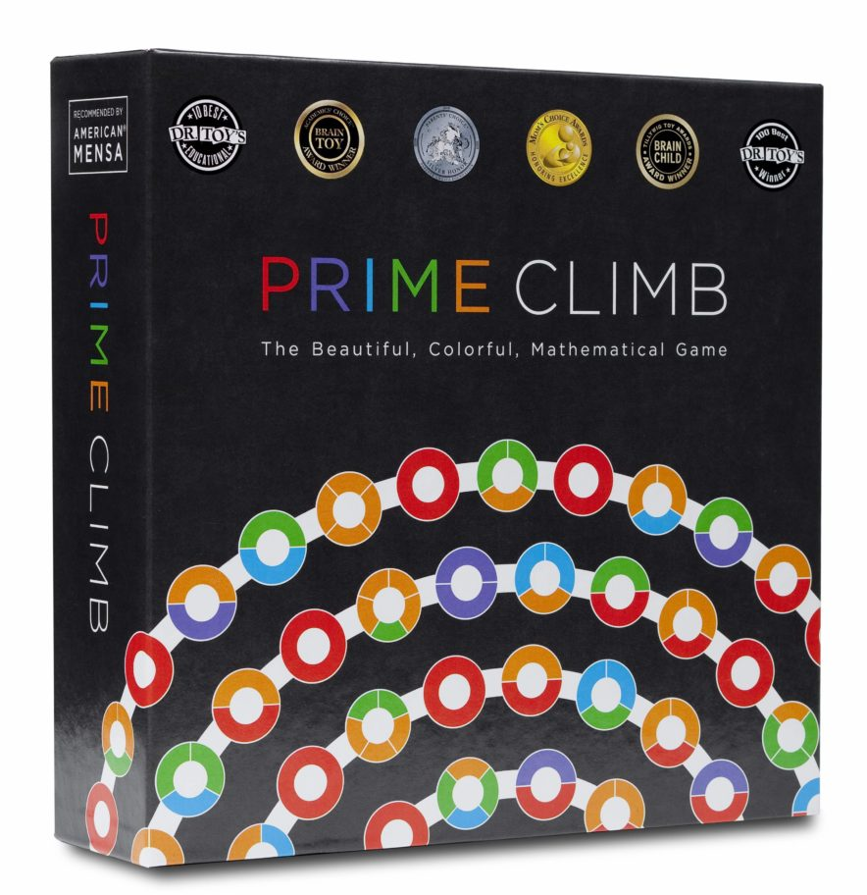

Prime Climb
Grade 4 +
Math involved: prime and composite numbers, multiplication, division, patterning
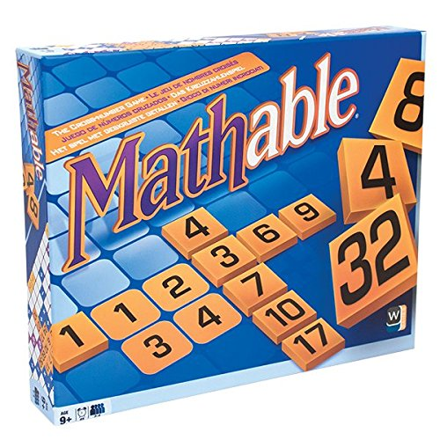
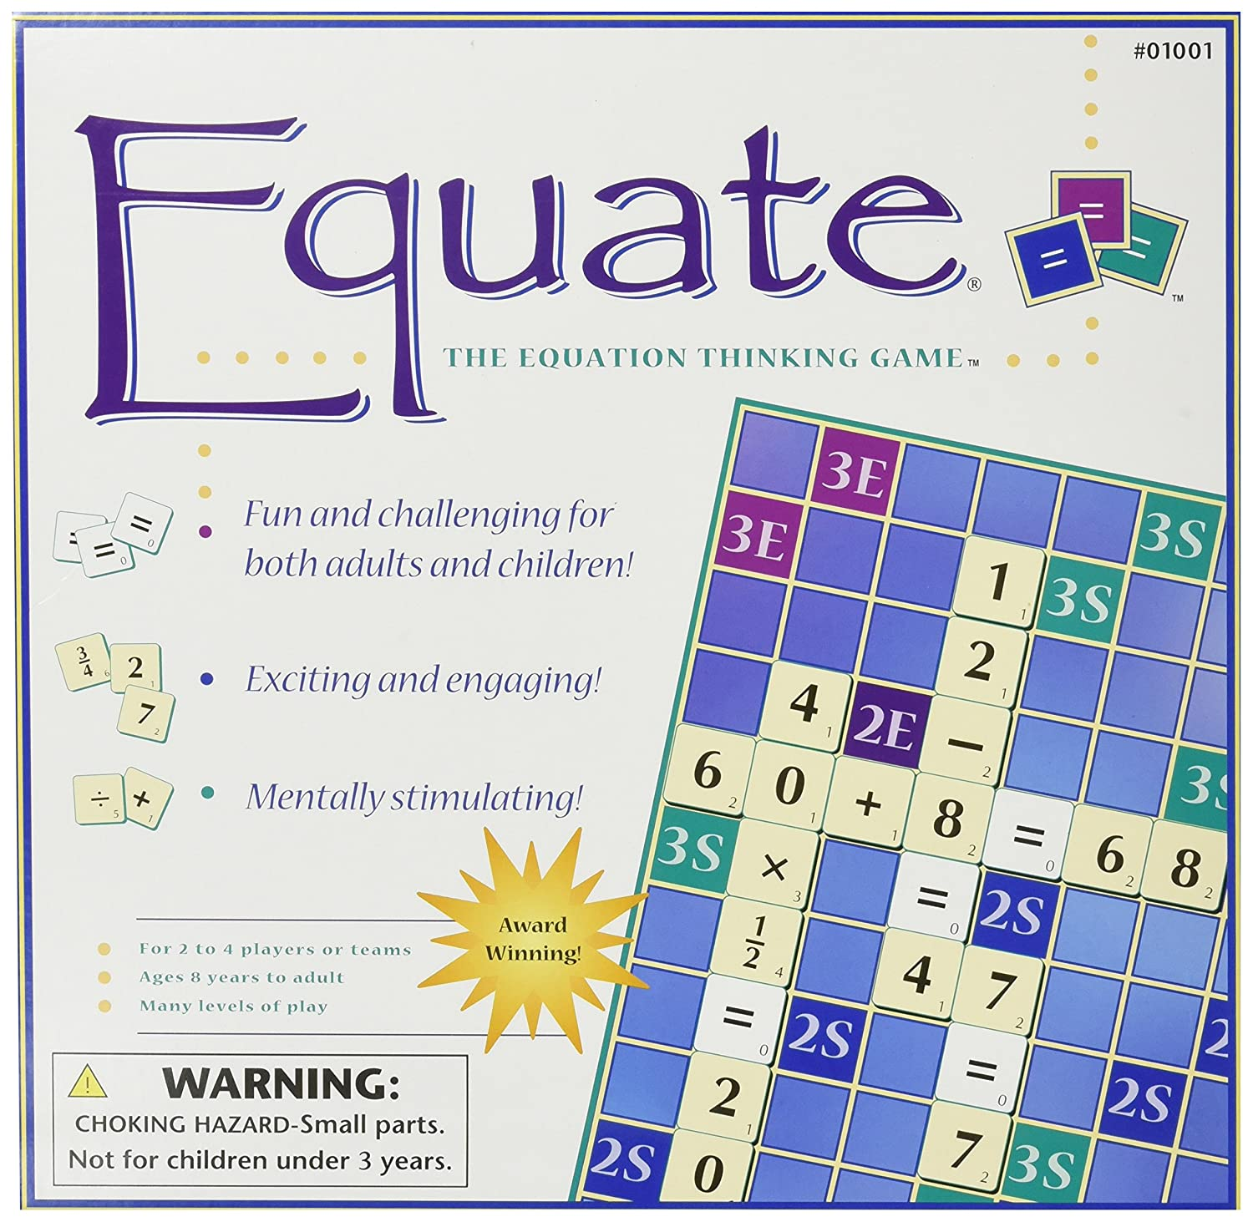

Equate or Mathable
Grade 3 +
Math involved: addition, subtraction, multiplication, division

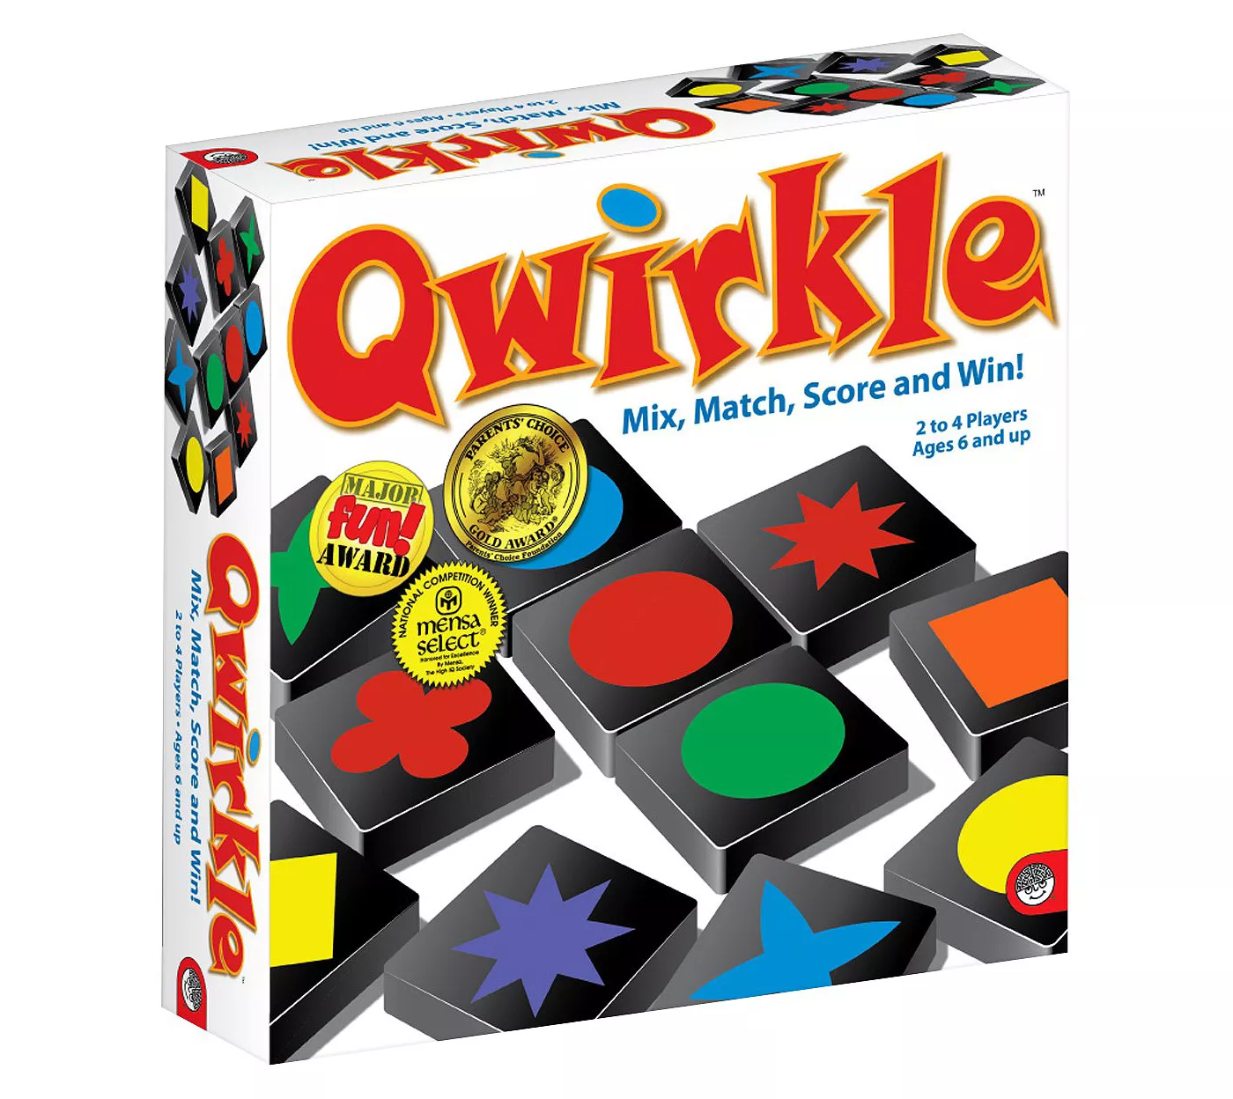

Qwirkle
Kindergarten +
Math involved: shape recognition, identifying attributes, spatial recognition, patterning
Requires no reading
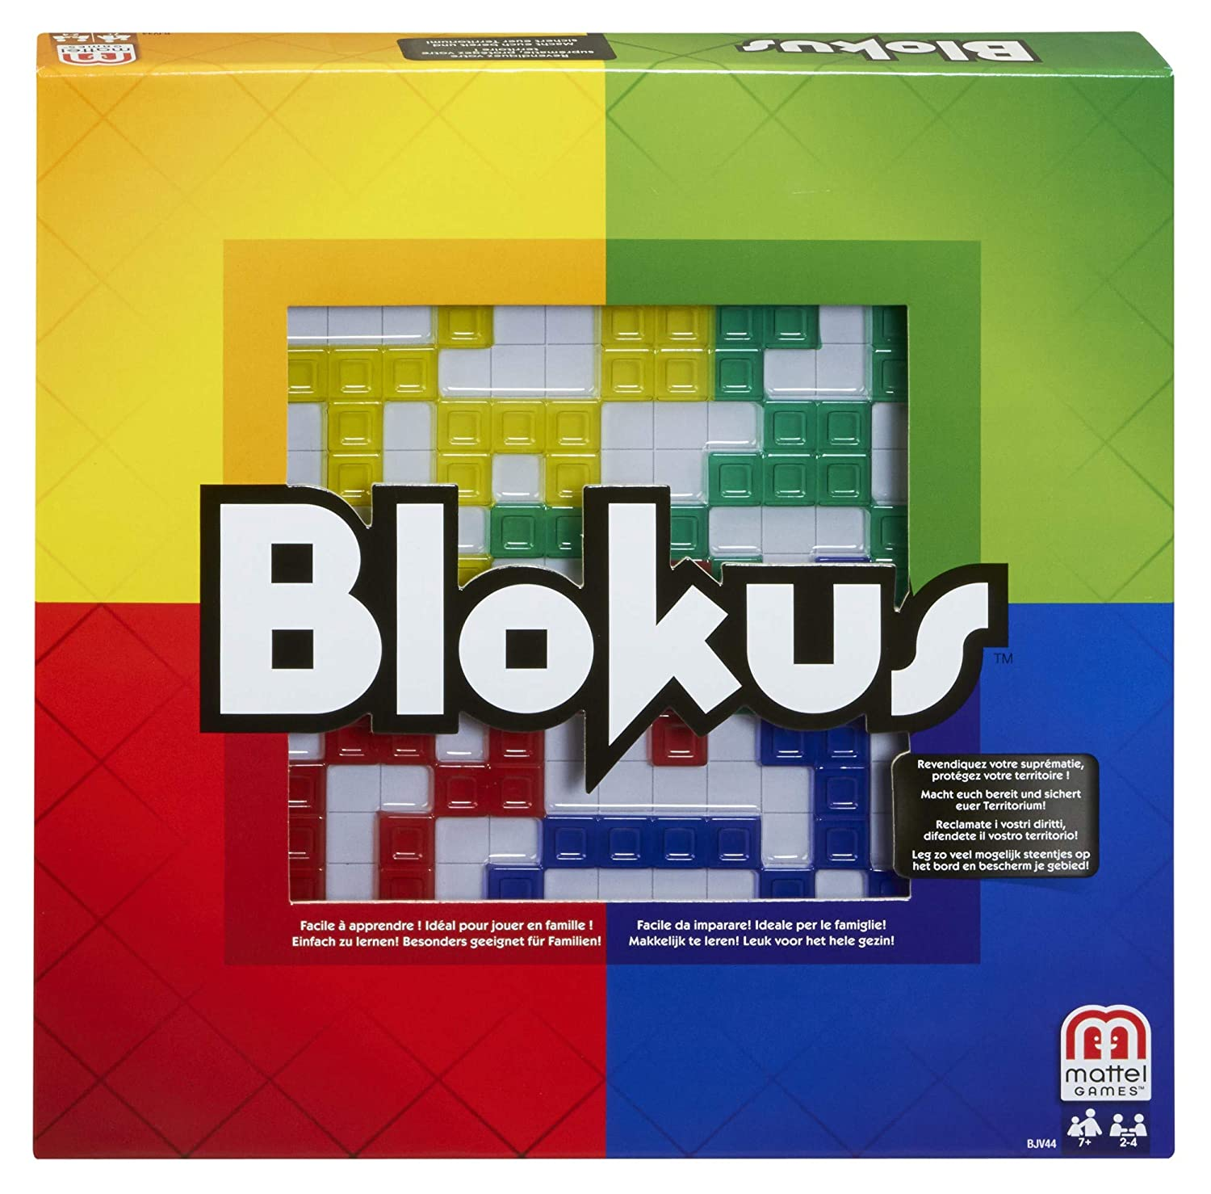

Blokus
Kindergarten +
Math involved: strategy, problem-solving, shape recognition, area, counting
Able to be played independently; requires no reading

