**Voice Dream Reader App**  iOS and Android

*Helps people read and interact with text = words

(Novels, Books, Textbooks, Websites, Articles)

*Tap in middle of iPad to bring tools back

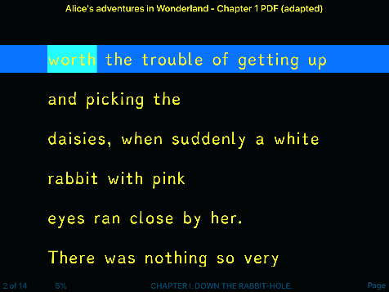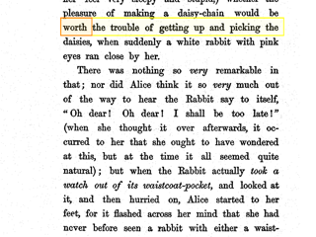**1. Customize Text**

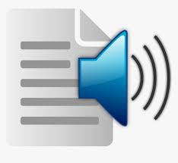 **2. Text to Speech (double tap on a word to have it read out loud)**

**Customize Audio**

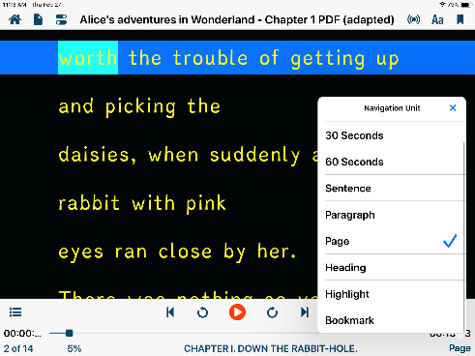

**3. Navigate = (move through) Text**



 **4. Interact or Annotate Text (select text by taping and holding on a word) up)**

**Tap to move to bookmark, highlight or note**

**Swipe left to delete bookmark, highlight or note**