Troubleshooting for the Ozobots:
If the Ozobots are acting weird or won’t turn on, try plugging them back in for a while. If that doesn’t solve the problem, you may need to update it in the app. Robots have software inside of them called Firmware and it often needs to be updated:
- Open the Ozobot App on an ipad or tablet
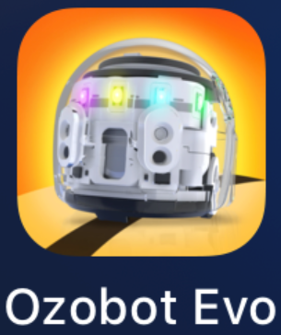
- Feel free to create an account but you don’t need to for this. Press on “Play without signing in”.
- You may be prompted to press Connect right away, please press it. If you are not prompted, follow the instructions that it gives you to connect to an Ozobot.
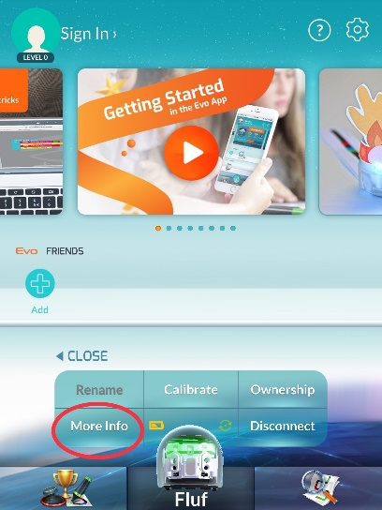
I recommend moving other Ozobots away from the area where you are working and making sure that all the others are turned off. You are able to connect to a whole bunch of them at once but it is often difficult to tell which bot you are working on.
- If you see Settings press it or
- press More Info.

- Press Run Evo checkup
- If it asks you to update, press Update Firmware. This will take a few minutes.
- If the box beside Classroom Mode is not ticked off, put a checkmark there to turn it on. Classroom Mode should eliminate extra beeps and fidgeting behavior.
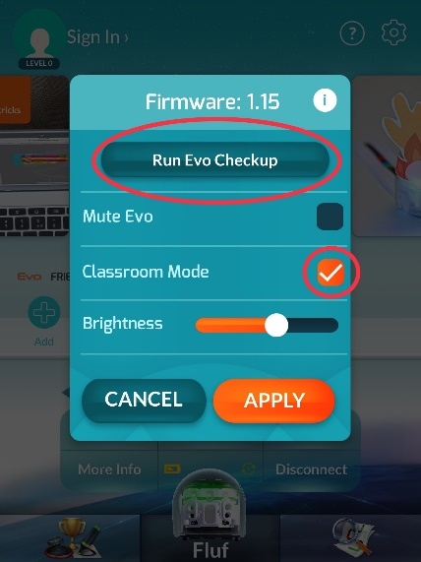

- When you are finished, press Disconnect

