This is what I’m using at the moment; it may change later on but I like the simplicity of it right now and using the table makes it look simple for parents and is easier to read.

Evidence of Learning:  (insert a picture, video, audio file) | Description of Learning Activity:  (what is the student learning, connected to core learning area or competency)
Feedback:
(one specific note, plus a comment on next steps)

Next Steps –
Comparison to Grade Level Expectations (for this concept at this time):
Exceeding / Meeting / Not Yet Meeting

Parents, we welcome your comments, please add your thoughts below.

Things to note when copying and pasting into the post in the portfolio:
- The formatting needs to be changed in Scholantis as it doesn’t transfer. Look for the icon at the bottom right and select the far left choice.
- To make the table fit the screen when viewing go to table layout, width & height, enter 95% into the table width.

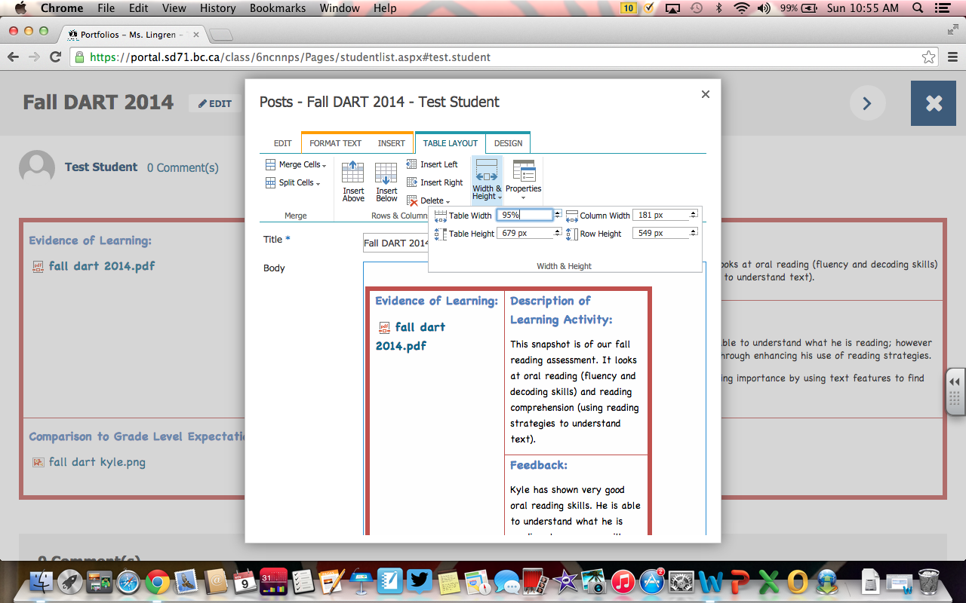

- This is what I’m using for my DART, Writing and DMA assessments. I took out the exceeding, meeting and not yet meeting and inserted (in Scholantis) a rubric that showed where they were at for everything.
- In the evidence of learning I inserted (in Scholantis) a pdf copy of their DART and hope to eventually include their oral reading recoding.

Evidence of Learning: | Description of Learning Activity:  This snapshot is of our fall reading assessment. It looks at oral reading (fluency and decoding skills) and reading comprehension (using reading strategies to understand text).
Feedback:
Kyle has shown very good oral reading skills. He is able to understand what he is reading; however we will work on developing greater comprehension through enhancing his use of reading strategies.

Next Steps – develop his understanding of determining importance by using text features to find main ideas and details.
Comparison to Grade Level Expectations (for this concept at this time):

Parents, we welcome your comments, please add your thoughts below.

- This is what I will use for snapshots of their progress. Again any photos, documents and audio needs to be inserted in Scholantis.

Evidence of Learning:  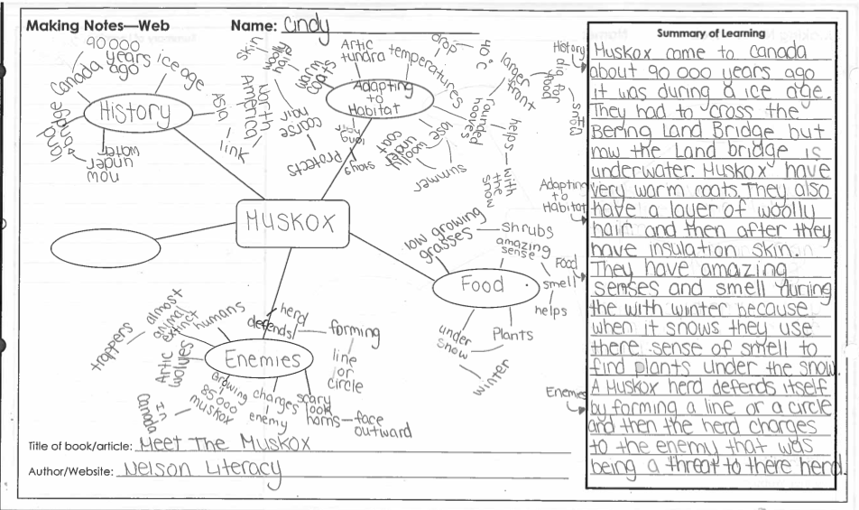 | Description of Learning Activity:  This snapshot shows Cindy’s understanding of the reading strategy of determining importance from non-fiction text.
Feedback:
Cindy has shown that she is able to use text features (titles & subtitles) to identify the main idea, subtopics and key facts and organize her thinking using the web graphic organizer. Great job of using your key facts to summarize your learning in your own words.

Next Steps – show her understanding of determining importance using the key word strategy for note making.

Comparison to Grade Level Expectations (for this concept at this time):
Exceeding / Meeting / Not Yet Meeting
Parents, we welcome your comments, please add your thoughts below.

