How To View Your Child’s ePortfolio
Your child’s teacher is using Scholantis ePortfolios to show evidence of how they are covering the core and curricular competencies in their class. Looking at the ePortfolio will allow you to see timely, specific, authentic and descriptive examples to give you a clear vision of how your child is doing in school.

Please follow these instructions to view your child’s ePortfolio:
1 | You will receive an email from your child’s teacher that is an invite to view their ePortfolio.  Click on the button to Go to Parent Portal | 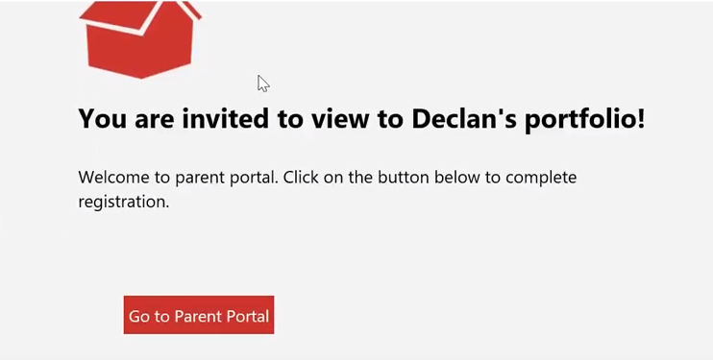
2 | This will bring you to a page of information. You should only need to fill in your child’s student number in the box that says Enter Student ID.  When you finish, click on Connect. | 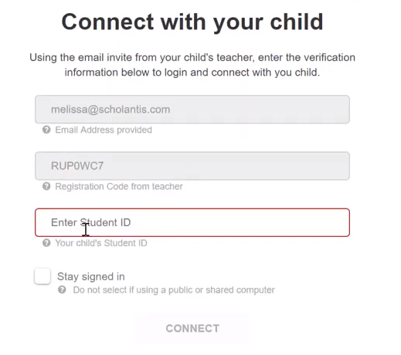
3 | You should now see your child’s portfolio (please flip over for a diagram on how to navigate it).  Please make a comment to encourage your child and let the teacher know that you have seen the post. Feel free to ask questions.
4 | Now you will receive emails from the teacher when there is a new post to look at. The link will take you straight in to the ePortfolio.
What are you looking at?
These controls allow you to add posts. Please do not use these unless the teacher has asked you to. Students use these to add posts themselves.

You can save this as a webpage to send to other schools when you move or to share with others.

Click here to view ePortfolios from past grades.

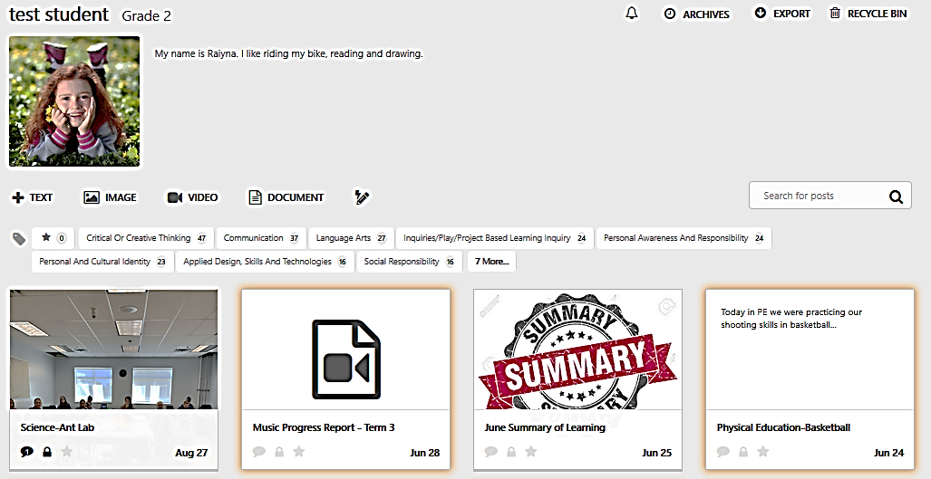
Click on a subject to look at posts only in that subject.
Click on the star to view favourite posts.

This shows that someone has commented on this post. The lock indicates that the post cannot be changed.
Click on a post to open it. Yellow lines around a post indicate that you have not seen it yet.

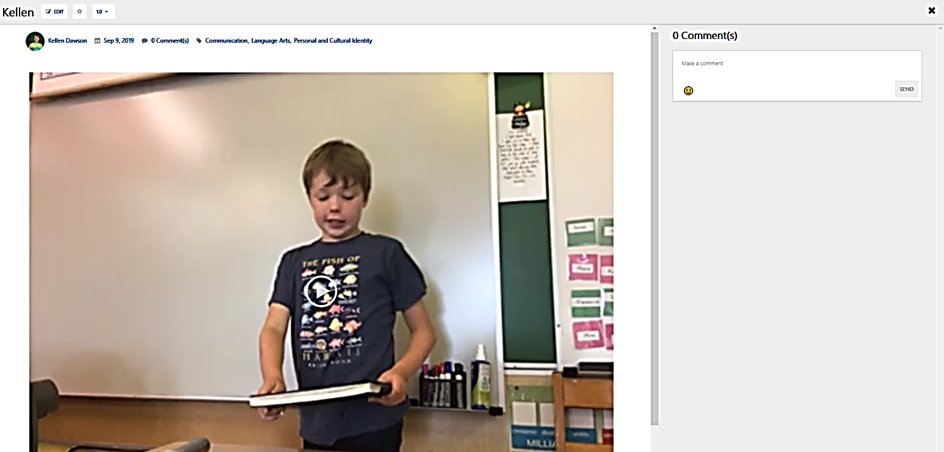
Posts:
Click the play button to watch videos.
Scroll down on the page to see more content.
Be sure to comment here. Click on the happy face emoji to open up more
Click on the X when you are done reading.
Click Send When you are done.

