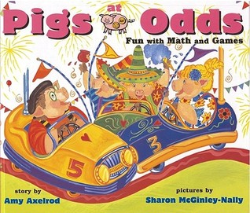
Primary Task
Data and Probability: Analyzing data and chance enables us to compare and interpret.

likelihood of events:
- using comparative language (e.g., certain, uncertain; more, less, or equally likely)

Open Questions: Data Management and Probability k-3
Marian Small & Ryan Tackaberry

Before:
Something is very unlikely to happen today and you are happy about this. What could this be? Something else is very likely to happen today, and you are happy about that as well. What could it be? How is it possible that something very unlikely and something very likely can both be things that make you happy? Peer turn and talk and share back to group.

During:
Partner probability game. Partners will pull linking cubes out of a bag. Make at least two rules for your games. p. 100
Possible rules:
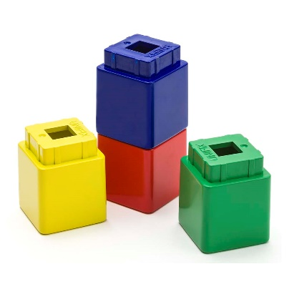
You are more likely to pick a _______ (color) cube that a _______ (color) cube.
You are ___________ to pull out a _______________ cube from the bag.
You are equally likely to pull out a ____(color) cube.
It is impossible to pull out a ______ (color) cube.
Have your partner read the rules and prepare the cubes in a bag based on the rules.
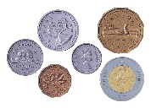
Play the game with Canadian coins. p.100
Possible rules:
It is likely but not certain that the coin will be silver.
It is certain that I will pull out a coin that is worth something.
It is impossible to pull out a coin that will have a super hero on it.
It is certain you will never spend one of these (penny).

Use these words to make a sentence. sometimes bike friend usually

Try: beach unlikely possible bucket
Try: certain park swings impossible

After:
A probability line begins with impossible and ends with certain

Where would you put the following terms: unlikely, less likely, more likely, equally likely

