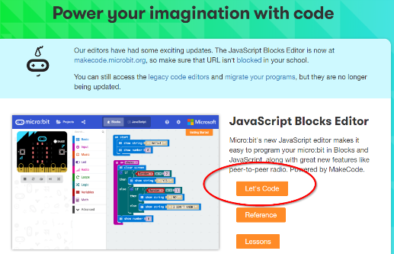
Introduction to the BBC Micro:bit
Let’s Code:
- Go to microbit.org
- Click on Let’s Code at the top
- Click on Let’s Code again
What are you looking at?
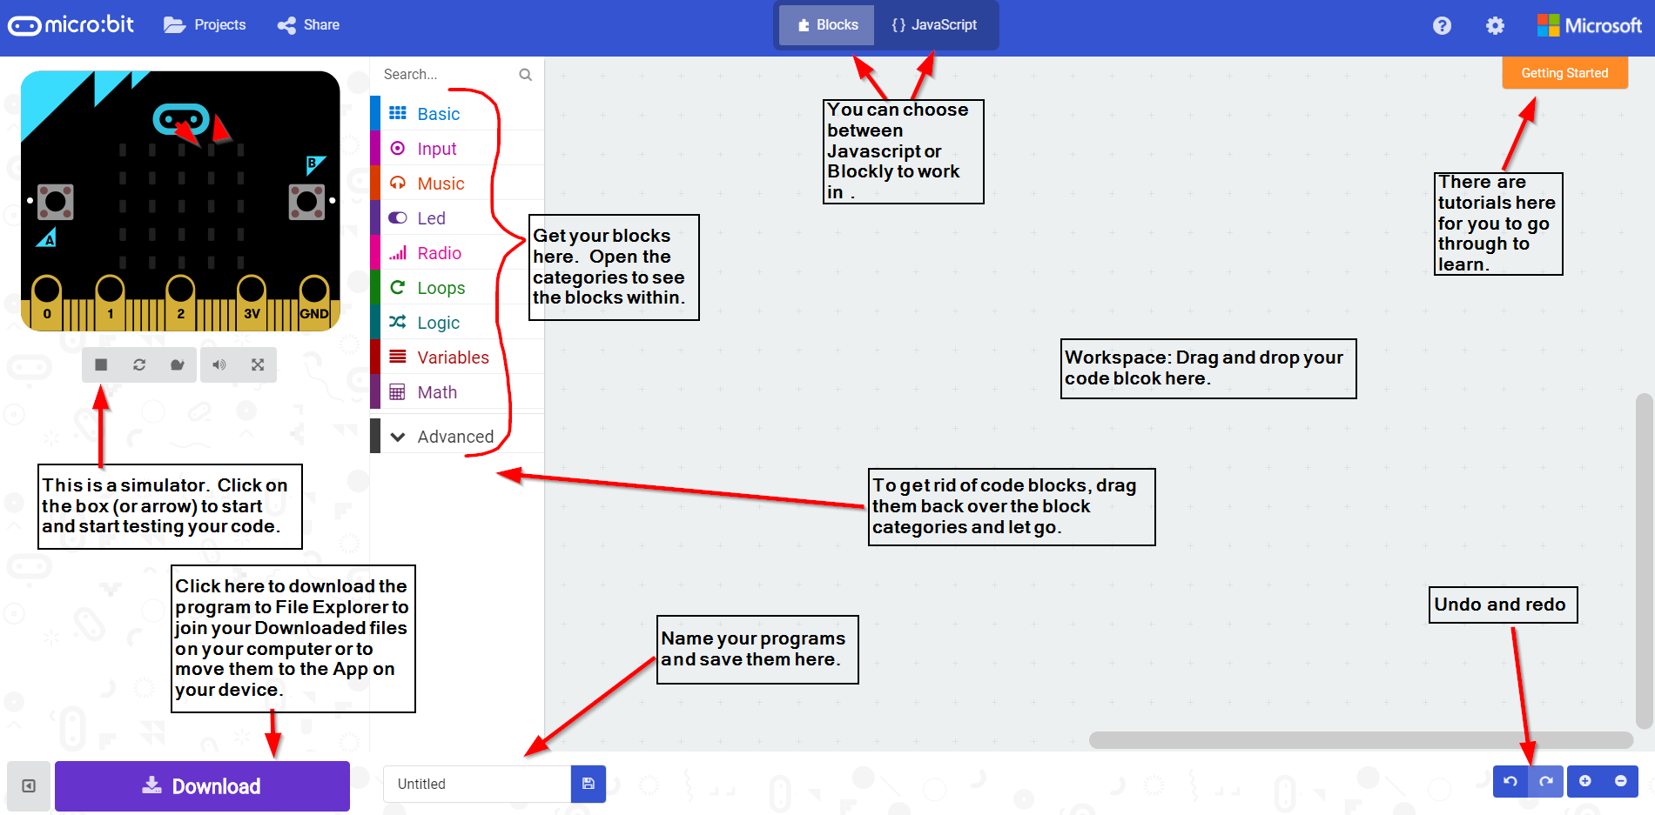
If you are on a personal device, click here if you do not see the simulator
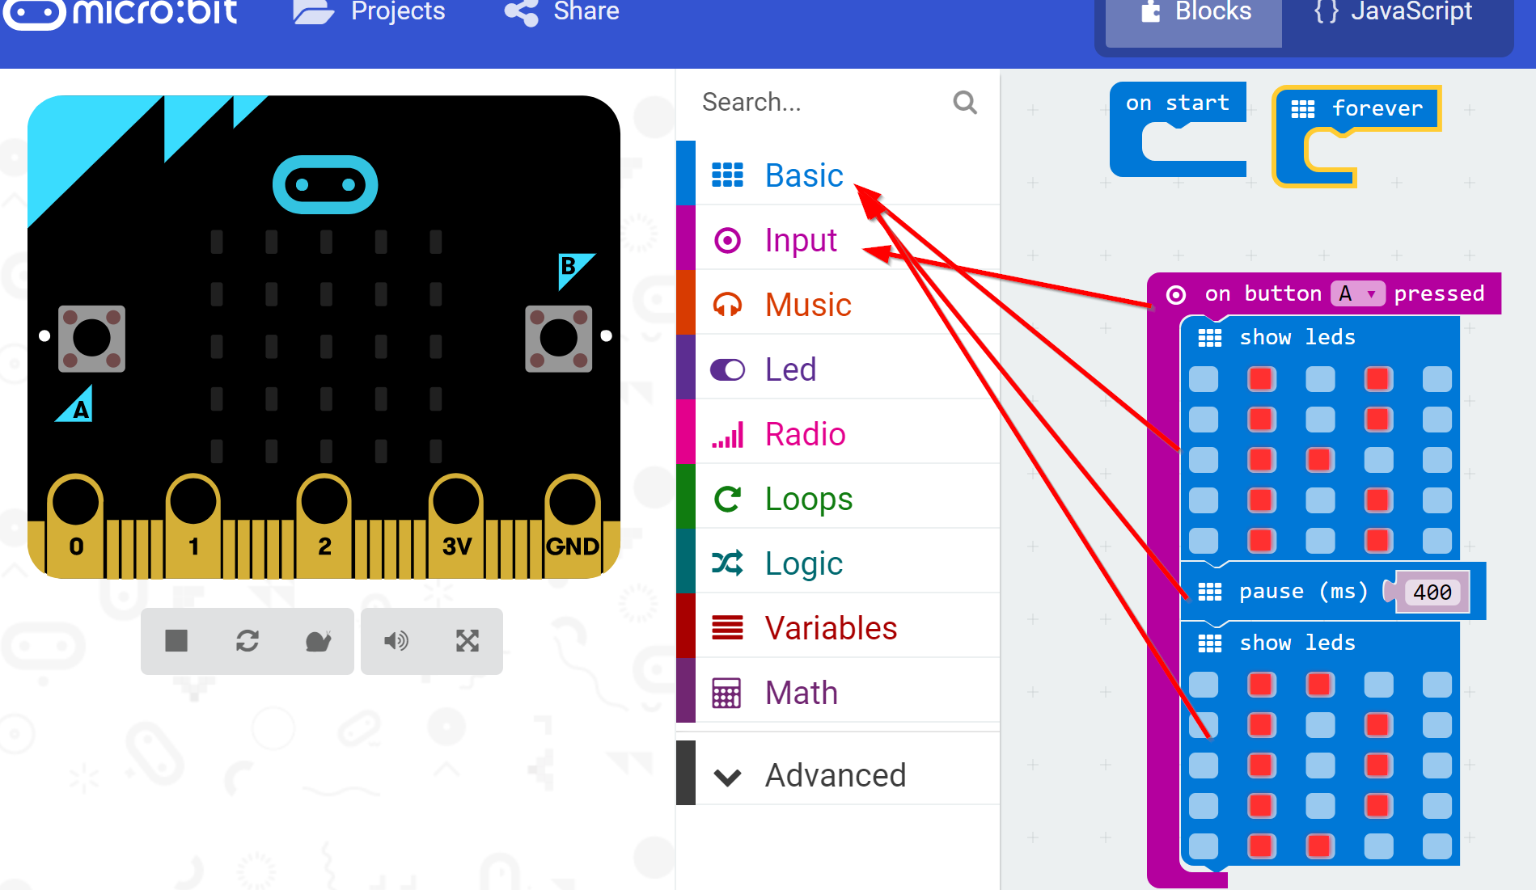
Code your initials:

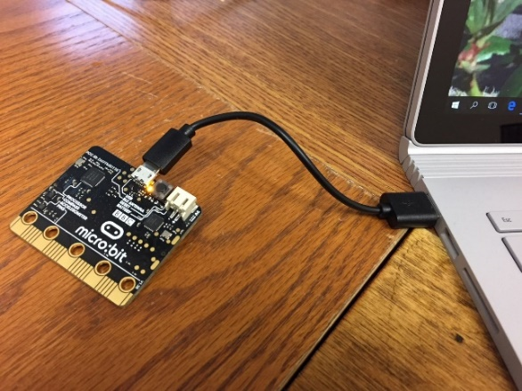
How to hook the Micro:bit up to your computer:
Plug the Micro USB end (the small end) of the connector into the
Microbit and the USB end into your computer.

How to Connect the Micro:bit to your Personal Device:
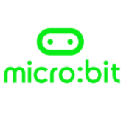
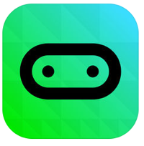
The device must have Bluetooth and requires IOS 9 or later or Android 4.4 and up.

- 1. Download the app for IOS or Android:

- 2. Open the App and click on Choose Micro:bit (IOS) or Connections (Android)
- 3. Click on Pair a new Microbit
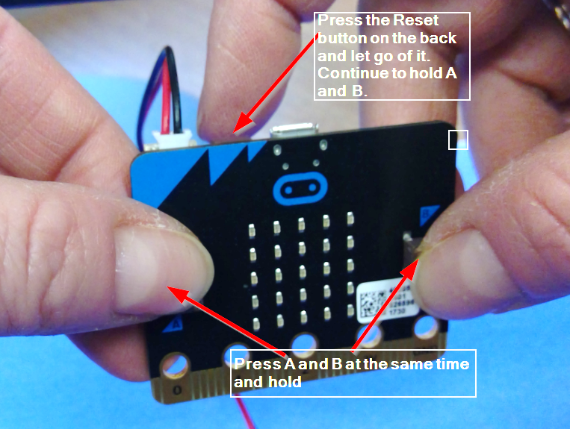
- 4. Hold the A and B buttons down. While you are holding them down, press and release the Reset button:

5. It will ask you to put a code in after this. Copy the led pattern on the Micro:bit onto the computer.
6. It may also ask you to add a numerical code-just follow their instructions
How to get your program onto your Micro:bit using a computer:
- 1. Plug your Microbit into your computer.
- 2. Click on the Download button.
- 3. Open your File Explorer and find your Download files
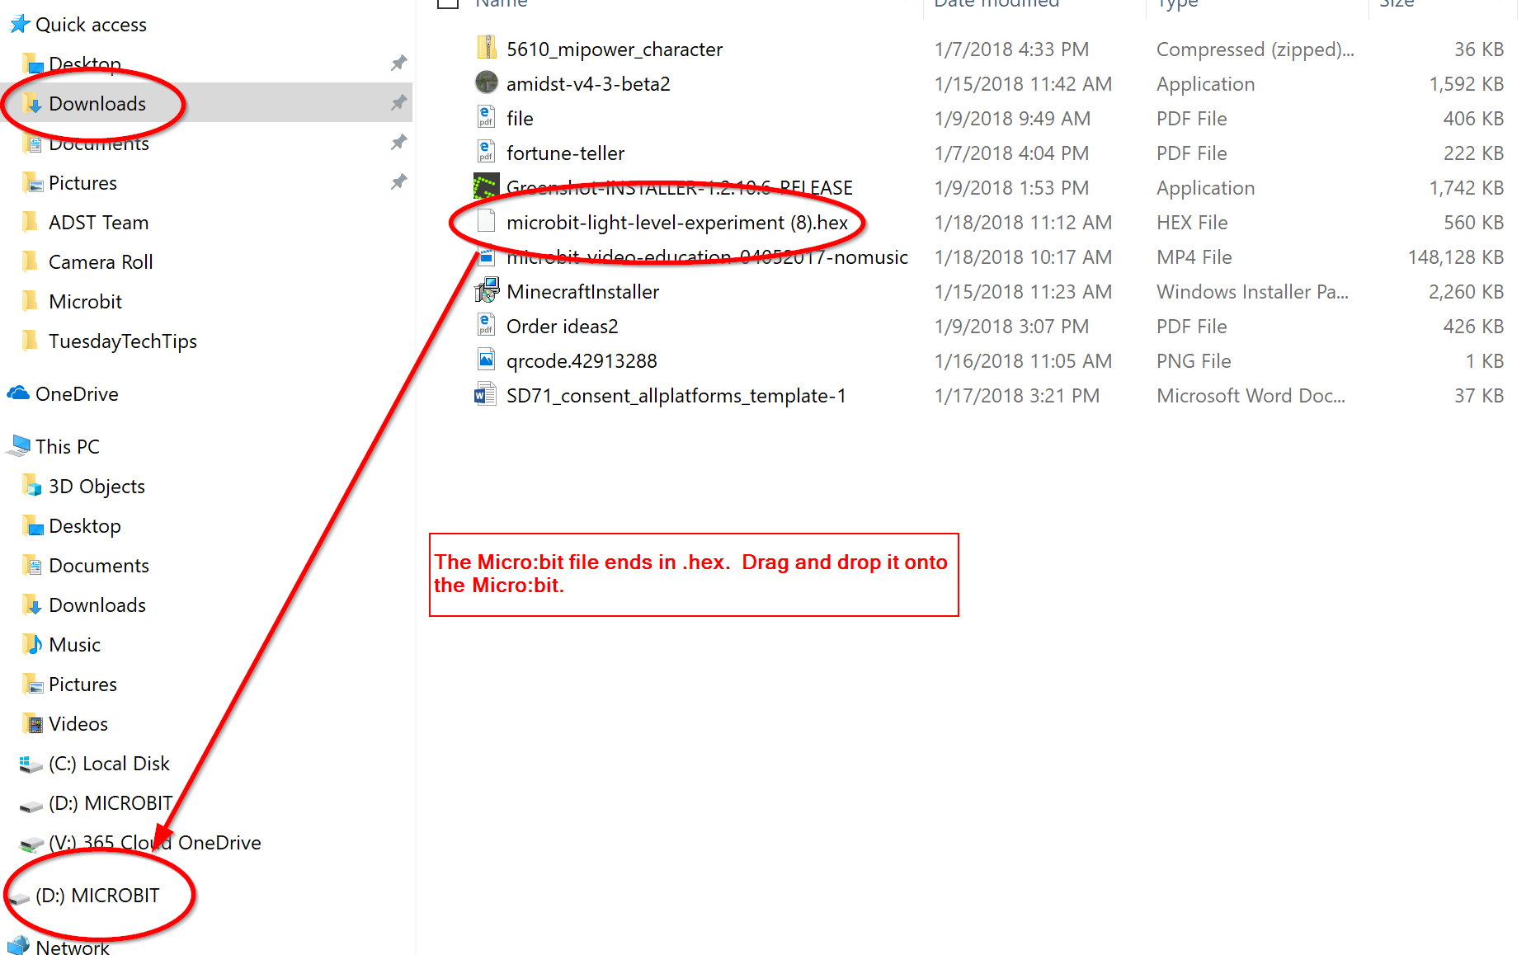
4. Click on your Micro:bit file (it ends in .hex)
- 5. Drag it to the Microbit on the left
- 6. Drop it and watch it happen.
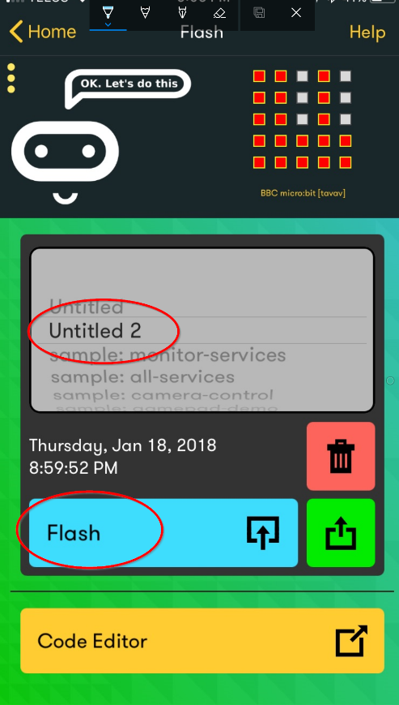
How to Get Your Program onto your Micro:bit using the app:
- Reconnect your Micro:bit to your app.
- Go back to the program and press on Download
- Press Download again when a screen pops up
- Press Open on the next screen
Now you should be back in the app.
- Press Flash
- On the Scroll bar-find your program
- Press on Flash

Some Projects for you:
Please visit Kara’s Corner for all the links I used and more projects and ideas:
http://bit.ly/2rpoqtM You can also get here from Learn71.ca
