Getting Your Class into Google Apps
- After students log into the computers, have them open up Google Chrome. Chrome is recommended over using Internet Explorer and Firefox as it seems to work a lot smoother.
- Have them go to the School District website: sd71.bc.ca
- Have them click on Google Apps/Student Webmail
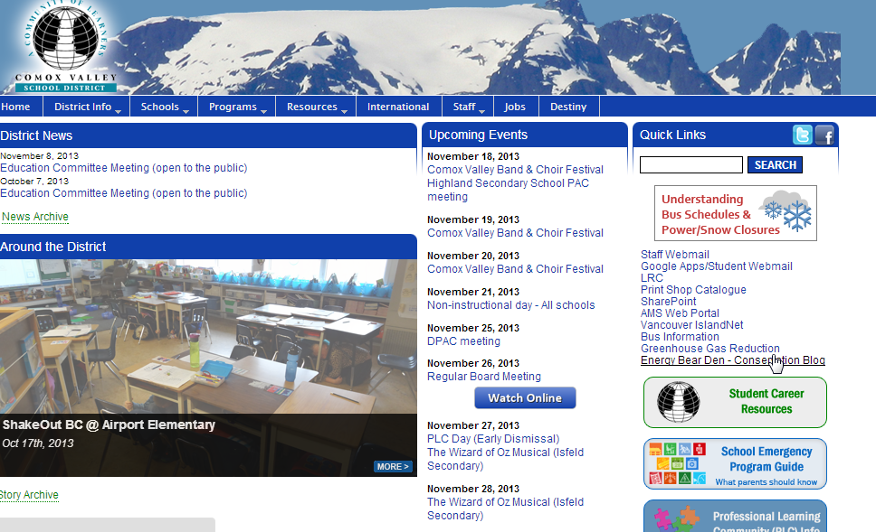

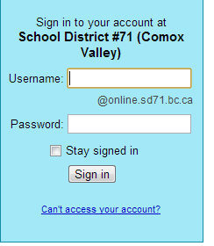

Student number
The first time students go in this should be their student number. Students will be asked to change their passwords when they get in for the first time.

- The first time students go in to Google Apps, they will be asked to read an agreement and figure out the letters in one of those test boxes. Ask the kids to help their neighbors figure out the letters if they are having a tough time with it. Students will then be asked to type in their old password (student number) and to type in a new password-you may choose to regulate this: for example use the student’s phone number and initials. It will need to be 8 characters long and include letters and numbers.
- At this point you are going to need to take some time to help the kids that can’t get in. Some will have set passwords that they don’t remember and some may be new to the district and not added yet but there is always one…

Using “Google Apps Administration” to Fix Problems with Accounts
- You will need to return to the School District Website (sd71.bc.ca). Go to the Resources section and then click on Information Technology
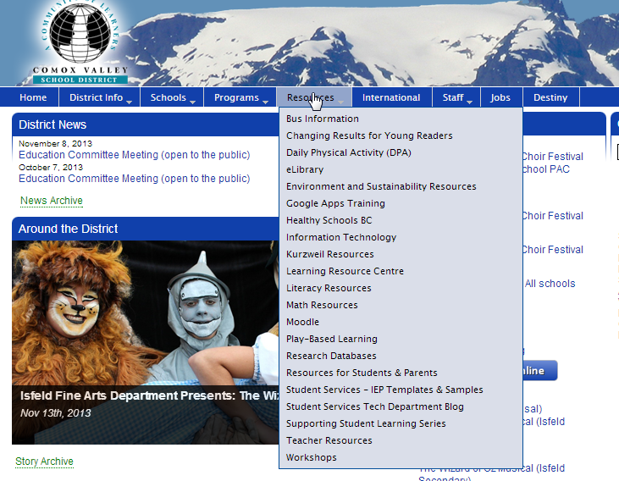

- On the right side of the screen, find Google Apps Admins and click on it.
- Click on User Maintenance Menu.
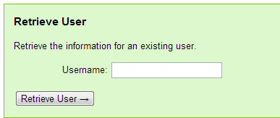
- First make sure that the student in already in the system. Go to the box called Retrieve User and type the student’s student number in the box beside Username. Then click Retrieve User.

- If the student is in the system, their information will show up at this point. If so, go back. If their name does not appear, go to instruction number 8.
- Scroll down until you find the Update Password box.
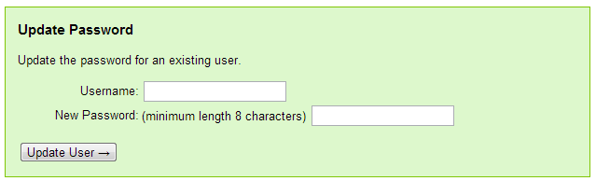
- Type in their Username and a new password-computer71 works if you are in a hurry. Click on Update User and that student should be done.
- If the student is not already in the system, you will need to add that person:
- Scroll up to the Create User box.
- Fill in the student’s information (don’t forget to give them a password that is easy to remember)and click on Create User. The student should now be able to log in.
Students are in Google Apps
Now What?
When students first go in, they will be in the email section. You could use this for an opportunity to do a lesson on email etiquette:
http://www.weareteachers.com/lessons-resources/details/email-etiquette- This is an example of a lesson done in the classroom
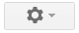
Students enjoy exploring at this point and can adjust the settings of their email account:
- Click on the Settings button in the top right corner
- Click on Themes
- Students can explore these and decorate their screen
Google Docs
Once you are in the email section, you can move on to the apps that are available. Up in the top right of the screen, click on the 9 little squares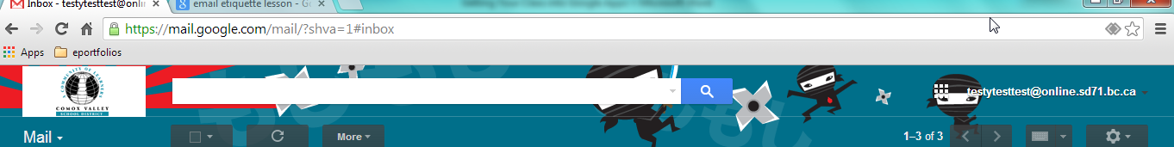
This shows some of the programs that are available to you:
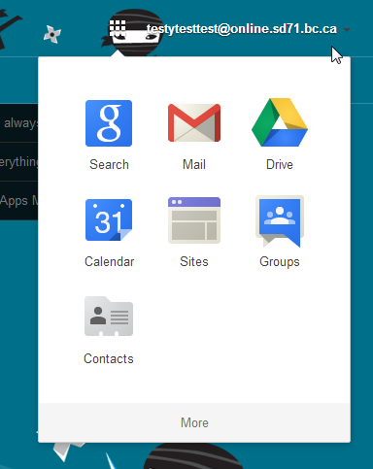
Your email
Google Docs is found here
Search in Google
Use to start and join group discussions
Organize your calendar

Make and manage websites

Check here for more apps

Click on the Drive icon to get to Google Docs. Here you can see all of the creations that you have made in Google and those that others have shared with you.
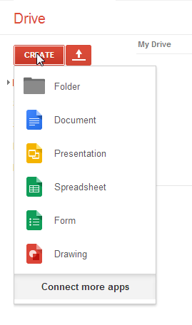
To create a new document, click on Create on the left side of the screen. Now you will see the choices that you have to use to present your work:
Google Docs-this is a word processor like Microsoft Office
Create presentations like PowerPoint
A simple version of Excel
Create surveys, share them and the program will organize the results for you
Here you can create drawings and diagrams to use in your presentations

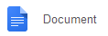
Students should now click on
This program works like Microsoft Word (if you need further instruction on using this, please contact kdawson@sd71.bc.ca ) but has some special features:
You don’t have to save your work-Google will do this for you!
You can share documents and work on projects in the same document at the same time:
Sharing Documents in Google Apps
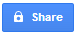
At any point students are able to share their documents with each other, the teacher, their parents, or the world.
- Click on in the top right corner
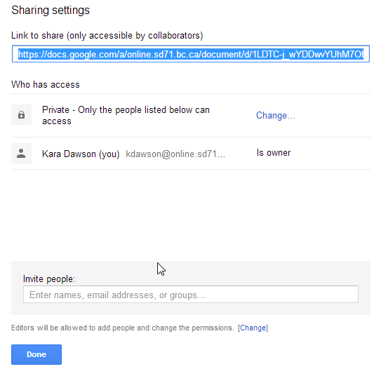
- If you haven’t already named your document at this time you will be prompted to do so. Then:
          - Click here if you would like to share with the general public.

Click here to share with individuals that you choose

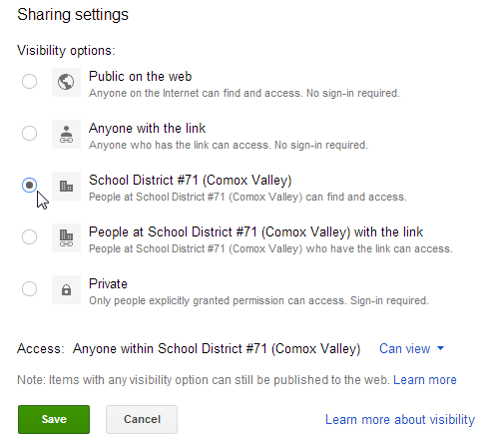
- If you chose to share with the public, you can now
narrow down what selection of the public
to share with. If you choose “Anyone with the
link” then you must give people the link for them
to find your document. If you choose School
District #71 then only people with sd71 accounts
will be able to view it.

After you choose who you are going to share with,
you will need to decide if you would like them to be
able to edit your document, comment on it or just
view it.

- If you chose to share by “Invite People” you will be prompted to add the individual’s email addresses.
- Click on Save then Done
- To view the documents that were shared with you, return to the drive: Click on the blue box in the top left corner of your screen.
- Now Click on “Shared with me” to find the document that was shared. If this doesn’t bring it up, Check to make sure the student put in the correct address.

