Teacher Cheat Sheet - How to Create a Game with Scoring
Create a Program that keeps score as you collect points.  This code goes on the Prey in your game. | 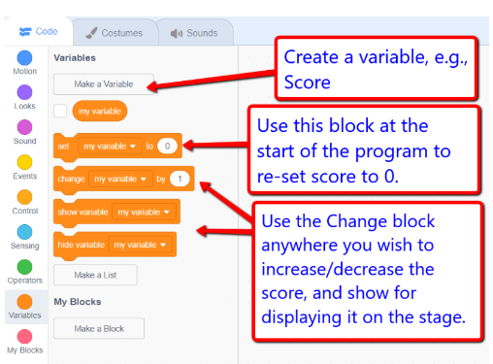  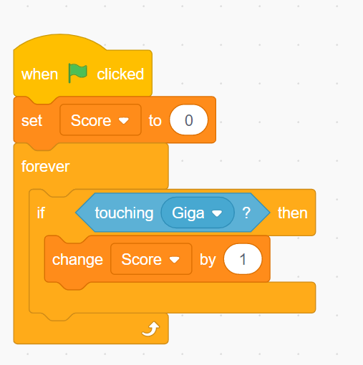  One Option:  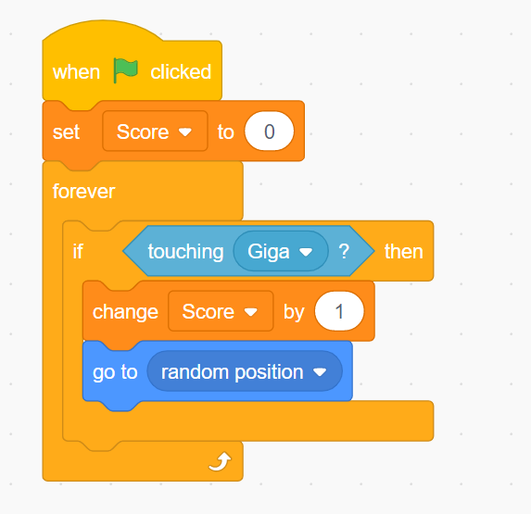  Another Option:  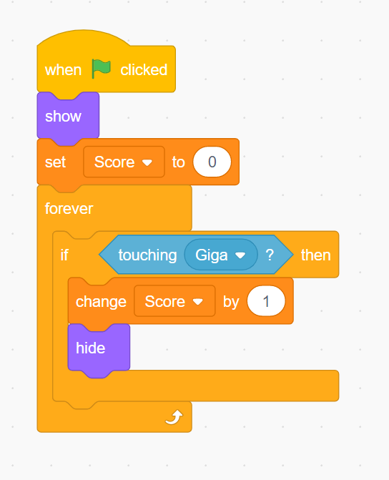 | - You will need to create a variable called Score (or points)  - Click on the Variable category and then Make a variable.  - Type in the name Score then click OK  - When the flag is clicked have the game start with a score of 0:  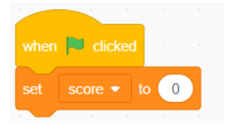  - Now place a Forever block from the Control Section.  - Place an If Then block inside the forever.  - Drag an If touching mouse pointer from the Senses category and place it in the appropriate spot.  - Click on the down arrow beside Mouse Pointer and change it to the name of the sprite that is the predator.  - Now add a Change Score by 1 block so that if the prey is touched by the predator the score will go up by one.  Your score will keep going up uncontrollably at this point. Two ways to prevent this (there are lots of different variations and the students will come up with some great ones on their own).  One Option:  Make the prey reappear in a random position by adding a go to random position block from the Movement section.  Another Option:  Have the Prey disappear after the Predator gets it by adding hide and show from the looks section.

