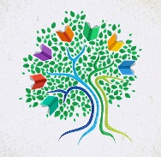
Environmental and Outdoor Learning-SD71

EOL Updates!
With the return to schools this week there has been a lot of interest for more outdoor learning ideas and supportive material. Again, please remember, anything you already have prepped you can likely take ‘out-of-doors’.
If you are interested in diving into some nature-based learning, this week we are highlighting pollinators. I have also re-attached the sampling of more outdoor learning from last week.
More resources can be found on the districts EOL website:
http://learn71.ca/environmental-outdoor-learning-eol/teacher-resources/
What are pollinators:
Pollinators are animals (birds and bats) or insects (beetles, wasps, moths, butterflies and bees) that distribute pollen from one flower to another as they forage, and as a result allow for the fertilization of the plants. They are a key component of global biodiversity because they play a vital role in maintaining both wild ecosystems and plants that produce food (ie fruits, nuts and seeds) that wildlife and humans rely on to survive. At least two-thirds of the world’s crops depend on pollination by insects or animals
BC Pollinator ID Card: http://www.naturekidsbc.ca/wp-content/uploads/2018/04/Life-in-the-Flowers-Card-Final_-Web.pdf

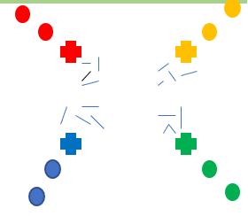
Active Pollinator Game:
Same orientation as 4 corners: see attached newsletter for full details.
- Object is to try to collect as much food as possible from other groups.
- Reflection: Who has the most food? Why? What was your strategy? Would pollinators have the same strategy?
Spring flower find:
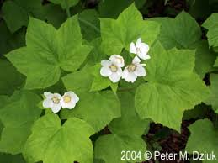
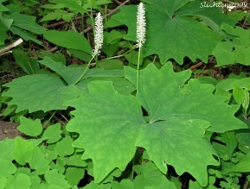
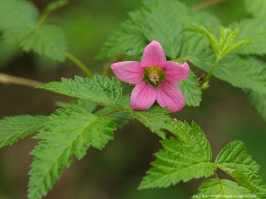
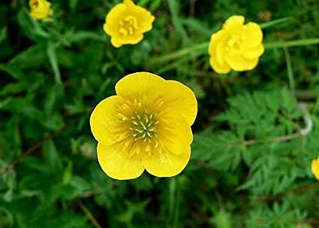
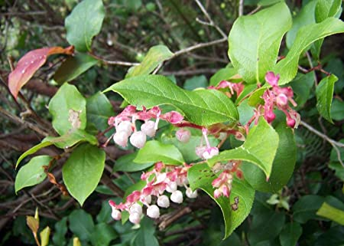
see attached printable

Sit Spot / Quiet Activity:
- Deer Ears for humming pollinators. Try to listen for the quiet sounds.
- Count or tally how many different kinds of flowers can see from your spot. How many of each?
- Write a letter to a pollinator- see attached newsletter for full description
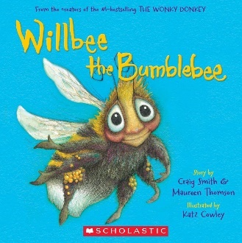
Book:

Read aloud -- outside

Supporting App.
iNaturalist -- Approved district app. -- please make sure students have parental consent if they are going to make an account. Otherwise you can utilize the missions to challenge students to find flora and fauna of interest.

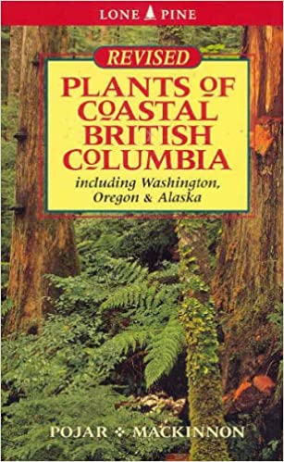
Book resource:
Plants of Coastal British Columbia, Pojar - MacKinnon
Best plant ID book around. Lists location and descriptions including the traditional Indigenous use of the plant.

INED resource:
Located on the District INED website
https://indigenouseducation.comoxvalleyschools.ca/apps/pages/index.jsp?uREC_ID=1064875&type=d&pREC_ID=1357948

