How To Build a Mason Bee House

Mason Bee houses are a great ADST project for students in grades 4-7.
The first thing that you will need to do as a teacher, is get trained in using your school Maker Cart. Once you are Safe and Certified you will need to do an inventory on you Maker Cart.
Each cart has a master list of what should be in it. If you are not sure or if you will need additional resources, please contact your District Careers Coordinator at they will be able to help you.

For this project you will need the following items:
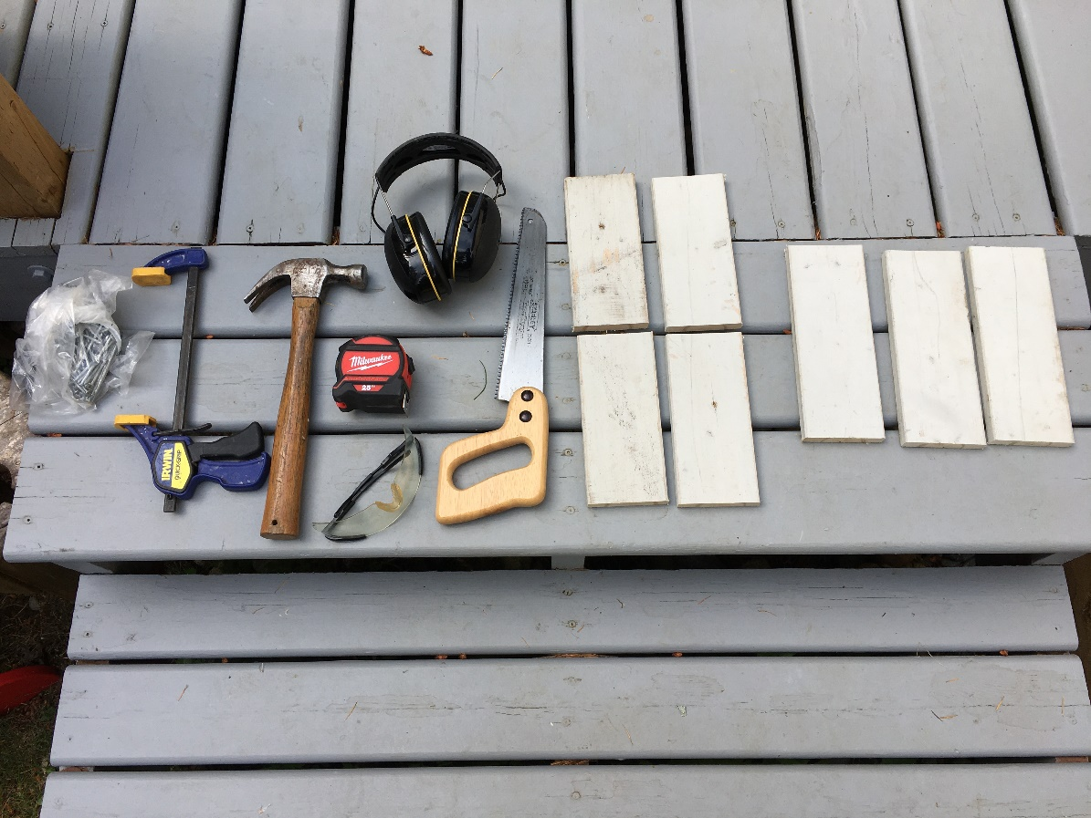

- Hammer 7. 1 ½ Inch Nails (17 per house)
- F Clamp 8. 1, 1” x 4” that is 6’ long (1 per house)
- Measuring Tape
- Safety Glasses for each student
- Ear Plugs- hammering
- Hand Saw
Once you have everything you are ready to start your project. Don’t forget to put on your safety glasses.
STEP 1:
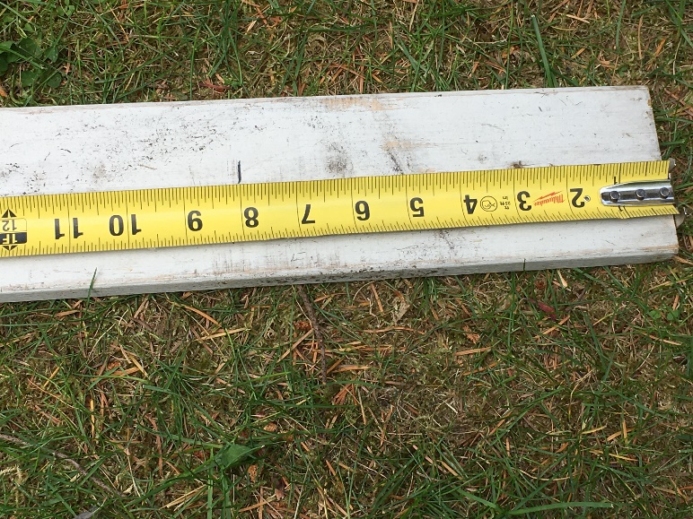
You will need to measure out 4, 6” pieces on the piece of 1” x 4”. These will be the square walls to your house.

Step 2:
Once you measure out your 4, 6” long pieces, you will need to clamp your wood down to a table and using your hand saw, cut them off. These 4 pieces will be used as your walls to your bee house.

Step 3:
Once you have your 4, 6” pieces of wood, you will need to nail them together to make a square. To do this, you will need your 4 pieces of wood, your f clamp, 8 nails and your hammer.
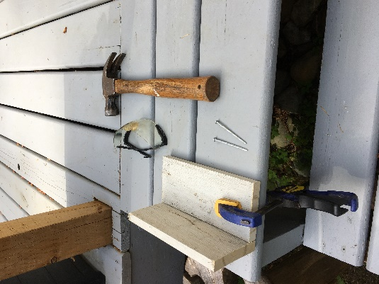

First you will clamp down one of your pieces of wood. You will use 2 nails and hammer these two nails in approx. 1 ½ inches in from each end. So that two pieces of wood are held together at 90 degrees.
Repeat this until you have all 4 walls attached. You should have a square box.

Step 4:
Next you will add the roof. You will now need to go back and measure out 2, 7.5” long pieces. Once measured cut these out.

Step 5:
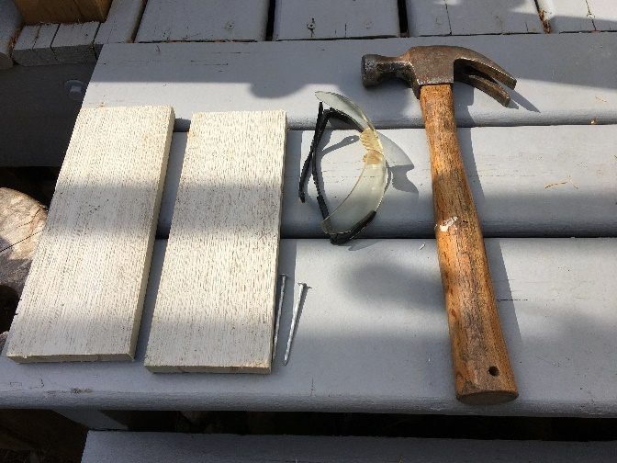

Now that you have 2, 7.5” long pieces, you will need to nail these together just like you did for the 4 walls of your house. You will need the F clamp, 2 nails, a hammer and your 2 pieces of wood.
Clamp once piece of wood down, put the other at 90 degrees and hammer them together.
Step 6:
Using the picture below, please notice that the roof of the house will NOT be perfectly even on both sides, one side will be slightly longer. Make sure to put the peak of the roof in the middle of your house. You can measure the middle point using your measuring tape. Once the peak is in the middle have a partner hold the roof in place while you nail 2 nails into each side. Make sure to line the nails up so that they go through the roof and the house walls, holding the roof on to the house body. Repeat this on the other side.
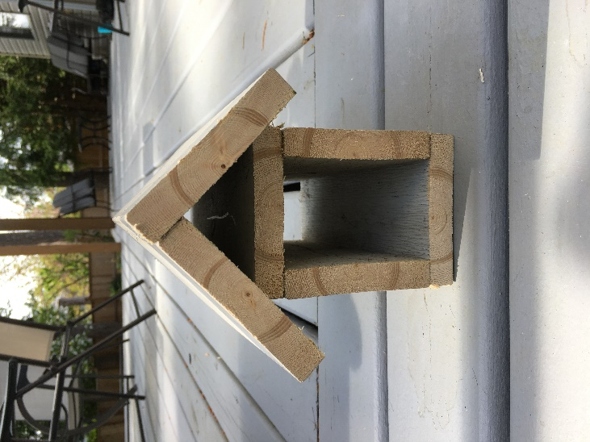

Step 7:
The house will need a back plate so that you can connect it to a house, tree, or building. Cut one last piece of wood that is 9” long. Once this is measured and cut place the house face down. Using 2 nails, nail the back plate to your bee house. It should now be ready for straws.
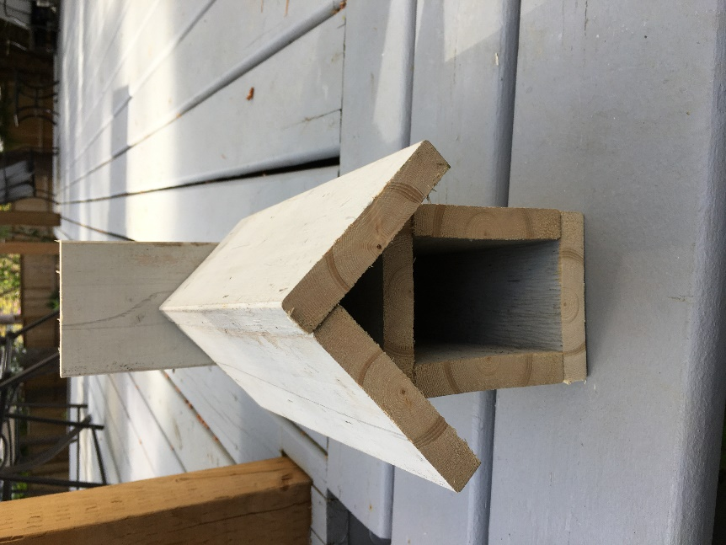
Step 8:
Using cardboard based straws, fill your bee house up. You may choose to place some sticks and other natural forest products in the house so that the bees have landmarks for finding holes.
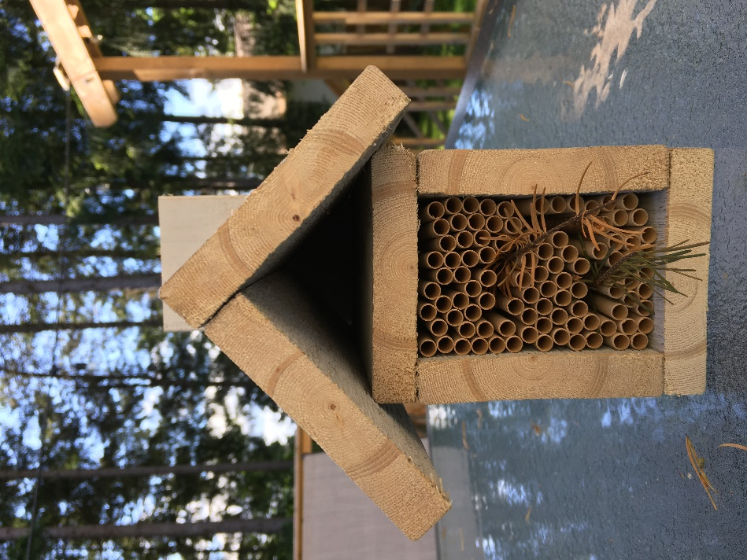

Step 9:
You bee house is now ready to be hung. You may use a drill and screw or 2 nails to hang your house to a building or tree. Please refer to the learning resources on where and how to care for your bees once they have settled in your home.

Good Job!!!

