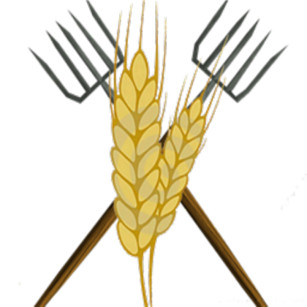

Name: Brian Smith | Visit the following places in order
You are a vegetable and poultry farmer from the Courtenay area. Once a week you come to Cowboy Town to sell your goods. You also like to have lots of fun in town with your friends enjoying good food and games. You really like sports.  Follow the instructions and visit the four locations listed. | First Station | General Store  Drop off your poultry  and chickens for sale.
Second Station | Saloon
Enjoy some fun entertainment
and have a good meal.
Third Station | Company Office
At the Company office you will be required to pay your land taxes.
Fourth Station | Blacksmith
Some of your equipment is getting old, now is a good time to have it repaired or buy something new.

