Decomposer Discovery: Scavenger Hunt!
Wood Bug  Observations: | Slug  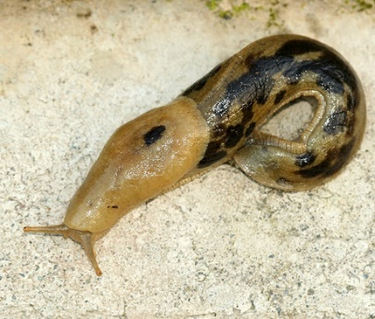  Observations: | Fungi  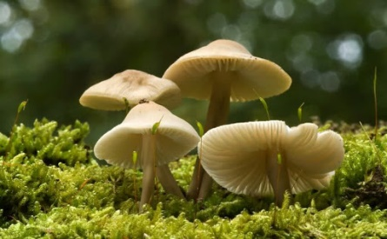  Observations:
What else did you find?  Observation: | What else did you find?  Observation: | What else did you find?  Observation:

What do these decomposers have in common?

Where do decomposers live?

What do decomposers need to survive?

Decomposer |  | Example |  |  | Description
Fungi |  | 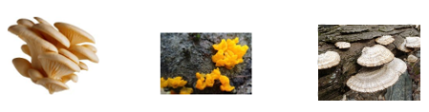 |  |  | Fungi release chemicals externally to break down dead plants or animals into simpler substances. They absorb some of these substances for growth, but others are utilized by other organisms, including plants.
Bacteria |  | 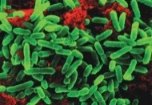 |  |  | Bacteria are tiny, microscopic organisms. The ones that live on dead materials help break them down into nutrients which are returned to the soil.
Invertebrates |  | 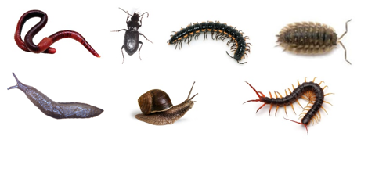  Centipedes are part of the decomposer group because they eat other invertebrate decomposers, thereby keeping the decomposer populations balanced.  Wood bugs Not a bug – a crustacean Related to shrimp and lobsters – where do those live? Wood bugs breathe through simple lungs that need to be very moist, therefore need moisture in the air Keep them under leaves provided. You can handle them gently, but not for long or they will run out of air. |  |  | Earthworms digest rotting plants, animal matter, fungi, and bacteria as they swallow soil. The waste that comes out of their bodies at the other end contains important minerals and nutrients ready for plants to absorb.  Millipedes, sow bugs, and fly larvae (maggots) do a similar process, at different rates, but they rely on a different food source.
 | Grade |  | Features | Function |  | Lifestyle
 | 1-2 |  | How many legs?  Are there males and females?  What texture are they? Do they have any markings? Stripes? Dots?  Where are their eyes located? | Do they only eat rotten wood?  Do they eat dead animals and humans? How many times a day do they poop?  How far/fast can they run in two minutes? How do they live?  How do they crawl into small spaces?  How do they eat?  How do they get water under a log? |  | How long do they live? How many eggs do they lay?  How long for the eggs to hatch?  How long do they live?
 | 3-4 |  | How many legs do they have? Why?  Do they have antennas? Why?  Why are they the colour they are?  Why do they have certain markings?  Can you tell male from female?  Why or why not do they have an exoskeleton? | What do they eat? Why do they need water (moisture) to breathe?  Do they eat garbage?  Can they swim?  Do they think? About what?  Do they make a sound? Can they talk? Interact? |  | How does your decomposer attract a mate?  How are they born? What happens to the newborn babies?  How do they feed babies?  How small are the babies when born?  Why do parents go away from babies? How big do they get? How long can they live? Or how old?

