**Office 365**

**Office365 OneDrive = (V:) 365 Cloud OneDrive**

* **Can access on any device from anywhere**
* **Allows you to share files**
* **Saved within Canada**

**Saving in School District #71**

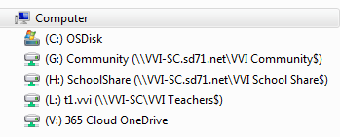

Saving in a program may look slightly different. This is what you might find when saving in MS Word:



**School**

**(H:) SchoolShare**

* **Students and staff can save here**
* **Cannot be accessed from home**

**(L:) - Personal**

* **Only you can save here**
* **Access at home through the portal with HomeDrive (it is easier to use the V Drive)**

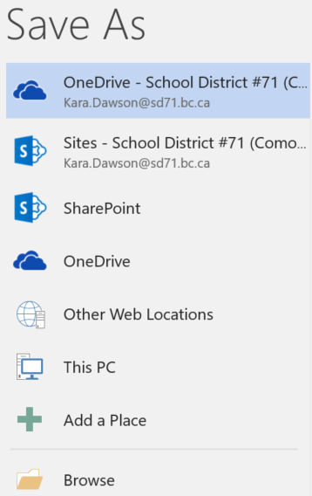

This is the **Office 365** One Drive – A good place to save

Do not save here

These two will allow you to pick the option of **Office 365** or the **School** options.