Hello everyone...here are some simple instructions to get you going in our new Mathletics account.
These instructions begin with an online browser. You may also load the Mathletics app on your device and work through a phone or tablet.
In your browser type in Mathletics and click on ‘Mathletics Sign In’.
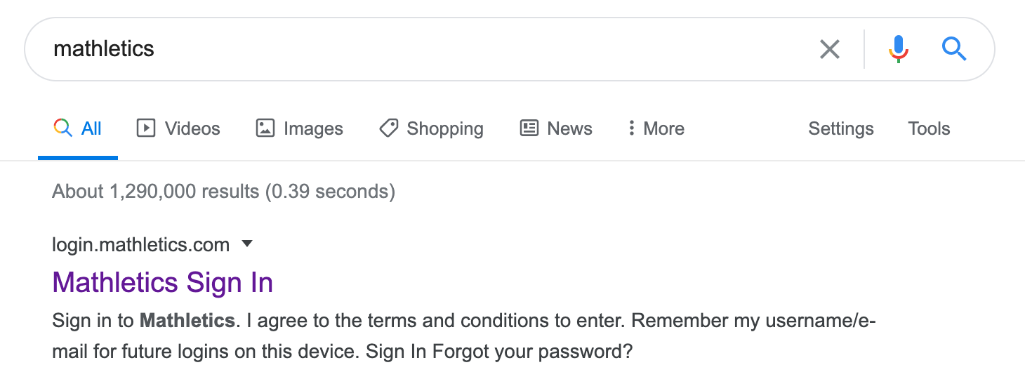
Now click ‘SIGN IN’ at the top left for the screen.
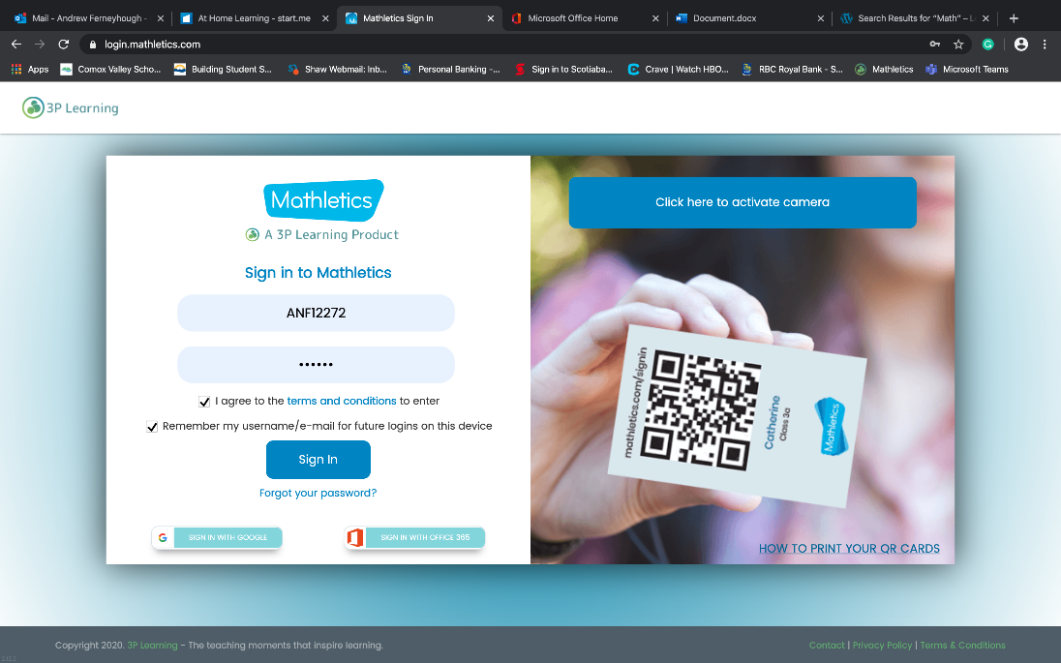
Don’t forget to add this page as a ‘Favourite’ in your menu bar so that you can easily come back next time.
Type in your username and password provided to you by your teacher.
Check the boxes to ‘agree’ to terms and ‘remember password’ if you want.
Welcome to your homepage.
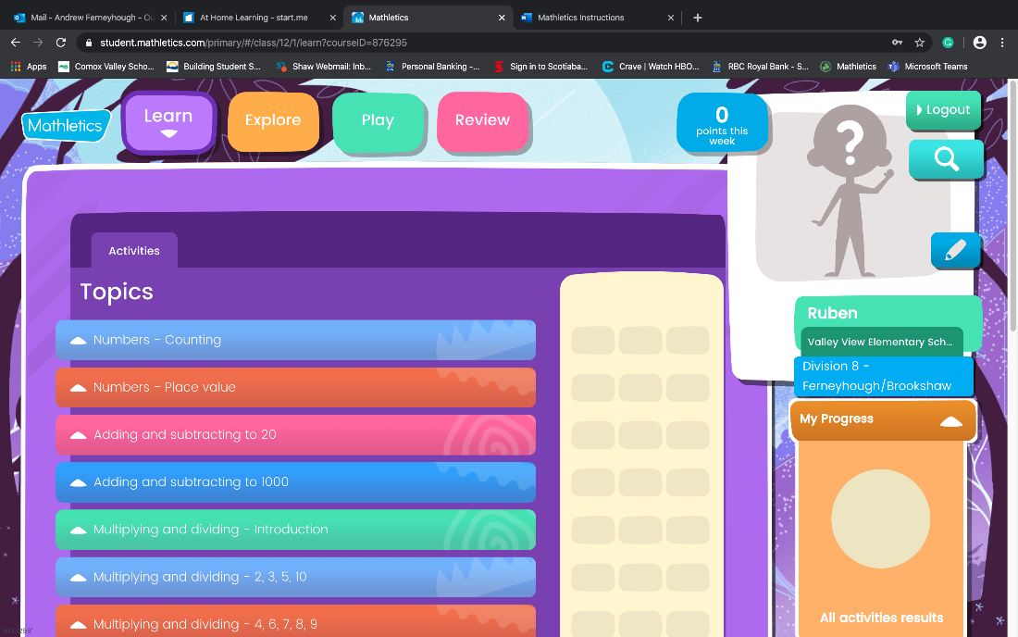
You will spend most of your time in this ‘Learn’ section.
Your teacher will ask you to go to a specific Unit, such as ‘Multiplying and Dividing’.
Click on the arrow to drop down the sections in that unit.
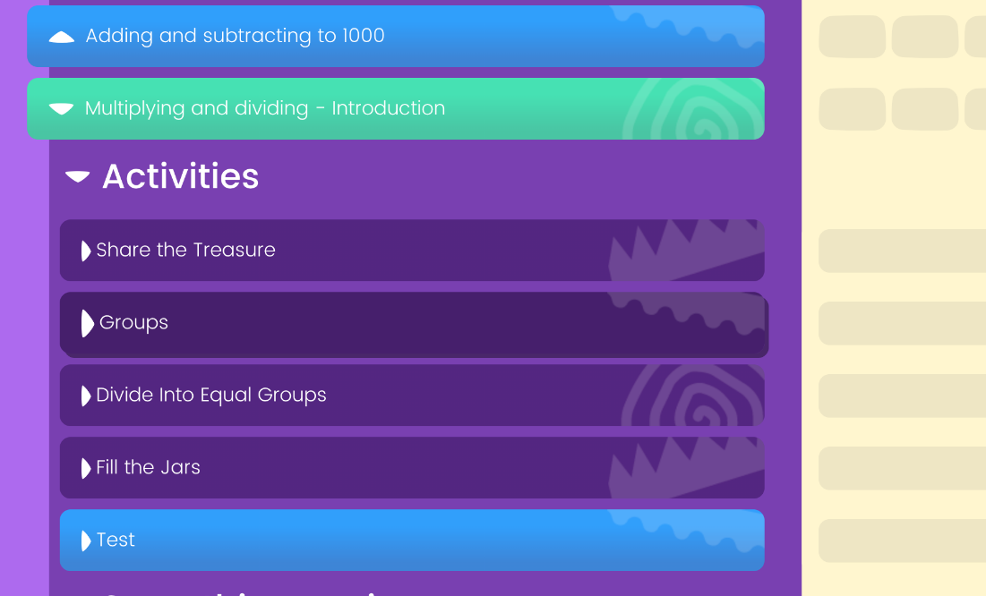
Click on the first ‘Activity’ (Share the Treasure) and it will take you to your first task.
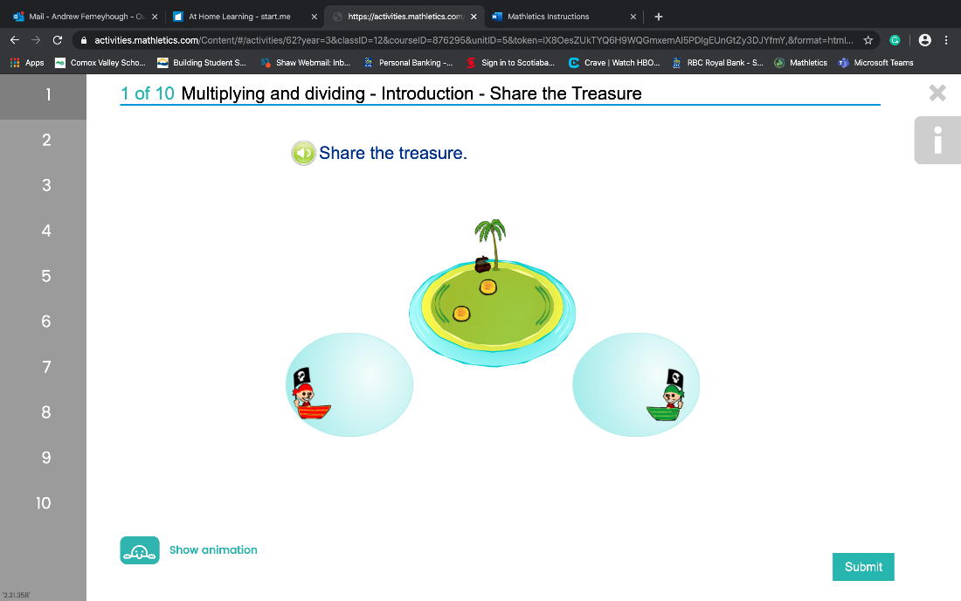
When you are done the question/activity..press ‘Submit’.
When you get to the end of the first ‘Quiz’ you will see a screen like this..
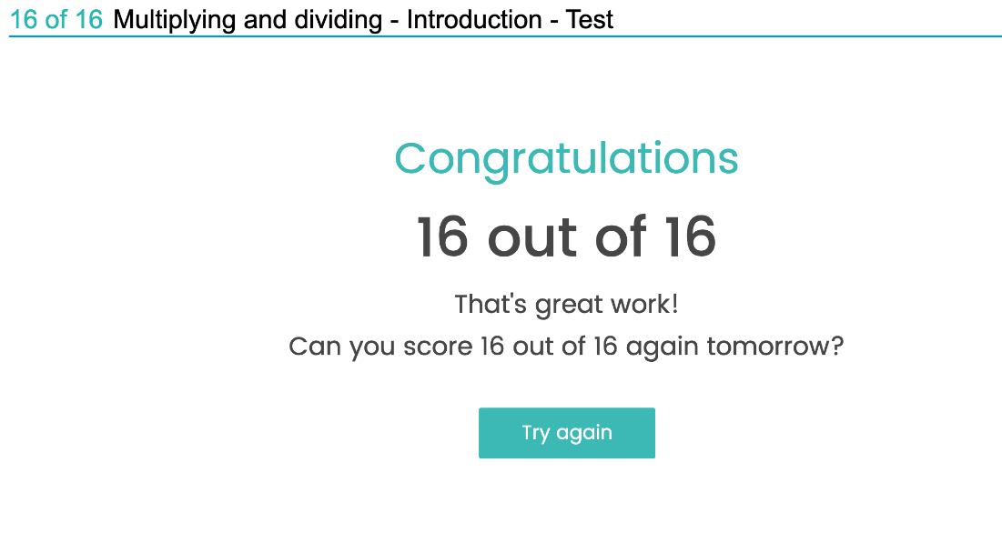
After you have spent a certain amount of time in the ‘Learning’ section. This will be specified by your Teacher or by your Parent/Home Facilitator, you may check out the ‘Explore’ and ‘Play’ areas.
However, I will not explain that here as it is your job to ‘Explore’ and ‘Play’.
I have set the ‘Live Mathletics’ at a Grade 2 level. If you would like me to increase that level, just send me a note.
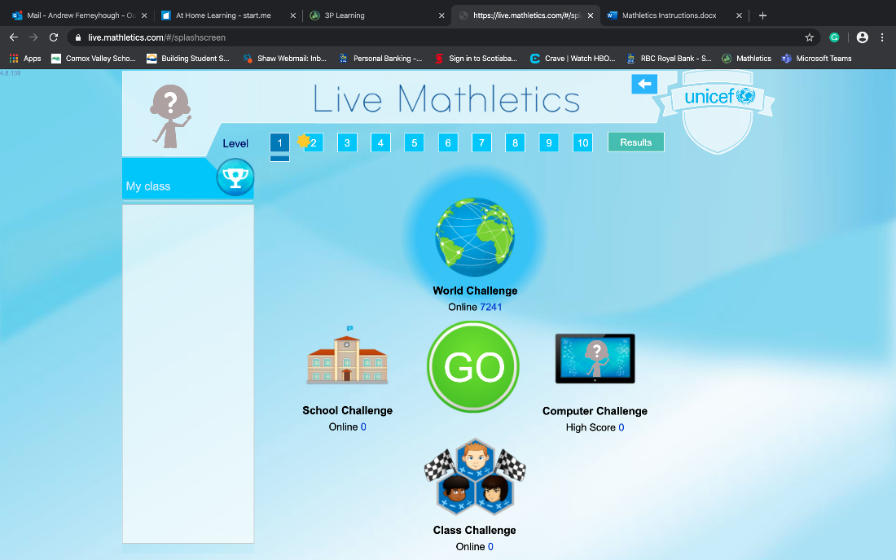
I think that is enough to get us going. We will chat about assessment and tracking and all that good stuff once we have data to track.

Happy Mathing!
Please let me know if you have any questions.

