Connecting to Others through our Conversations: Wonder Writes

“I didn’t write because I had anything to say, but in order to find out what there was to say.”
Eugene Peterson

Let’s write about our conversations. What do our ideas and our conversations say to us when they are written down. What do your ideas say about us?
I wonder is it correct that ‘90% of our ideas come from writing things down’?
Use pen and paper, dry erase and markers or tech such a chatter pix to record conversations ~ real or made up! Fiction or non-fiction

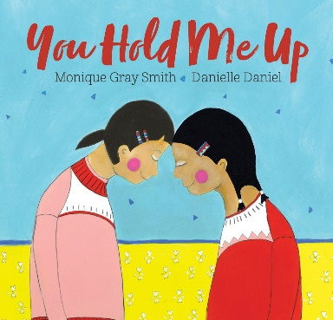 | Monique Gray Smith reads her book You Hold Me Up: https://www.youtube.com/watch?v=Uiuev2fXvRU  https://soraapp.com/open  Monique wrote this book for ‘our littlest citizens’ but the message of reconciliation and healing is for all ages. It is a book about connecting with our heart and fostering empathy.  Wonder prompts for writing:  Who holds me up? How? Who am I holding up? How do I show them my care? As you wonder you might write these thoughts in a journal to become a story later on.  Author’s Note: https://www.youtube.com/watch?v=g4JW6Ckl0yQ
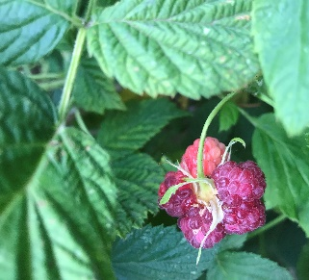 | When we talk math….I wonder what we’ll learn.  This google link is a place for investigative maths….what do you notice in the photograph? What do you wonder? What math lives in these images?  https://bit.ly/2YUrb5m  With someone at home ask some questions: Why is the solution important? Can we find a solution in this image or just more questions? Can we explain our thinking to one another? Is there another way to look at this?  What if we changed ___ … how would the maths change?
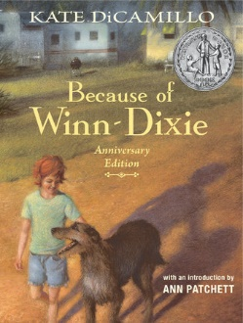 | Because of Winn Dixie by Kate DiCamillo is available in e-book format through Follett Destiny on school library accounts.  India Opal, the main character, is developed through the conversations she has with her father, her furry companion and all the fine quirky folks she meets in her new hometown.  https://m.youtube.com/channel/UCDDl33DkzLRMJCVizE0018A/videos  Conversations can start us off into story places where we can imagine characters and create a world of wonder.
? | Where do you get your ideas? Think about this question we all ask ourselves as we write: I wonder where my favourite authors get their ideas:  https://www.kidsaskauthors.com/blog/where-do-you-get-your-ideas-with-mo-williams April 3,2020 podcast 6:24

