Connecting to Nature: Wonder Writes
Most of our outings are not available with the recommendation for social distancing (staying 2 metres from others) but nature is there for us. When this global pandemic is overwhelming, go or look outside at our earth and sky…hear the birds that are singing and see the sun as it shines. Although we humans are having a rough go, our ecosystem hasn’t shifted due to this and it’s a great opportunity to reconnect. So, take advantage of your yard, your neighborhood, the park, local beaches, hikes, etc. You could also make it a learning or creative opportunity by studying nature, making collections, creating art with what’s growing around us. Anela Deisler
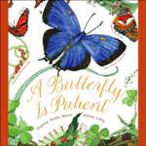 | A Butterfly is Patient  I wonder what other creatures in nature are patient?  I wonder how I could describe other creatures I see/hear in my backyard?  A cricket is…..  An earthworm is….  Take on the role of scientist/observer and walk about with a wonder lens.  https://www.tumblebooklibrary.com/Book.aspx?id=4670
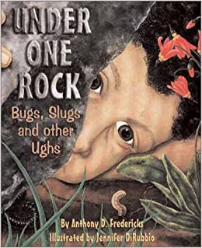 | Under One Rock: Bugs Slugs and other Ughs  Explore the fascinating community of creatures that live under one rock. Viewing this book with its colourful, close-up illustrations may just prompt you to lift a rock – sketch what you observe. Share your wonders in a scientific journal: I notice…I wonder….It reminds me of….. ! ? =  Students log in to Sora with their computer user name and password.  Here's the link: https://soraapp.com/library/comoxvalleyca  Search: Under One Rock
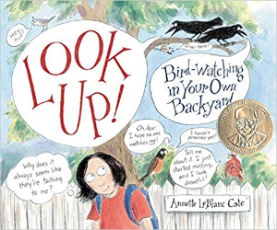 | You don’t have to own binoculars and know a bunch of fancy Latin names to watch birds! No matter where you live, they’re in your neighborhood just look up. https://www.youtube.com/watch?v=wpU7i_lh4gY  I wonder what I have around the house to help me bird watch?  When you are out on a backyard bird watch where will you record your wonders? How might you draw your ‘notices’?  Look up in wonder and record your observations.  Students log in to Sora with their computer user name and password.  Here's the link: https://soraapp.com/library/comoxvalleyca  Search: About Birds Cathryn Sill
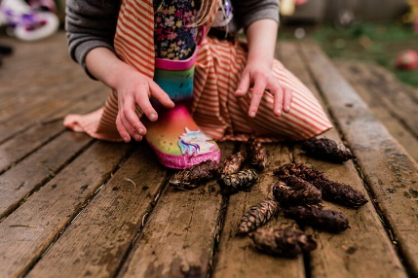 | Three prompts for deeper nature observation:  https://johnmuirlaws.com/deep-observation/  With your own photos adopt a wonder-filled approach:  What do you notice in this photo?  What are you wondering?  What does this remind you of?  ! ? = Photo: Anela Deisler
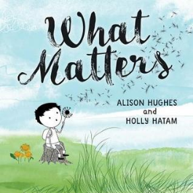 | What Matters by Alison Hughes This beautiful book is available through Follett Destiny on sd71 website in ebook format.  Wondering: How can one tin can affect so much?  Noticing: What are the effects of paying attention to one small thing?  A feeling of mattering is so very important. We matter to others and are there ways we can let others know they matter to us. I wonder how we might show our care for others today...

