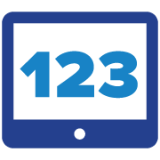
At home learning with Virtual Manipulatives

https://www.mathlearningcenter.org/resources/apps

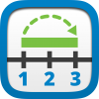 | Using the Open Numberline app lesson activities to get you started Kindergarten through Grade 6 https://www.mathlearningcenter.org/sites/default/files/pdfs/LTM_Numberline.pdf  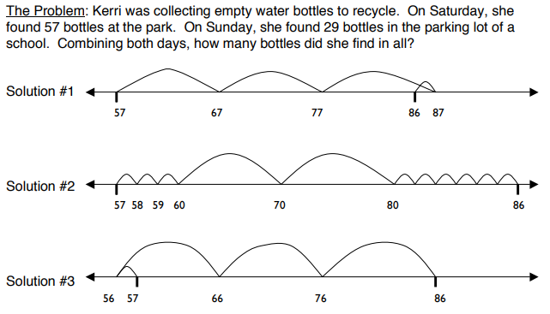
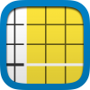 | Using Number Pieces app helps students develop a deeper understanding of place value while building their computation skills with multi-digit numbers. Students use the pieces to represent multi-digit numbers, regroup, add, subtract, multiply, and divide.  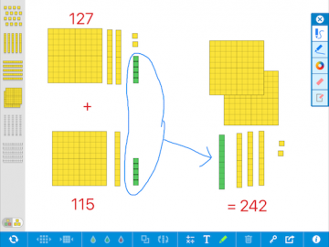
Using the Math Rack app ~ Rekenrek
Building on the idea that students must be able to “see” numbers within other numbers (e.g., 7 might be thought of as “5 and 2 more”), Learning to Think Mathematically with the Rekenrek helps students recognize number combinations of 5 and 10, develop a rich sense of numbers between 0 and 20, and build a strong set of intuitive strategies for addition and subtraction with single- and double-digit numbers.
The beads move in clusters rather than one by one. The beads are always anchored ‘white on the right’. This fantastic tool emphasizes important number relationships: one/more/less, two more/less; part/part/whole decomposing; spatial relationships and benchmarks of 5 & 10.
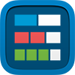 | Using the fractions app  The Fractions app lets students use a bar or circle to represent, compare, and perform operations with fractions with denominators from 1 to 100. Choose the fraction model and number of equal parts. Use a color to select specific parts to show a fraction of the whole.  http://fractiontalks.com/  https://mathforlove.com/lesson/fraction-talks/
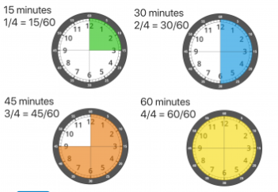
Using the Math Clock app

Telling time, elapsed time
Where does time do? How is a clock face
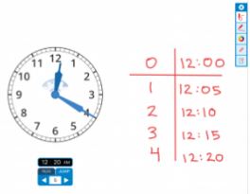
different from a digital clock? What does it allow us to so/show? So much math here.

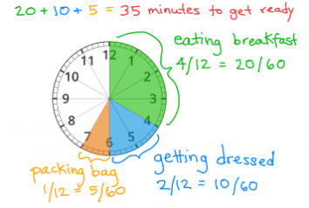

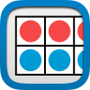 | 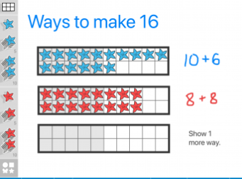  Using the Number Frame app  Number Frames help students structure numbers to 5, 10, 20, and 100. Students use the frames to count, represent, compare, and compute with numbers in a particular range.
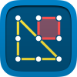 | Using the Geoboard app  The Geoboard app is a tool for inviting & exploring a variety of mathematical topics introduced in the elementary and middle grades.  Learners stretch bands around the pegs to:  ~ form line segments and polygons  ~ make discoveries about perimeter, area, angles, congruence, fractions, and more….  Can you make a: triangle, right triangle, isosceles right triangle,a shape with no sides  - How many triangles fit in a square?  - How many shapes can you make with only a square and a triangle?
At home activities of the day | https://sites.google.com/mathlearningcenter.org/math-at-home/activities-of-the-day#h.hze4hc8cf2b5

