Connecting to Feelings: Wonder Writes
Kids are no different …..when they focus on ideas and information that they care about, when they conduct research to satisfy their own curiosity, they will craft lively, interesting writing just brimming with passion.
Melissa Stewart blogpost: https://www.melissa-stewart.com/

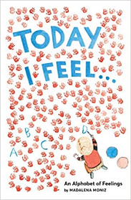 | Madalena Moniz wrote a book through the alphabet of feelings. She did not hold back in choosing rich vocabulary not usually associated with ABC books for young children.  Play with a thesaurus today. Wonder what emotions & feelings words would you include in your wonder write. https://kids.wordsmyth.net/we/  I wonder if there are 26 words to describe my feelings today?
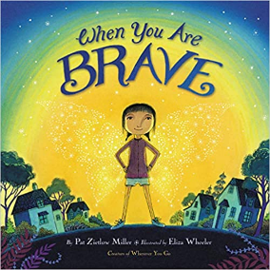 | When you Are Brave by Pat Zietlow Miller https://www.youtube.com/watch?v=q_IcXC8dyeM  Our worries and our wonders are connected. After you listen to the story When you are Brave, consider yourself and your wonders. List things that concern or worry you. When do you know you need to be brave? How do you know that you are brave?
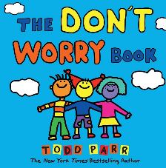 | The Don’t Worry Book by Todd Parr  https://www.youtube.com/watch?v=bqmNyLcWvS0  Sometimes I’m Scared When by Todd Parr  https://www.youtube.com/watch?v=4RupBjV5-N0  I wonder what worries I could write about? How do I face my worries?
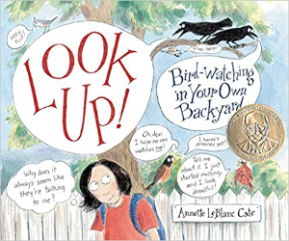 | You don’t have to own binoculars and know a bunch of fancy Latin names to watch birds! No matter where you live, they’re in your neighborhood just look up. https://www.youtube.com/watch?v=wpU7i_lh4gY  I wonder what I have around the house to help me bird watch?  What do you notice? What do you wonder? When you are out on a backyard bird watch. Where will you record your wonders? How might you draw your ‘notices’?  Look up in wonder and record your observations.
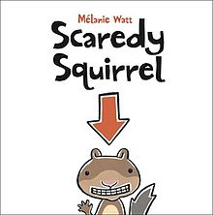 | Returning to this favourite picture book: Scaredy Squirrel by Melanie Watt  https://www.youtube.com/watch?v=mYuWUs1roks  What do you notice about Scaredy Squirrel this time you listen to the story? Picture book authors share many character feelings through words and illustrations. Choose an emojii and develop a wonder write around it.  😊
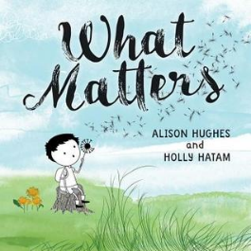 | What Matters by Alison Hughes This beautiful book is available through Follett Destiny on sd71 website in ebook format.  Wondering: How can one tin can affect so much?  Noticing: What are the effects of paying attention to one small thing?  A feeling of mattering is so very important. We matter to others and are there ways we can let others know they matter to us. I wonder how we might show our care for others today...

