Voice Dream Reader Customized Settings Name: ____________
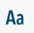
Customize Text

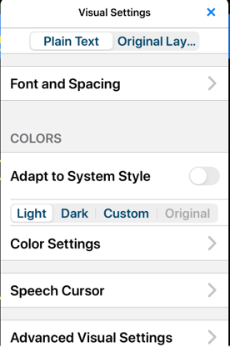
Font ___________________ Text Size __________________
Character Spacing ________ Line Spacing _______________
Side Margins ____________________
Colours: Circle
Light Dark Custom
Text ________________ Background _______________
Highlight ____________ Selection _________________
Spoken Word ________ Spoken Line _______________
Speech Cursor _______________________________________
Advanced Visual Settings ______________________________
___________________________________________________

Audio Settings

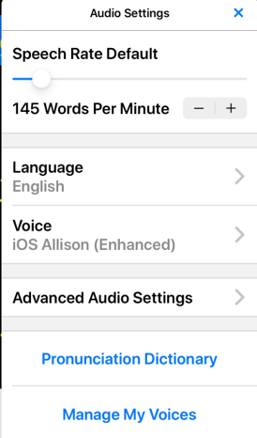
Speech Rate ___________________ Words per Minute
Voice _________________________________

