Microsoft Teams in Comox Valley Schools
To facilitate Online Collaboration, Remote Learning and Educational Continuity, SD71 IT Services has set up Microsoft Teams as the preferred collaboration tool.

What is Microsoft Teams
Microsoft Teams is a unified communication and collaboration platform that combines chat, video meetings, file storage (including collaboration on files), and application integration. The service integrates with Microsoft Office and is the evolution and upgrade path from Skype for Business.

How To Access Microsoft Teams
Web Browser
You can access Microsoft Teams using a web browser at https://teams.microsoft.com/
Teams is supported on Edge, Chrome, Firefox, and Safari, although some Chat and Meeting features may not be available on all browsers.
Log in using your District userid with '@sd71.bc.ca' (e.g. john.doe@sd71.bc.ca) and your district password.
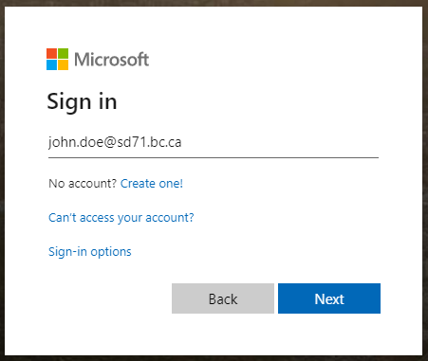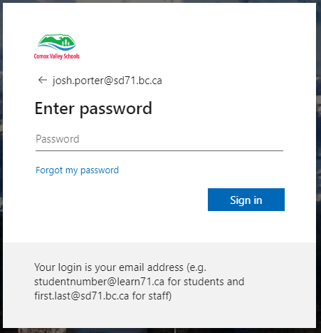
Microsoft Teams Application
A more full fledged user experience with additional features is available using the Teams desktop application. You can download and install the Microsoft Teams application to your Windows or Macintosh computer, and access Teams using this application. On the Microsoft Teams web page, there is a download button in the lower left hand corner of the page. Click this button to download the application to your computer and install it.
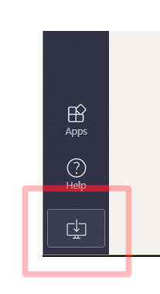
Mobile Devices
On an iOS or Android mobile device, you can install the Microsoft Teams app from the Apple Store or the Google Play Store. Log in to the application using your district userid with @sd71.bc.ca (e.g. john.doe@sd71.bc.ca) and your district password.
Alternatively you can visit this link to download Microsoft Teams: https://teams.microsoft.com/downloads

Scheduling a New Meeting
Outlook Plugin:
The outlook client Teams plugin can also be used to schedule a meeting and sending a link to all participants.
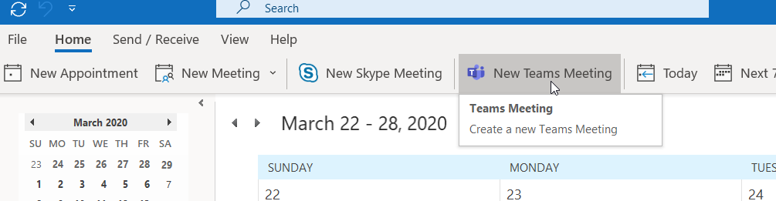
Outlook on the Web:
If you are using Outlook webmail, when creating a new Calendar entry, simply select “Add online meeting” and choose Teams meeting.
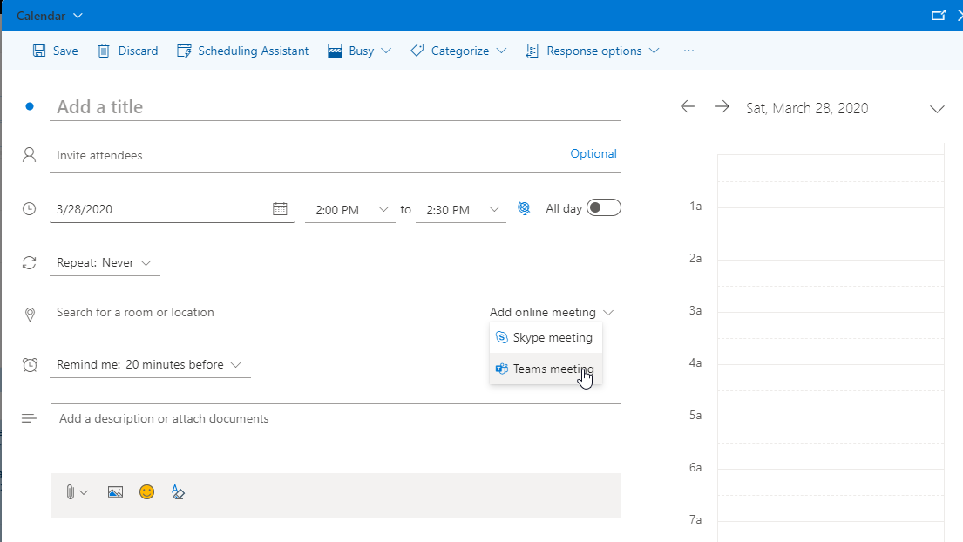

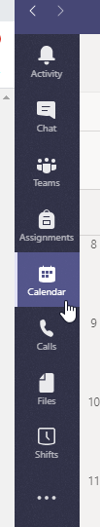
Meet Now – Adhoc Meeting
There may be cases where you want to have a quick ad-hoc meeting. To start the meeting, in the Teams app, click on Calendar on the left, then click Meet Now.
Once you have joined the meeting, you can invite other attendees by clicking in the Invite Someone field on the right and entering in their name, or their email address. If you are inviting someone external to the district, you will need to use their email address (e.g. somebody@gmail.com).
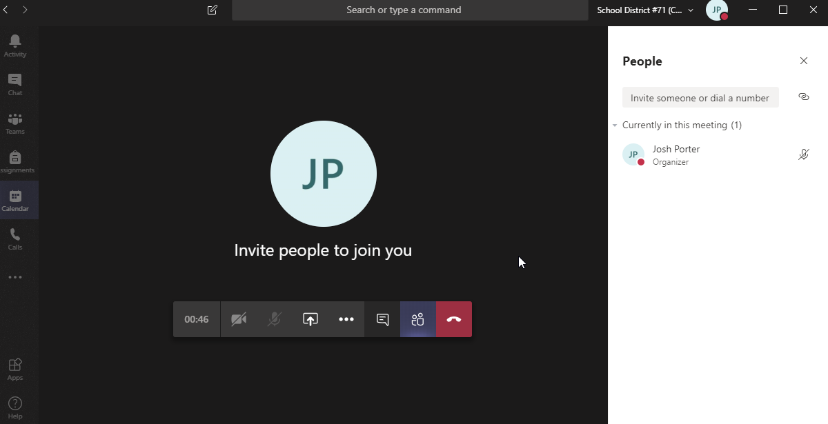

Hosting a Meeting
Controlling Attendee Microphones
Background noise in a meeting is always an issue. If you have more than five participants in your meeting, new participants will enter with their microphones muted. There is a "Mute all" button which you can use to silence all microphones if you are getting a lot of background noise. Remind your participants to keep their microphones muted unless they wish to speak as good virtual meeting etiquette.
Audio Issues - Feedback Problems
On some devices, there will be feedback between the speakers and the microphone. This will manifest as an echo or loud feedback noise.
If you are experiencing audio drop-outs, encourage everyone to turn off video unless they are speaking, video uses quite a bit of extra bandwidth.
Sharing your desktop or application window
Anybody attending the meeting can share their desktop or a single application window with the meeting participants. Use the "Share" button to choose what you would like to share with the group. When you are sharing a window or desktop, this button will change to an icon with an X on it. Click the button to stop sharing with the group. It is usually best to share just a single application window so that pop-up e-mail notifications are not shared with the entire meeting.
Meeting Chat
Use the "Chat" button to open a side dialog where you and your meeting participants can type messages as the meeting is progressing. This can be a good way for meeting participants to ask questions of a presenter without interrupting.
Meeting Notes
Use the "Meeting Notes" option to record notes as the meeting progresses. The meeting notes will be available to all participants.

Recording a Meeting
You can record a meeting in Microsoft Teams by clicking on the Meeting Options button and select Start Recording. You can also stop and start recording throughout the duration of the meeting. After the meeting is over, the recording will be available to all meeting participants.
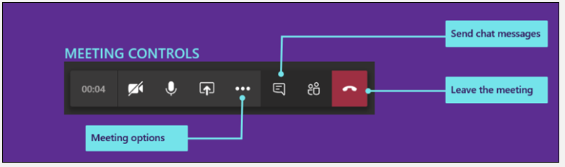
Additional Information
  - Teams Quick Start Guide - A four page PDF with some quick start tips for working with Teams
  - Teams Video Tutorials - Some short video tutorials on all things Microsoft Teams
  - Free Instructor-led courses on Microsoft Teams - Sign up for these free live courses
  - On demand training videos for Microsoft Teams - On demand video recordings from the live courses

School or Department Teams
We have set up a Team for each school and department. These Teams can be used for your staff to communicate with each other, and to share files. You can also use these Teams to hold virtual meetings with your staff.

Channels
The Team Owners (Principal and Vice Principals for school Teams) can add or remove channels to meet the needs of your school or department.

Private Channels
Private channels can also be created if you need to restrict access to a subgroup of your entire Team. The best practice is to limit the use of these to only those situations where confidential information must be shared, as the private channel access restrictions must be managed by the Team Owners. Also, be aware that anybody whom is set as a Team Owner will be able to access any private channels.

Supporting Educational Continuity for Teachers
Comox Valley Schools recommends Microsoft Teams for staff communication. For student communication, the district will support teachers using Microsoft Teams, Scholantis Portal, MyEducation BC, Canvas. If you are already familiar with one of these tools feel free to continue using it. If you are unfamiliar with any of these tools, then likely using Microsoft Teams will minimize your new learning. The following links will give you more information about these tools:
Microsoft Teams
Overview
  - Quick Start Guide - 15 page visual guide
  - Using Teams for Remote Learning - Tips for teachers and students
  - OneNote Class Notebooks - Learn more about the digital binders in Teams
  - Help & How-To - FAQs
  - Learning Modules - Topic-specific resources
  - Teacher Training Packs - Online courses with activities
Teacher Author Resources
  - Alice Keeler Teams Playlist - Series of very short videos on YouTube
Accessibility to Support Emerging Readers and Writers
  - Immersive Reader has read aloud features (text to speech), picture support (picture dictionary) and enhanced dictation (speech to text). It is integrated into most Microsoft products, such as Teams, OneNote, and the Edge internet browser.
  - Immersive Reader Handout
Material Preparation
  - PowerPoint has a built-in screen recording feature. It can be used to record video and audio with any program or website.
  - PowerPoint Handout
  - Office Lens is a virtual scanning app for your computer, tablet, or phone. It is a capture app that lets you copy and crop images of text and whiteboards to make them digitally accessible.
  - Office Lens Overview
If you have any questions, please contact the IT Help Desk (ineedhelp@sd71.bc.ca)

