Nature Walk’s: Mr. A’s Class, room 102
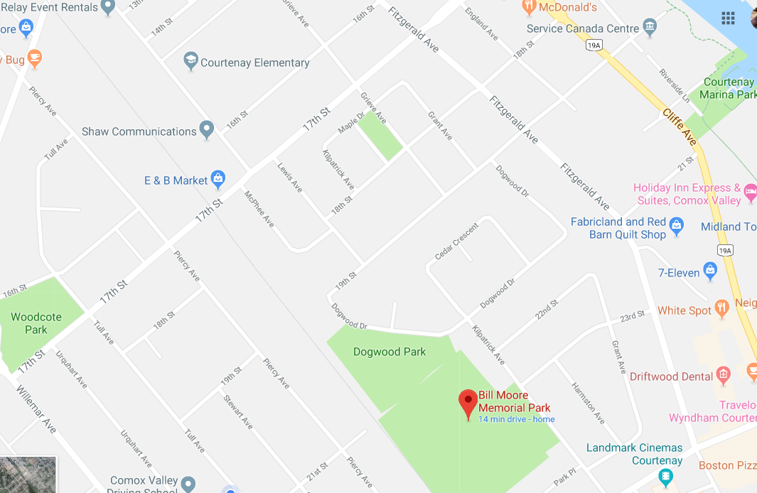
You are here

Date | Time | Location

Mr. A
Contact: 250-555-5555
Email:
Ms. B
Contact: 250-555-5555
Email:

