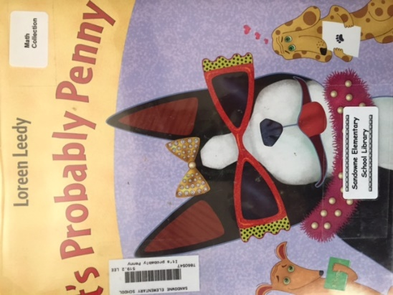 | It’s Probably Penny by Loreen Leedy  - Probability  For her homework, Lisa has to think of an event that will happen, one that might happen and one that can’t happen. Who is the Boston terrier that keeps popping up? It’s probably Penny! A fun way to introduce probability
 | It’s a Possibility by

